Кроссворд
Saturday
для учащихся 8-11 классов,
влюбленных в английский язык
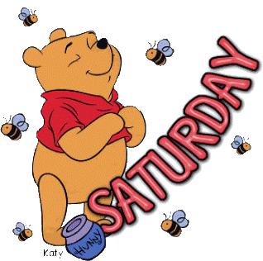

Автор:
Ольга Михайловна Степанова

учитель английского
языка
МБОУ «Цивильская СОШ №2»
города Цивильск
Чувашской Республики

2014

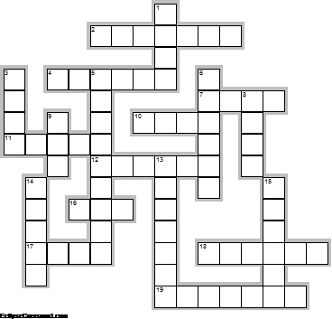
Across

2. In a rhyme reciting the days of the week, ... Grundy 'Died on Saturday.' (7)
4. In astrology, Saturday is associated with the planet ... . (6)
7. It’s not advised to ... on Saturday. Superstition. (4)
10. You must not bake a ... on Saturday. Kentucky Superstition. (4)
11. It causes bad luck to begin building a ... on Saturday. Superstition. (5)
12. In Thailand the color associated with Saturday is ... . (6)
16. If you cut your finger nails on Saturday, you will get ... tomorrow. Kentuckey Superstition. (3)
17. Dreams will come ... if you share them with others on Saturday. Superstition. (4)
18. Better days are coming. They are called Saturday and ... . ~Author Unknown (6)
19. Saturday ... is a notable television time block aimed at children while generally airing animated cartoons. (7)

Down

1. A new ... on Saturday means foul weather. (4)
3. Every man has a right to a Saturday night ... . ~Lyndon B. Johnson (4)
5. Middle age is when you're sitting at home on a Saturday night and the ... rings and you hope it isn't for you. ~Ogden Nash (9)
6. In ... , Saturday is usually the only day of the week when children are allowed to eat sweets. (6)
8. A rainbow sighted on Saturday means it will ... all the next week. Superstition. (4)
9. Some say that the “... always shines on Saturday”. (3)
13. Saturday Night Country, the home of Australian Country Music, is a music ... from ABC Local Radio Australia. (7)
14. “If birthdays fell from the sky like Saturdays shaped like saxophones, I’d learn how to play the ... on Tuesdays.” Jarod Kintz (5)
15. The Saturdays are an English-Irish girl group based and formed in ... , England, UK. (6)

Учащимся будет интересно работать с этим кроссвордом в онлайн режиме, так как он одновременно помещается в интернете по адресу:
file:///C:/Users/1/Desktop/%D1%83%D1%87%D0%BF%D0%BE%D1%80%D1%82%D1%84%20%D0%B4%D0%BB%D1%8F%20%D0%BE%D1%82%D0%BF%D1%80%D0%B0%D0%B2%D0%BA%D0%B8/Friday/Saturday%20Crossword.html
Ответы на следующей странице

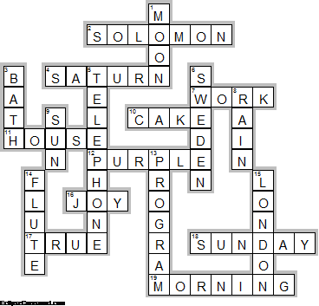
Across

2. SOLOMON—In a rhyme reciting the days of the week, ... Grundy 'Died on Saturday.'
4. SATURN—In astrology, Saturday is associated with the planet ... .
7. WORK—It’s not advised to ... on Saturday. Superstition.
10. CAKE—You must not bake a ... on Saturday. Kentucky Superstition.
11. HOUSE—It causes bad luck to begin building a ... on Saturday. Superstition.
12. PURPLE—In Thailand the color associated with Saturday is ... .
16. JOY—If you cut your finger nails on Saturday, you will get ... tomorrow. Kentuckey Superstition.
17. TRUE—Dreams will come ... if you share them with others on Saturday. Superstition.
18. SUNDAY—Better days are coming. They are called Saturday and ... . ~Author Unknown
19. MORNING—Saturday ... is a notable television time block aimed at children while generally airing animated cartoons.

Down

1. MOON—A new ... on Saturday means foul weather.
3. BATH—Every man has a right to a Saturday night ... . ~Lyndon B. Johnson
5. TELEPHONE—Middle age is when you're sitting at home on a Saturday night and the ... rings and you hope it isn't for you. ~Ogden Nash
6. SWEDEN—In ... , Saturday is usually the only day of the week when children are allowed to eat sweets.
8. RAIN—A rainbow sighted on Saturday means it will ... all the next week. Superstition.
9. SUN—Some say that the “... always shines on Saturday”.
13. PROGRAM—Saturday Night Country, the home of Australian Country Music, is a music ... from ABC Local Radio Australia.
14. FLUTE—“If birthdays fell from the sky like Saturdays shaped like saxophones, I’d learn how to play the ... on Tuesdays.” Jarod Kintz
15. LONDON—The Saturdays are an English-Irish girl group based and formed in ... , England, UK.

The End

