Animal Camouflage
Level 6

ГБОУ СОШ № 2084, г. Москва
Мойсеева Ульяна, 6 класс
ulihka2001@yandex.ru

Парасоцкая Ольга Николаевна,
учитель английского языка ГБОУ СОШ № 426 г. Москва
salchanka@yandex.ru
тел. 8-963-687-64-07

The chameleon belongs to the class of reptiles, to group of scaly, to a suborder of a lizard. All chameleons live in Africa, India, on Madagascar. They have a squeezed trunk. They have small sharp teeth in the mouth. Their legs are long and lean. Their eyes aren’t tied between: each of them looks in its side. The internal structure of a chameleon reminds a structure of primitive lizards. There was an opinion that the chameleon changed coloring for matching with their environment, using of this way to escape from the enemies. Now it’s proved that coloring changes according to influence on a chameleon. For example, they are hungry thirsty or tired they have their ordinary greenish coloring, but their coloring has its modulations from orange to the blue-green. If you grab a chameleon with a hand, it will start biting, but for the person it imperceptibly. Thus skin of a chameleon starts being poured by any colours and shades. This coloring differs from the initial.

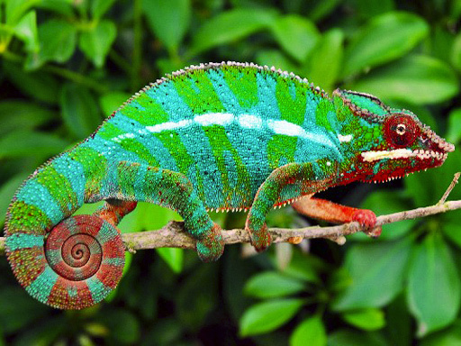

Questions:
- Where do chameleons live?
- Why do chameleons change their colour?
- Are chameleons dangerous for people?

Task 2
Some people have chameleons as their pets at home. Do you want to have one of them at your home? Why? Why not? (write 80-100 wards).

