«Теремок».

Сценарий внеклассного мероприятия по английскому языку, 2класс

Тип занятия: внеклассное мероприятие.
Цель: расширение кругозора учащихся, развитие интереса к изучению иностранного языка посредством занимательных форм обучения.

Тотмина Ирина Васильевна,
Учитель английского языка

2015
Ведущий 1: Good afternoon, my dear friends!
Ведущий 2: Добрый день, дорогие друзья! Welcome to our concert! We are glad to see You!
Ведущий 1: Добро пожаловать на наш концерт! Мы рады видеть Вас!
Чудный день и так светло,
Друг другу скажем мы «Hello!» (все вместе)
Сегодня сказку – «Теремок» на английском мы посмотрим,
И что-то новое для себя запомним!
Ведущий 2 : Возле леса – Wooden House,
Мимо шла малышка Mouse.

(Выбегает Мышка - Mouse. Замечает теремок, подходит к нему)
Mouse: What a nice house! Tock! Tock! Tock! Who lives in the house? Nobody. I can live in the house.
(Выпрыгивает Лягушонок- Frog. Подходит к теремку)
Frog: What a nice house! Tock! Tock! Tock! Who lives in the house?
Mouse: I am a Mouse. I live in the house. My name is Ira . Who are you and what can you do?
Frog: I am a Frog. My name is Dasha. I can swim and jump. (На словах swim – «плавает», jump-«прыгает»)
Mouse: Very good. Come in. (Лягушонок заходит в теремок) (Выходит Лиса, подходит к теремку)
Fox: What a nice house! Tock! Tock! Tock! Who lives in the house?
Frog: I am a Frog.
Mouse: I am a Mouse. I live in the house. My name is Ira . Who are you and what can you do?
Fox: I am a fox. I have a box. My name is Kate.
I like to jump
I like to run
I like to play
Its fun.
Mouse: Very good. Come in. (Лиса заходит в теремок)
(Выходит Кошка, подходит к теремку)
Cat: Oh, what a wonderful house! It is very nice! Tock! Tock! Tock! Who lives in the house?
Frog: I am a Frog.
Fox: I am a fox
Mouse: I am a Mouse. I live in the house. My name is Ira . Who are you and what can you do?
Cat: I am a cat. My name is Vika!
Little mouse, Little mouse
Where is your house?
Little cat, Little cat
I am a poor mouse
I have no house.
Mouse: Very good. Come in. (Кошка заходит в теремок)
(Выбегает Петушок. Подходит к теремку)
Cock: What a nice house! Tock! Tock! Tock! Who lives in the house?
Frog: I am a Frog.
Fox: I am a fox.
Cat: I am a cat.
Mouse: I am a Mouse. I live in the house. My name is Ira . Who are you and what can you do?
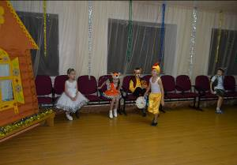
Cock: I am a Cock. My name is Ivan. I like a clock: 1,2,3,4,5,6,7,8,9,10,11,12.(Достает большие часы и считает время на них)
Mouse: Very good. Come in.

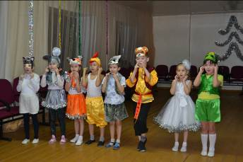
Ведущий 2:
Как проснутся все вокруг,
Cock – спортсмен уж тут как тут!
Всех зовет он на зарядку,
Звери вышли на полянку. (Исполняют песню «Head and shoulders»)

Head and shoulders knees and toes
Knees and toes
Head and shoulders knees and toes
Knees and toes
Eyes and ears
And mouth and nose
Head and shoulders knees and toes
Knees and toes

(Выбегает Волк. Подходит к теремку)
Wolf: What a nice house! Tock! Tock! Tock! Who lives in the house?
Frog: I am a Frog.
Fox: I am a fox.
Cat: I am a cat.
Cock: I am a Cock.
Mouse: I am a Mouse. I live in the house. My name is Ira . Who are you and what can you do?
Wolf: I am a grey wolf! My name is Vlad. I am a hungry wolf. I want some soup. I can run and growl (рычать)
(Выходит медведь, собирает грибы и цветы)
Bear: What a nice house! Tock! Tock! Tock! Who lives in the house?
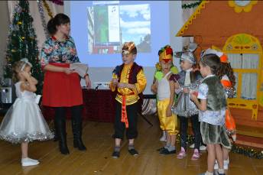
Frog: I am a Frog.
Fox: I am a fox.
Cat: I am a cat.
Cock: I am a Cock.
Wolf: I am a grey wolf.
Mouse: I am a Mouse. I live in the house. My name is Ira . Who are you and what can you do?
Bear: I am a Bear. My name is Denis. Look at my flowers – they have many colours: red, yellow, white, blue, orange, pink. (Дарит цветы своим новым друзьям).
Ведущий 1:Дружно Friends- друзья живут,
И друг друга берегут!
Каждый день встречают вместе,
Исполняя эту песню!
Five little monkeys jumping on the bed
One fell off and bumped his head
So Momma called the doctor and the doctor said
No more monkeys jumping on the bed!

Four little monkeys jumping on the bed
One fell off and bumped his head
So Momma called the doctor and the doctor said
No more monkeys jumping on the bed!

Three little monkeys jumping on the bed
One fell off and bumped his head
So Momma called the doctor and the doctor said
No more monkeys jumping on the bed!

Two little monkeys jumping on the bed
One fell off and bumped his head
So Momma called the doctor and the doctor said
No more monkeys jumping on the bed!

One little monkey jumping on the bed
He fell off and bumped his head
So Momma called the doctor and the doctor said
No more monkeys jumping on the bed!

No little monkeys jumping on the bed
None fell off and bumped his head
So Momma called the doctor and the doctor said
Put those monkeys back in bed!
