XI Международная дистанционная олимпиада «Эрудит»
Английский язык, 7 класс, I тур
Савинич Дарья, 7 класс

SEVEN WONDERS OF THE ANCIENT WORLD

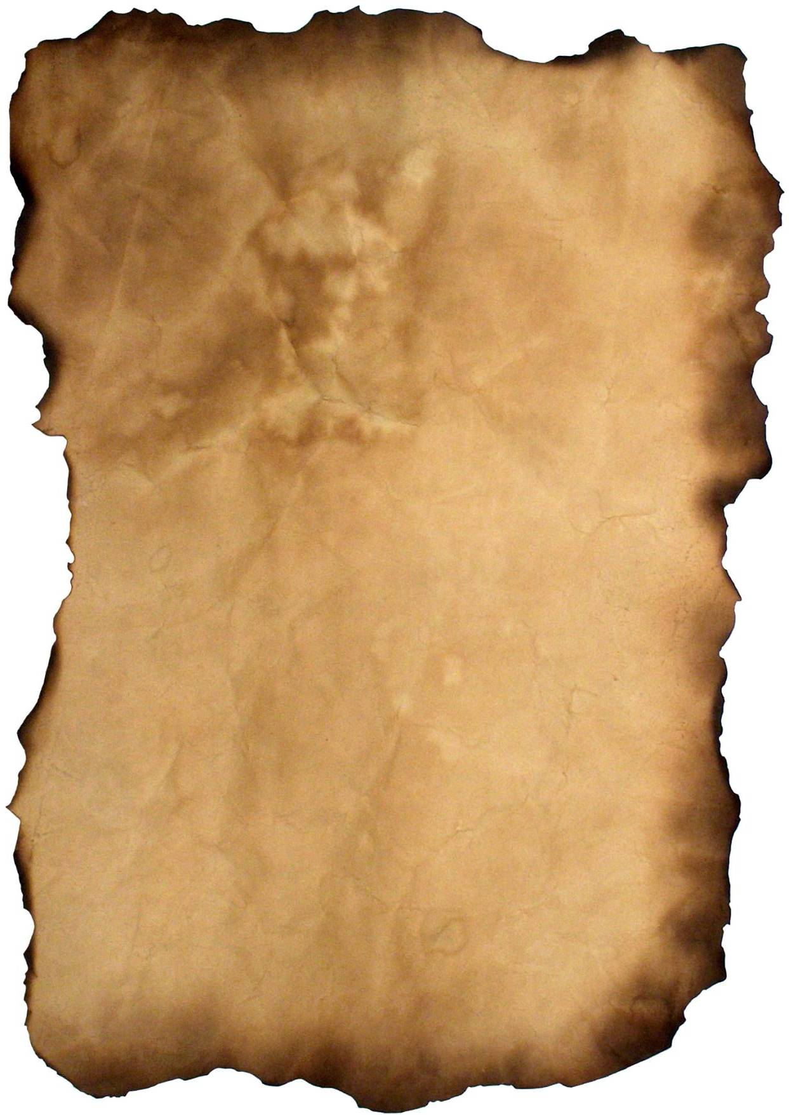
Six of the seven wonders of the ancient world were described by Philon of Byzance, a II century before Jesus Christ engineer, in a manuscript entitled "Péri tôn hépta théamatôn" (About the seven wonders of the world). This manuscript including six layers only described six constructions. The seventh, the mausoleum of Halicarnassus, is only described in the introduction of the manuscript because the last layer disappeared.
The canonical list refers to the seven following wonders:
- The Great Pyramid of Giza
- The Hanging Gardens of Babylon
- The Statue of Zeus at Olympia
- The Temple of Artemis at Ephesus
- The Mausoleum at Halicarnassus
- The Colossus of Rhodes
- The Lighthouse of Alexandria

The Great Pyramid of Giza
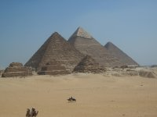
It’s considered that the Pyramid of Khufu was built near 2800 BC but the uncertainty concerning this date remains important. This pyramid would have been drawn by Imhotep, Egyptian architect of the third dynasty of ancient Egypt.
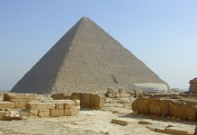
The Egyptians reached the perfection by building this edifice that was raised by the Pharaoh Khufu and that we know nowadays with the name of the Great Pyramid of Giza.

The Hanging Gardens of Babylon
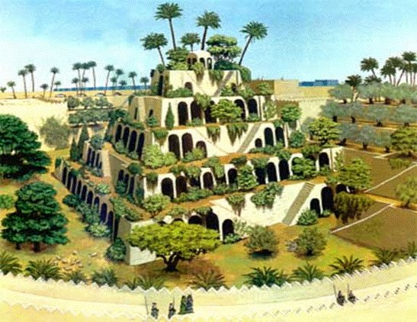
The gardens were located on east the bank of the river Euphrates, in the city of Babylon (50 km from Bagdad) and may have been built in 600 bc. No Greek historian have seen them, it just consists in stories told by solidest, which is a quite doubtful source of information.
According to the legend king Nebuchadnezzar II (604-562 BC) would have made build the famous hanging gardens of Babylon for his wife Sémiramis to remind her the vegetation of the mountains from her natal country: Media (actual Iran).
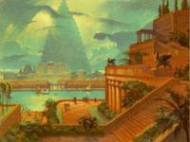
These gardens were composed of several floors, each was a terrace of 120 m² supported by vaults and pillars of brick. An immense staircase, made of marble, connected the terraces, where water was brought from the river Euphrates by a system of hydraulic screws.

The Statue of Zeus at Olympia
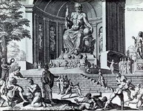
This statue was located on the west coast of Greece at Olympia. In the antiquity, this city was a place of cult which contained numerous treasures of the Greek art: temples, monuments, altars, theaters, statues and marble or bronze votive offerings. It was realized with golden and ivory, measured 12 m (39 feet) height and was placed on a base of 2 m (7 feet). The base of the statue was 6 m (21 feet) wide and 1 m height. The statue's perimeter was 13 m (43 feet). This work touched almost the ceiling of the temple. On the other hand, the throne was decorated with precious stones, ivory, ebony and gold.

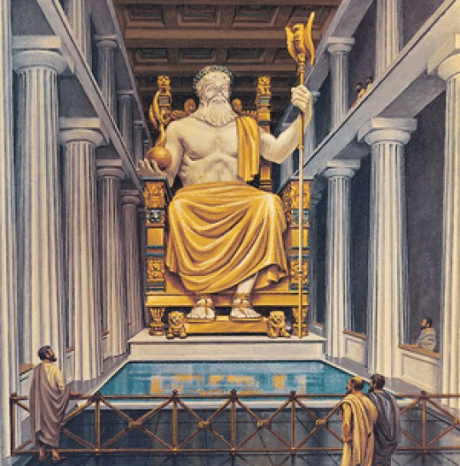

The Temple of Artemis at Ephesus

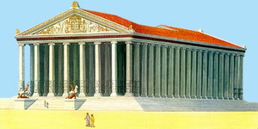
It was located in Turkey, in the ancient city of Ephesus which is nowadays called Selcuk, and which is located 50 km in the South of Izmir. This temple was set up from the middle of the eighth century to the middle of the third century BC. It has the peculiarity to have been demolished seven times in ten centuries.
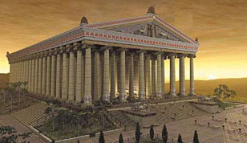
The first temple was primitive (8 columns on 4), however king Croesus ordered to destroy it in order to raise a new much larger one. With a base of 155 m (508 feet) on 60 (197 feet), the new sanctuary possessed 127 columns with sculptured reliefs. But it was destroyed again to leave place to the new temple drawn by the Greek architect called Chersiphron, even more gigantic than the precedent: its Ionic columns, adorned with gold, raised at more than 18 m height and contained scenes with mythological symbols sculptured by the lost famous sculptors and the Greek architects such as Scopas, Praxiteles, Phidias and Polyclitus.

The Mausoleum at Halicarnassus
It is very likely that Artemis, sister and woman of the satrap of Carie began the construction of this edifice in 353 BC, three years after the death of king, to honor him. The mausoleum was ended one year after the death of this woman.
With a total height of around 43 m (141 feet), it was sustained with thirty six columns and surmounted by a pyramid decorated of one quadriga2 with marble. The funeral chamber doubtless contained the graves of Mausole and Artemis. We could also observe a valuable frieze represented a fight of the Greeks against the Amazon and the Centaurs.
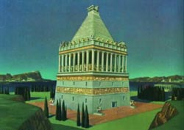

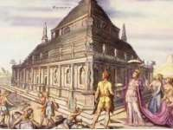

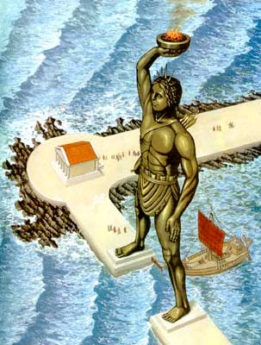
The Colossus of Rhodes

The Colossus of Rhodes was located in the wearing of Rhodes in Greece, probably at the end of the current Saint-Nicolas Day mole, where some marble blocks have been found and could have been used to build the base of the statue. The Colossus of Rhodes was set up between 303 and 291 BC, so it took twelve years of hard work to totally finish it.
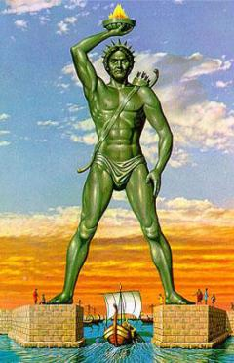
Made of bronze and based on marble block, the statue was 32 meters (105 feet) height from the top of the head to the feet, that is to say 14 meters (46 feet) less than the statue of liberty in New York. The height enabled the statue to be visible by the ships approaching to the port. In his raised arm, the sun god held a torch while his other arm was pressed on a lance. Contrary to the illustrations we usually find, ships were not passing under the colossuses’ legs to enter in the wearing of Rhodes. It was technically impossible that the statue had its legs split.
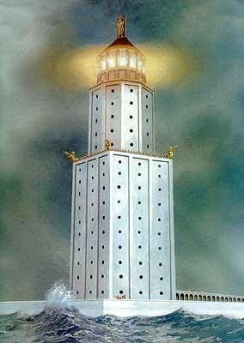
The Lighthouse of Alexandria
The Lighthouse is located in Egypt on the island of Pharaos in front of the city of Alexandria. During the centuries, this island was connected with the continent by the alluviums of the Nile, on which we built a road and a bridge. The lighthouse, built on the island, was begun under Ptolemy II Philadelphus and ended around 280 BC by Sostratus of Cnidus.
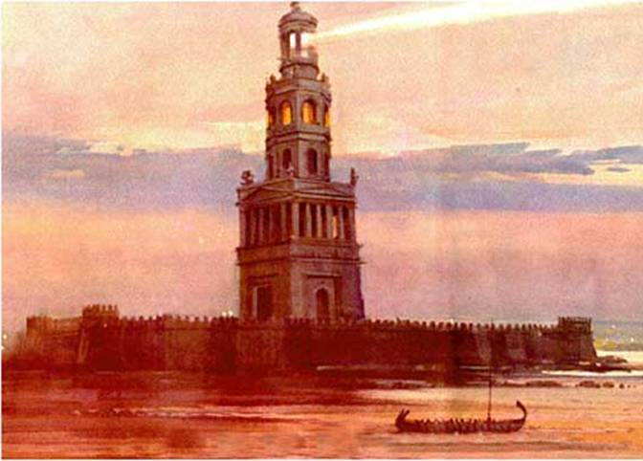
The lighthouse counted three floors: the first one was squared, the second was octagonal and the third cylindrical. The white marble whole measured approximately 135 m (440 feet) height from where we could see ships located 100 miles far away. Angles were decorated with bronze tritons which were used either to warn of the approach of the enemy by terrifying sounds, but also to carry mirrors which, during the night, reflected the light of a fire. In the daytime, the smoke indicated to the boats the entrance of the port.
Resources

- http://eva.ru/jsf/forum/print-all.jsp?topicId=2769264
- http://www.infohome.com.ua/gallery.php?category=articles&id=30&i=4
- http://www.playcast.ru/?module=blog&action=showArticle&articleId=93880
- http://www.poiradar.ru/poiGallery/AlexandriaMayak-9826/Alexandria-9825/Sightseeings_ArchitectureMonuments

- http://russims.ru/forum/25-1154-1
- http://7chydessveta.com/news/vhodyashchaya_v_sostav_semi_chudes_sveta_statuya_zevsa_dostigala_14_metrovoy_visoti.html

- http://altertours.ru/ajax_controller3.php?action=show_staty&id=68

- http://7chydessveta.com/koloss/5.html

- http://7chydessveta.com/koloss/4.html
- http://7chydessveta.com/galikarnasski/3.html

- http://altertours.ru/ajax_controller3.php?action=show_staty&id=68

- http://7chydessveta.com/hramartemidi/4.html
- http://slims.geo.tsu.ru/image/aHR0cDovL2tpdGEuY29tLnVhL2Jsb2cvcG9zdC9yZWxhdGlvbnNoaXAvNjI2ODQvc2hvdy5odG1s

