XI Международная дистанционная олимпиада «Эрудит»
Английский язык, 7 класс, I тур

MAGIC WORLD OF THE ANCIENT TIME

Today I’ll tell you about the seven wonders of our world! Our journey is called: "The wonders and attractions of our planet!"
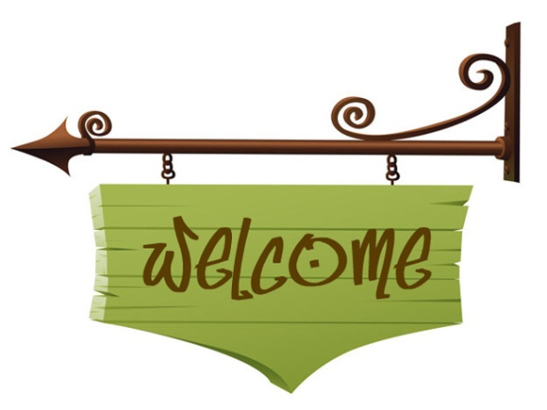

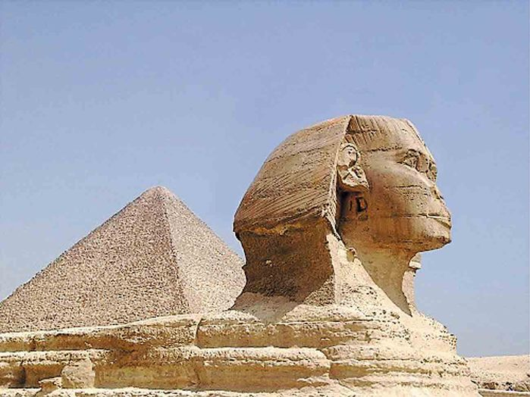
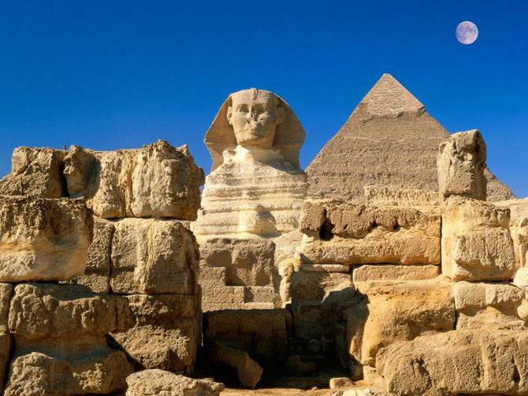
And so, the first miracle is Egypt. This is the most famous, beautiful and unique pyramid of Cheops! It has been constructed in 2540 BC, it’s located in Giza (Egypt) Egyptians built it. This is the only miracle preserved to our days! It was created for the tomb of Pharaoh of Cheops.

And this is Egypt again and the city of Alexandria. Here is the lighthouse of Alexandria which was built by the Greeks in the 3rd century BC. But ceased to exist lighthouse due to earthquake.

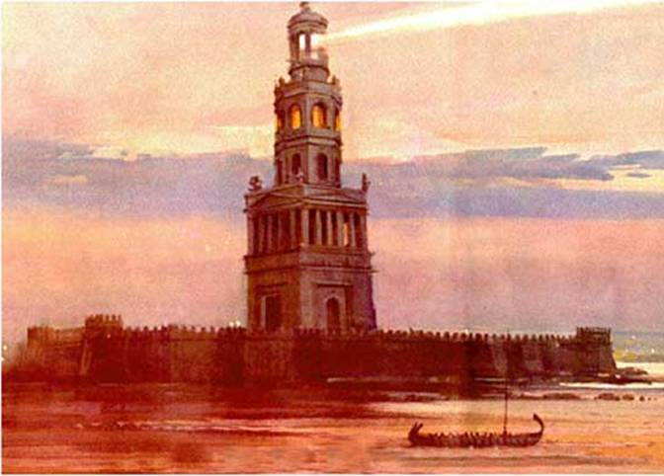
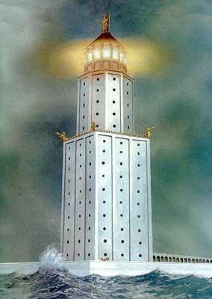
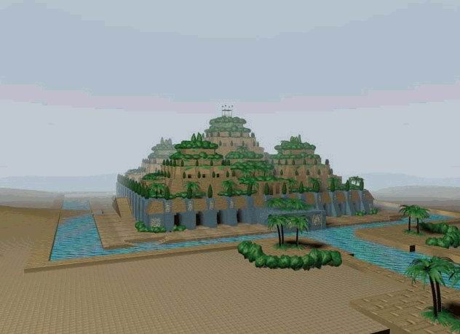
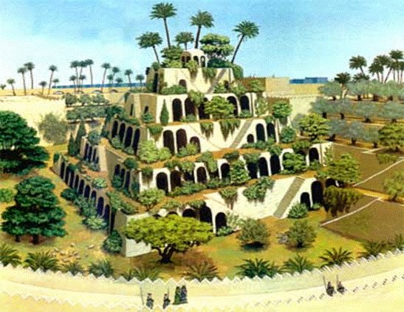
This is the city of Babylon. It’s Irak. These hanging gardens of Babylonian were built by Babylon in 605 BC. Destroyed the Foundation and the building collapsed.

Look at the right, now we are in Greece in the city of Olympus. Here is the most famous statue of Zeus. It was built by the Greeks in the 435 BC, the statue was burnt in the city of Constantinople during the fire at the Hippodrome.

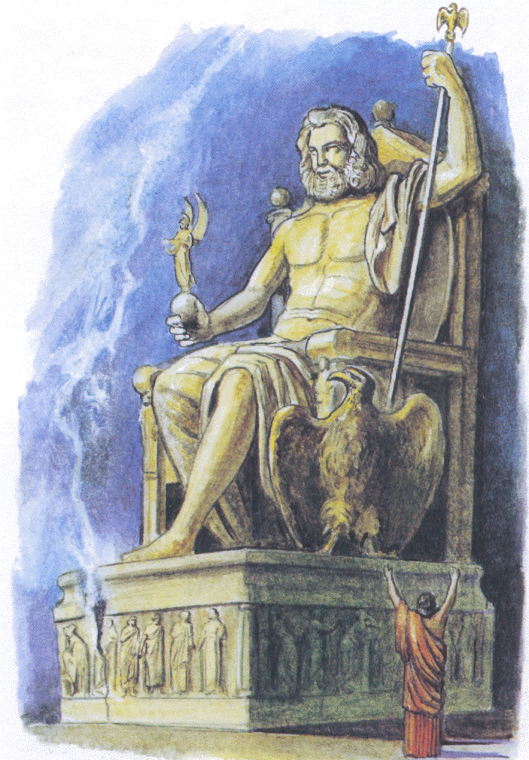
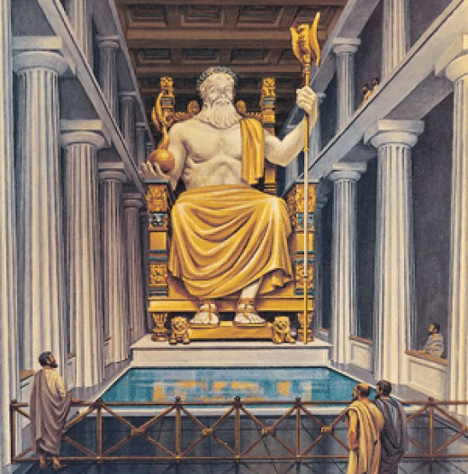

This is Greece again, but only the city of Rhodes, Rhodes town in the form of a Dolphin and here is the colossus of Rhodes, was built by the Greeks in 280 BC, in the disappearance of this landmark guiltily earthquake.
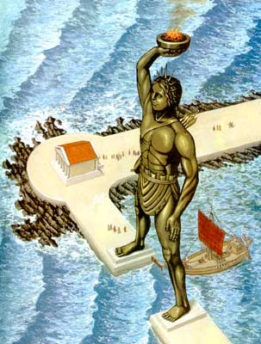
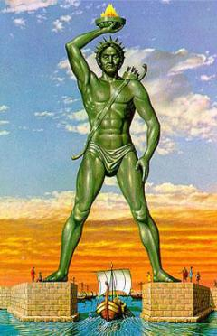

And this is the final country today, it is Turkey, Ephesus. Here is the famous temple of Artemis, built in 550 BC by the Greeks and the Persians the Church was built in honor of the goddess Artemis, and ceased to exist after the fire.
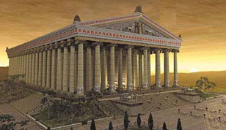

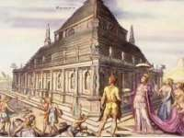
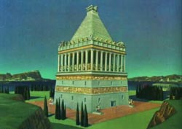
This is mausoleum, which is also in Turkey only in the city of Halicarnassus. It was built by Koreans, the Persians and the Greeks in 351 BC, ceased to exist after the earthquake, but the Foundation has been preserved.

That is all. I want to see you again.
Good luck, Buy!

Recourses:
- http://eva.ru/jsf/forum/print-all.jsp?topicId=2769264
- http://www.infohome.com.ua/gallery.php?category=articles&id=30&i=4
- http://www.playcast.ru/?module=blog&action=showArticle&articleId=93880
- http://www.poiradar.ru/poiGallery/AlexandriaMayak-9826/Alexandria-9825/Sightseeings_ArchitectureMonuments

- http://russims.ru/forum/25-1154-1
- http://7chydessveta.com/news/vhodyashchaya_v_sostav_semi_chudes_sveta_statuya_zevsa_dostigala_14_metrovoy_visoti.html

- http://altertours.ru/ajax_controller3.php?action=show_staty&id=68

- http://7chydessveta.com/koloss/5.html

- http://7chydessveta.com/koloss/4.html
- http://7chydessveta.com/galikarnasski/3.html

- http://altertours.ru/ajax_controller3.php?action=show_staty&id=68

- http://7chydessveta.com/hramartemidi/4.html
- http://slims.geo.tsu.ru/image/aHR0cDovL2tpdGEuY29tLnVhL2Jsb2cvcG9zdC9yZWxhdGlvbnNoaXAvNjI2ODQvc2hvdy5odG1s

