XI Международная дистанционная олимпиада «Эрудит»
Английский язык, 6 класс, II тур

The world is so manic
That we don’t have a chance
To get rid of the panic
And look around us.
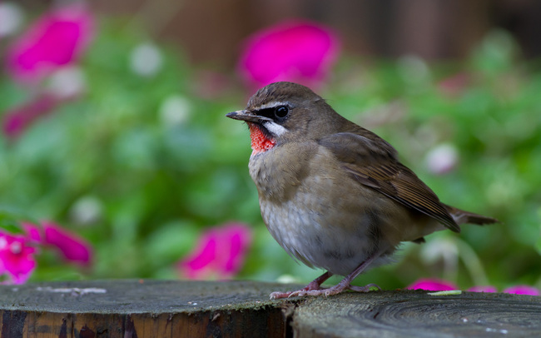
Time goes by
But we can’t still enjoy yet
Bird’s loud cry
And the song of spring joy.
Out life is avoid of dreams
And is spent on digital machines.
We stare at computer screens
Which bring fake imagination.
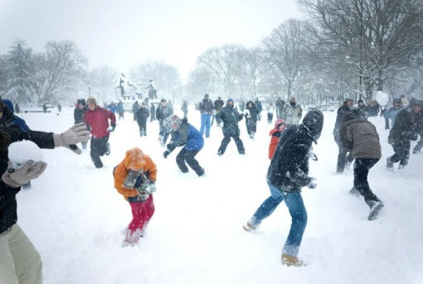
Let’s live a daily life
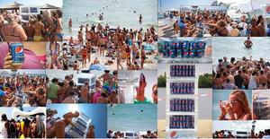
Like this is the last one
Exult at warmth of May,
Mid-August heat and winter fun.
The only precious things you’ve got
Are family and friends to be you with.
Remember that no matter what,
They are your air to breathe.

Источники
- http://otvali.ru/photos/nochju_v_tokio_svetlo_kak_dnem_foto:39765.html
- http://bestforce.skeeks.com/gdefon/download/site/bestforce/id/466760/name/ptica_seraya_fokus_penki_derevo_cvety_yarkie_razmy/
- http://lugansk.lug.slando.ua/obyavlenie/igrovoy-kompyuter-intel-2-yadra-4giga-operativy-500gb-vinchester-ID5VJfD.html
- http://vsevesti.com/go/ru/article/id/1169929/samoe-holodnoe-pepsi-etogo-leta.html
- http://pikabu.ru/story/shkolote_ne_ponyat_874017

