X Международной дистанционной олимпиаде по английскому языку
для учащихся 7 класса.
CHRISTMAS IN AUSTRALIA
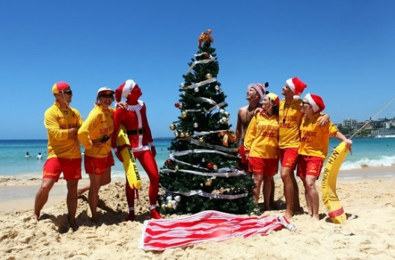

Australia,
UK

Dear pen-friend,
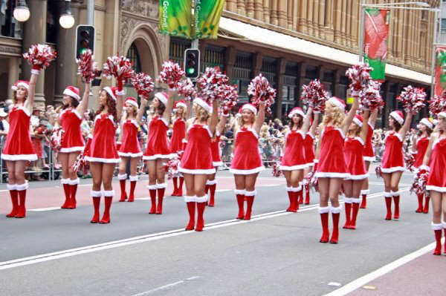
I’d like to tell you about Christmas in Australia. In the middle of November you can visit Christmas parade. Santa Claus arrives to the city, but usually he’s called “Swag Man”. In spite of the hot weather and high temperature, people with great pleasure organize picnics and dinners with their friends, relatives and colleagues. They become kinder, friendlier and closer. In the streets sellers, bank-workers and bus-drivers wear caps with deer horns. Australians celebrate Christmas with their families. They cook traditional dishes: a turkey and a pudding, a cold chicken, salads and X-mass cake. The most popular present is towel for beach.
By the way, what do Russians do on Christmas Day? What is usual weather on this day?
Drop me a line and I’d like you to come to Australia for Christmas.
Love,
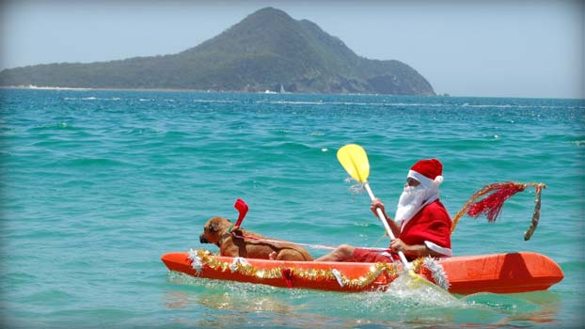
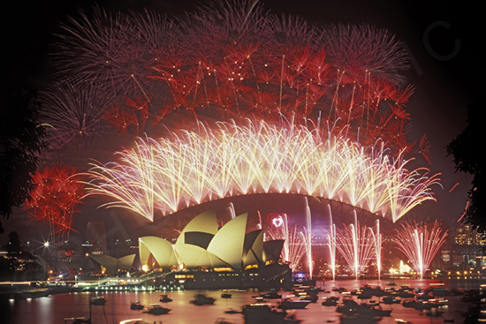
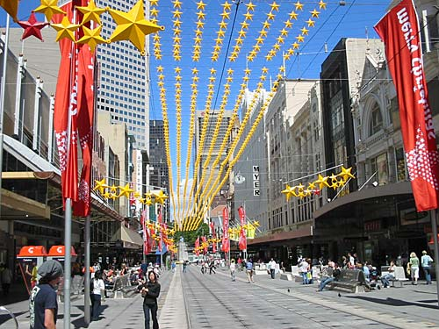
Kate

Источники:

http://www.wikihow.com/Celebrate-Australia-Day
http://www.nationmaster.com/encyclopedia/State-(subnational)
http://wiki.answers.com/Q/What_cross_is_on_the_Australian_flag
http://www.canberra.edu.au/university/canberra
http://review-planet.ru/2012/02/sidnejskij-opernyj-teatr-fotografii/
http://festival.1september.ru/articles/520193/
http://en.wikipedia.org/wiki/Ned_Kelly
http://simple.wikipedia.org/wiki/Didgeridoo
http://en.wikipedia.org/wiki/Tasmanian_devil
http://www.uta.fi/FAST/US1/REF/aust-eng.html
http://dic.academic.ru/dic.nsf/eng_rus/427390/arvo
http://www.english-online.at/geography/australia/plants-and-animals-in-australia.htm
http://www.english-online.at/geography/australia/sydney-canberra-australian-cities.htm
http://www.english-online.at/geography/australia/australian-way-of-life.htm

