**XI Международная дистанционная олимпиада «Эрудит»**

**Английский язык, 6 класс, II тур**

**There are some things which we don’t pay attention to. Now I have 24 hours and what I’ll do…**

**Now it’s winter. I can clear away snow, sprinkle roads. I can make feeders and feed birds, homeless animals. I can write declaration in which people don’t throw garbage.**

[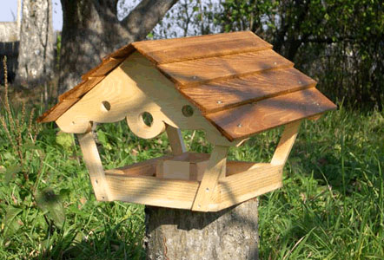](http://images.yandex.ru/#!/yandsearch?text=кормушки &fp=0&pos=2&uinfo=ww-1903-wh-985-fw-1678-fh-598-pd-1&rpt=simage&img_url=http%3A%2F%2Fimg1.liveinternet.ru%2Fimages%2Fattach%2Fc%2F6%2F93%2F663%2F93663181_1255170330_kormushka4.jpg)

**[](http://images.yandex.ru/yandsearch?text=%D1%83%D0%B1%D0%BE%D1%80%D0%BA%D0%B0%20%D0%B2%20%D0%B4%D0%BE%D0%BC%D0%B5%20%D0%B2%20%D0%BA%D0%B0%D1%80%D1%82%D0%B8%D0%BD%D0%BA%D0%B0%D1%85&fp=0&pos=0&uinfo=ww-1263-wh-878-fw-1038-fh-598-pd-1&rpt=simage&img_url=http%3A%2F%2Fcs403322.vk.me%2Fg41232806%2Fe_4e1f6cc7.jpg)I have parents who ask me about something. It may be taking care of my younger brother until they are busy. Also they ask me to clean the house.**



**[](http://images.yandex.ru/#!/yandsearch?text=they ask me to clean the house&fp=0&pos=25&uinfo=ww-1903-wh-985-fw-1678-fh-598-pd-1&rpt=simage&img_url=http%3A%2F%2Foverstockfootage.com%2FeBay_template%2Fimages%2Fsbc_08.jpg)**

**At the end of this day, we will get thanks, it will be nice.**

**Help all and do good then it will return to you.**

Источники

1. [**http://anna.besaba.com/kormushki-i-domiki-dlya-ptic/**](http://anna.besaba.com/kormushki-i-domiki-dlya-ptic/)
2. [**http://www.liveinternet.ru/users/lady\_fairy\_teller/blog/**](http://www.liveinternet.ru/users/lady_fairy_teller/blog/)
3. [**http://www.laventure.ru/communication/blog/index.php?page=blog&blog=poleznye-zametki&year=2013&month=8**](http://www.laventure.ru/communication/blog/index.php?page=blog&blog=poleznye-zametki&year=2013&month=8)
4. [**http://www.smeha.ru/lastnews/page/228/**](http://www.smeha.ru/lastnews/page/228/)