**XI Международная дистанционная олимпиада «Эрудит»**

**Английский язык, 7 класс, II тур**

**THE TIME MACHINE JOURNEY**

England

10th February

Dear friend,

I’m during the Renaissance in England widespread dramatic literature, which was associated with the development at the time of theatrical performances.

[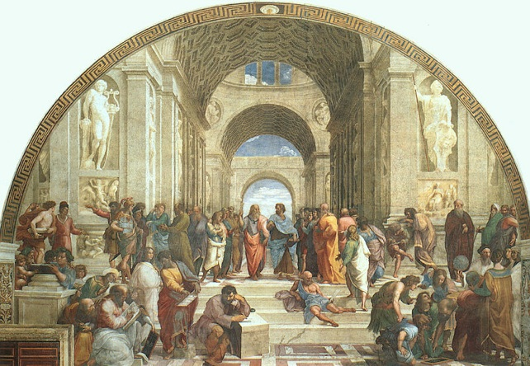](http://images.yandex.ru/yandsearch?text=%D1%8D%D0%BF%D0%BE%D1%85%D0%B0%20%D1%80%D0%B5%D0%BD%D0%B5%D1%81%D1%81%D0%B0%D0%BD%D1%81%D0%B0%20%D0%B2%20%D0%B0%D0%BD%D0%B3%D0%BB%D0%B8%D0%B8%20%D0%B2%20%D0%BA%D0%B0%D1%80%D1%82%D0%B8%D0%BD%D0%BA%D0%B0%D1%85&fp=0&pos=13&uinfo=ww-1263-wh-878-fw-1038-fh-598-pd-1&rpt=simage&img_url=http%3A%2F%2Fupload.wikimedia.org%2Fwikipedia%2Fcommons%2Fthumb%2F3%2F31%2FLa_scuola_di_Atene.jpg%2F220px-La_scuola_di_Atene.jpg)Theatre in England had its own characteristics that distinguish it from other countries in the theater. English theater contained significant elements of religious and social struggle. Although there are already religious activities often turned into paintings modern household. Plays are increasingly worn edifying character, the authors sought to create vivid images that are the personification undoubted virtue, or vice versa, unconditional vices. Thus, the traditions of the Middle Ages in England were not dead, but have undergone expansion and deepening. From the medieval stage productions preserved here, for example, a mixture of the tragic and comic works division into separate independent episodes, crowd scenes, parallel actions, and other features. In addition, the drama was influenced ancient and humanistic drama. A large role in the development of dramatic art and played the national recovery, ensure the dissemination of national traditions on stage. The result was a peculiar combination of opposite directions, which is one of the most important features of English Renaissance theater.

[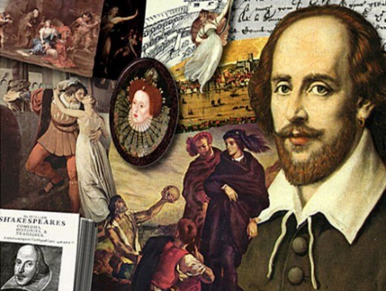](http://images.yandex.ru/yandsearch?text=%D1%88%D0%B5%D0%BA%D1%81%D0%BF%D0%B8%D1%80%20%D0%B2%20%D0%BA%D0%B0%D1%80%D1%82%D0%B8%D0%BD%D0%BA%D0%B0%D1%85&img_url=http%3A%2F%2Fimg1.liveinternet.ru%2Fimages%2Fattach%2Fc%2F5%2F85%2F927%2F85927877_shakespearecollage.jpg&pos=6&rpt=simage&lr=213&noreask=1&source=wiz)English drama this time is characterized by a variety of genres, high skill technology and rich ideological richness. It also noted the wealth of fantasy, fast-paced action, the saturation of images, the power of passion and tension volitional actors. Are reflected in the theater and various epochs, nations, national strata. Development of all these traits contributed many prominent playwrights. However, the head of all costs, of course, William Shakespeare, who made an invaluable contribution to the transformation of the English theater. He unusually deepened everything that took his predecessors, found generalized and harmonious expression of feelings, thoughts and problems that agitated people in those days. He portrayed the flourishing of the human person and the richness of life in all forms and colors galore, and, moreover, all this led to the unity and regularity.

[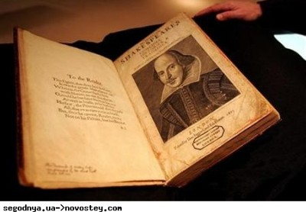](http://images.yandex.ru/yandsearch?source=wiz&fp=0&text=%D1%88%D0%B5%D0%BA%D1%81%D0%BF%D0%B8%D1%80%20%D0%B2%20%D0%BA%D0%B0%D1%80%D1%82%D0%B8%D0%BD%D0%BA%D0%B0%D1%85&noreask=1&pos=14&lr=213&rpt=simage&uinfo=ww-1263-wh-878-fw-1038-fh-598-pd-1&img_url=http%3A%2F%2Fwww.dkvartal.ru%2Fsystem%2Fimages%2Fnews%2F000%2F386%2F287_x_large.jpg)Shakespearean theater era is still a festival, carnival in the square. However, while growing interest in the art of the theater led to the formation of permanent professional troupes instead of the previously existing temporary amateur associations. Began to build a special building for theatrical productions. Availability theater for all segments of the population made ​​it nationwide and led to the creation of varied repertoire. All these features were of great importance for the development of English drama.

Subjects for his works Shakespeare, like many writers of the time, borrowed from existing sources. But he, unlike the others, with great skill combined these sources, deepening and developing their stories. Adopting known, he made ​​it into the tradition of national culture.

Because of it can truly be said that "He has everything - borrowed, and all - mine." In those days, the concept of authorship in general played no important role. Often it never claimed. Theater plays are often written by several authors at the same time, and each brought something different to work.

[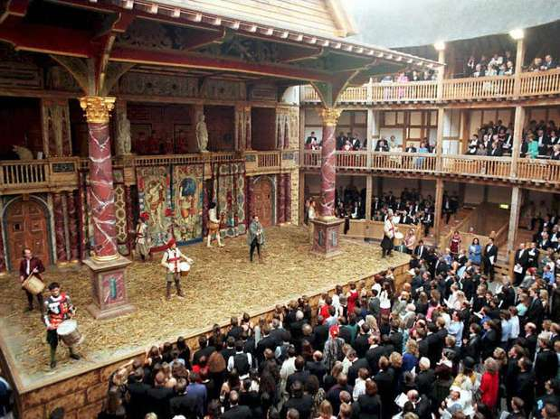](http://images.yandex.ru/yandsearch?text=%D1%82%D0%B5%D0%B0%D1%82%D1%80%20%D1%88%D0%B5%D0%BA%D1%81%D0%BF%D0%B8%D1%80%20%D0%B2%20%D0%BA%D0%B0%D1%80%D1%82%D0%B8%D0%BD%D0%BA%D0%B0%D1%85&fp=0&pos=19&uinfo=ww-1263-wh-878-fw-1038-fh-598-pd-1&rpt=simage&img_url=http%3A%2F%2Fwww.examiner.com%2Fimages%2Fblog%2Fwysiwyg%2Fimage%2Fglobe_theatre.jpg)[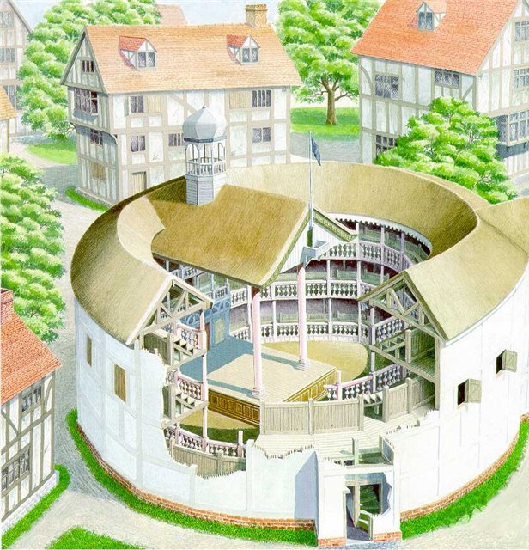](http://images.yandex.ru/yandsearch?text=%D1%82%D0%B5%D0%B0%D1%82%D1%80%20%D1%88%D0%B5%D0%BA%D1%81%D0%BF%D0%B8%D1%80%20%D0%B2%20%D0%BA%D0%B0%D1%80%D1%82%D0%B8%D0%BD%D0%BA%D0%B0%D1%85&fp=0&pos=12&uinfo=ww-1263-wh-878-fw-1038-fh-598-pd-1&rpt=simage&img_url=http%3A%2F%2Fs41.radikal.ru%2Fi093%2F0810%2Ff6%2Fc445e63e93ed.jpg)In the theater of former times had to take their word as the main role in the formulation was assigned the story and the action as it happened behind the scenes. Shakespeare did not wish to assume the right to judge character solely on the basis of words. He develops the action directly on the stage, whereby the characters acquire greater brilliance, depth and mobility. "The tragic person certainly should excite themselves to participate," - wrote Belinskiy . And Shakespeare, this requirement was achieved in full. Joined the great playwright in his works, many of those traditions that already existed. But he set a new law of the genre. He did not take the genre as something complete and unchangeable, did not recognize the binding patterns and rules. His genre - is a way of seeing, visual angle, reflecting the central theme: the tragedy - a man in a comedy - the nature, the chronicle - history. It was he who introduced a new wave of drama - the movement of historical time.

Already at the beginning of his artistic career Shakespeare acquired deserved fame as a talented playwright. It is difficult to overestimate his contribution to the development of theatrical traditions, he opened a new era of dramatic literature , and his works were subsequently escalated his life and retained interest and relevance to the present day.

Love,

Dasha

Источники:

1. <http://www.liveinternet.ru/users/3173294/post218106714/>
2. <http://www.stihi.ru/2011/04/23/528>
3. <http://www.pergam-club.ru/book/2405>
4. <http://www.proshkolu.ru/user/sunflower53/file/3085922/>
5. <http://propext.ru/video/smeh/784-vostok-zapad-renessans-i-islam.html>