**XI Международная дистанционная олимпиада «Эрудит»**

**Английский язык, 7 класс, II тур**

**THE TIME MACHINE JOURNEY**

England

5th February

Dear friend,

[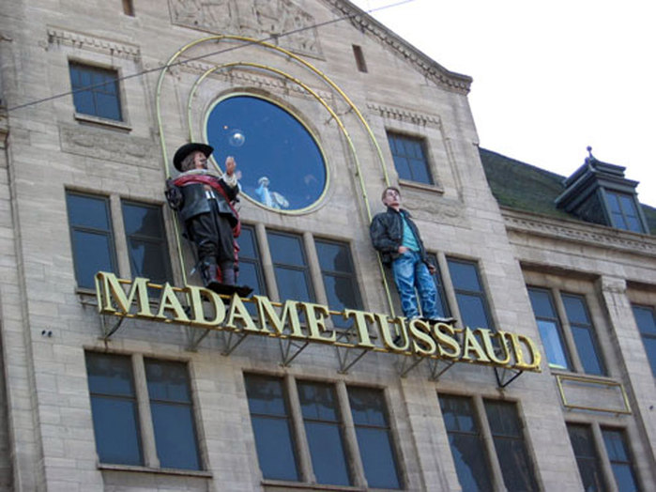](http://images.yandex.ru/yandsearch?text=%D0%BC%D1%83%D0%B7%D0%B5%D0%B9%20%D0%BC%D0%B0%D0%B4%D0%B0%D0%BC%20%D1%82%D1%8E%D1%81%D1%81%D0%BE%D0%B4%20%D0%B2%20%D0%BA%D0%B0%D1%80%D1%82%D0%B8%D0%BD%D0%BA%D0%B0%D1%85&fp=0&pos=0&uinfo=ww-1263-wh-878-fw-1038-fh-598-pd-1&rpt=simage&img_url=http%3A%2F%2Fi1.i.ua%2Fprikol%2Fpic%2F9%2F5%2F438659.jpg) As I’ve remembered, I promised you to tell about my happiness to find a time machine and travel to different and famous places in England. I’m ready to tell you about that amassing thing.    
With helping of the time machine I moved at the time when magnificent museum Madame Toussaint was just founded. There were so many beautiful and not dissimilar shapes. In this museum fit celebrities of those times. It is an unforgettable experience!

[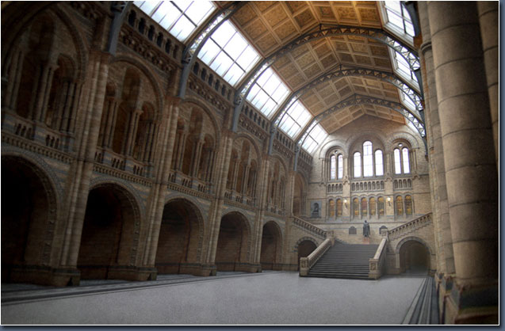](http://images.yandex.ru/yandsearch?text=%D0%B8%D1%81%D1%82%D0%BE%D1%80%D0%B8%D1%87%D0%B5%D1%81%D0%BA%D0%B8%D0%B9%20%D0%BC%D1%83%D0%B7%D0%B5%D0%B9%20%D0%B2%20%D0%BB%D0%BE%D0%BD%D0%B4%D0%BE%D0%BD%D0%B5%20%D0%B2%20%D0%BA%D0%B0%D1%80%D1%82%D0%B8%D0%BD%D0%BA%D0%B0%D1%85&fp=0&pos=4&uinfo=ww-1263-wh-878-fw-1038-fh-598-pd-1&rpt=simage&img_url=http%3A%2F%2Fwww.3dm3.com%2Ftutorials%2Fmattepainting%2Flondon-museum%2F20_step2_rightpillarsmore2.jpg)Next trip was to the National Gallery. What sort of magnificent paintings and costumes of kings. This is a wonderful story that I have told the costumes, in their mind, they speak for themselves, I knew every fold, because this kind of mesmerizing paintings and costume!   
 The next trip was not only cultural but also scientific. We visited the Museum of Science. There have been devices that I've never seen. Also in this museum were pioneers UK of their history, biography, and much more.

Time Machine moved me to the History English Museum. This museum tells about the beautiful old buildings and the most interesting excursions and discoveries. Also about animal and plant life in that time.

[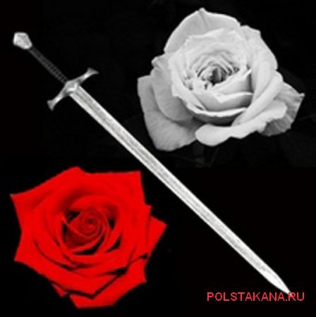](http://images.yandex.ru/yandsearch?text=%D0%B2%D0%BE%D0%B9%D0%BD%D0%B0%20%D0%B1%D0%B5%D0%BB%D0%BE%D0%B9%20%D0%B8%20%D0%BA%D1%80%D0%B0%D1%81%D0%BD%D0%BE%D0%B9%20%D1%80%D0%BE%D0%B7%D1%8B%20%D0%B2%20%D0%BA%D0%B0%D1%80%D1%82%D0%B8%D0%BD%D0%BA%D0%B0%D1%85&fp=0&pos=0&uinfo=ww-1263-wh-878-fw-1038-fh-598-pd-1&rpt=simage&img_url=http%3A%2F%2Fimg1.liveinternet.ru%2Fimages%2Fattach%2Fc%2F1%2F56%2F36%2F56036786_image151.jpg)The next trip was to the British Museum. The museum has many monuments, drawings, medals. Also gavyury, encyclopedias and many stories.

[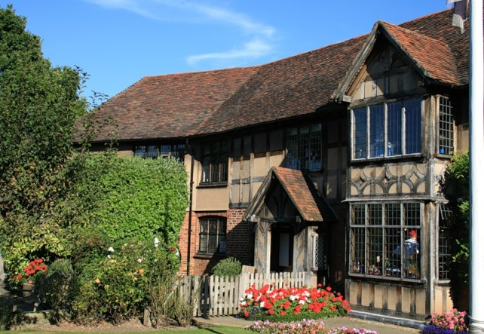](http://images.yandex.ru/yandsearch?text=%D0%BC%D1%83%D0%B7%D0%B5%D0%B9%20%D1%88%D0%B5%D0%BA%D1%81%D0%BF%D0%B8%D1%80%20%D0%B2%20%D0%BA%D0%B0%D1%80%D1%82%D0%B8%D0%BD%D0%BA%D0%B0%D1%85&fp=0&pos=1&uinfo=ww-1263-wh-878-fw-1038-fh-598-pd-1&rpt=simage&img_url=http%3A%2F%2Fimg-fotki.yandex.ru%2Fget%2F6001%2Fgaltchonok.19%2F0_65437_c4d7a106_XL)Next we went to the museum, which was all about the story of White and Red Roses. Told about the bloody battles that took place there during the quarrel of York and Lancaster, and also to try on these two states.

And the last but not least was the Museum of William Shakespeare. I’ve got some information about music, literature, sonnets. It was great to be in such a wonderful place, where a well-known dramatist had been working.

It is a very wonderful travelling.

Love,

Paulina

Источники:

1. <http://www.liveinternet.ru/users/rosa_dossen/post122133763/>
2. <http://clubs.ya.ru/4611686018427435798/replies.xml?item_no=5962>
3. <http://itschool.bg/tutorials/article/1997/>
4. <http://www.liveinternet.ru/users/red_rous/post161533759/>