**Animal Camouflage**

**Level 6**

**ГБОУ СОШ № 2084, г. Москва**

**Сычук Дарья, 6 класс**

[**dasha.01@bk.ru**](mailto:dasha.01@bk.ru)

**Парасоцкая Ольга Николаевна,**

**учитель английского языка ГБОУ СОШ № 426 г. Москва**

[**salchanka@yandex.ru**](mailto:salchanka@yandex.ru)

**тел. 8-963-687-64-07**

**Brown bears.**

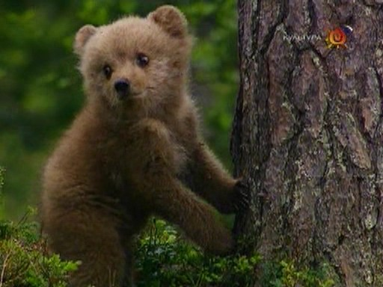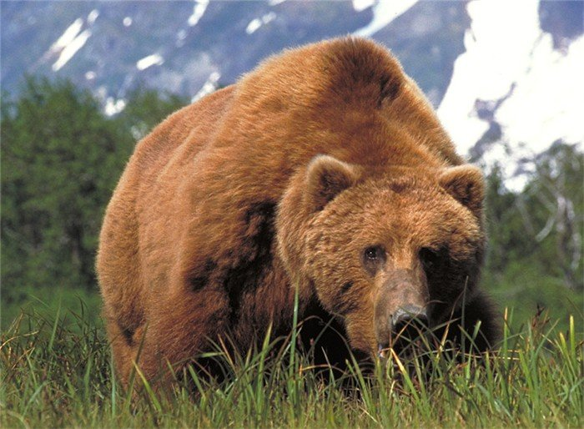**Brown bears have included in the Red List. In Russia the animals can be met in the Far East and Chukotka, in Siberia and on Kamchatka. The dense impassable woods attract bears where they can take cover or lie down in a den. The brown bear is considered one of the largest predators of a planet. The weight of an old animal reaches 600 kg, and body length about 2 meters. They’ve got a strong head with deeply put small eyes. In bondage predators live longer and usually 30 years in the natural conditions. 4 bear cubs are born by every female during the life. Their weight only 500-600 g, the whole month bear cubs blind and helpless, and by the 4th month they start leaving their mothers’ den and lead their own life.**

**Questions**

**1. The brown bear is considered one of the largest …..**

**a** animal

**b** predator

**c** fish

**2. The weight of an old animal reaches ….**

**a** 600 kg

**b** 300 kg

**c** 950 kg

3. **Every female bear has only … during the life.**

**a** 1 bear cub

**b** 5 bear cubs

**c** 4 bear cubs

4. **In Russia the animals can be met in the … .**

**a** south

**b** east

**c** west

**Task 2.**

**Nowadays it’s very popular to present bears as pets. Do you think it’s a good idea? Why? Why not? (Write 80-100 words).**