**XI Международная дистанционная олимпиада «Эрудит»**

**Английский язык, 7 класс, II тур**

**THE TIME MACHINE JOURNEY**

England

10th February

Dear friend,

I continue to travel the Victorian era. Ah, those were the days! The days were of good old England. It flourished and grew.

[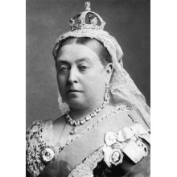](http://images.yandex.ru/yandsearch?text=%D0%92%D0%B8%D0%BA%D1%82%D0%BE%D1%80%D0%B8%D0%B8%20(%201837-1901%20)%20%D0%B2%20%D0%BA%D0%B0%D1%80%D1%82%D0%B8%D0%BD%D0%BA%D0%B0%D1%85&fp=0&pos=0&uinfo=ww-1263-wh-878-fw-1038-fh-598-pd-1&rpt=simage&img_url=http%3A%2F%2Fchervonec78.ru%2Fimage%2Fcache%2Fdata%2Fgerby%2Feurope%2FG.B%2F10%29Victoria%281837-1901%29-220x220.jpg)[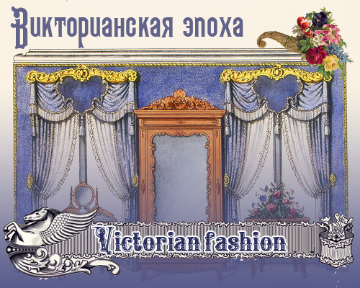](http://images.yandex.ru/yandsearch?text=%D1%8D%D0%BF%D0%BE%D1%85%D0%B0%20%D0%92%D0%B8%D0%BA%D1%82%D0%BE%D1%80%D0%B8%D0%B8%20%28%201837-1901%20%29%20%D0%B2%20%D0%BA%D0%B0%D1%80%D1%82%D0%B8%D0%BD%D0%BA%D0%B0%D1%85&img_url=http%3A%2F%2Fnotebene.ucoz.ru%2FCeleBRIdiZZ%2Fvictorian_style.jpg&pos=6&rpt=simage&lr=213&noreask=1&source=wiz)The Victorian era is generally agreed to stretch through the reign of Queen Victoria (1837-1901). It was a tremendously exciting period when many artistic styles, literary schools, as well as, social, political and religious movements flourished. It was a time of prosperity, broad imperial expansion, and great political reform. It was also a time, which today we associate with "prudishness" and "repression". Without a doubt, it was an extraordinarily complex age that has sometimes been called the Second English Renaissance. It is, however, also the beginning of Modern Times. The social classes of England were newly reforming, and fomenting. There was a churning upheaval of the old hierarchical order, and the middle classes were steadily growing. Added to that, the upper classes' composition was changing from simply hereditary aristocracy to a combination of nobility and an emerging wealthy commercial class. The definition of what made someone a gentleman or a lady was, therefore, changing at what some thought was an alarming rate. By the end of the century, it was silently agreed that a gentleman was someone who had a liberal public (private) school education (preferably at Eton, Rugby, or Harrow), no matter what his antecedents might be. There continued to be a large and generally disgruntled working class, wanting and slowly getting reform and change.

Conditions of the working class were still bad, though, through the century, three reform bills gradually gave the vote to most males over the age of twenty-one. Contrasting to that was the horrible reality of child labor which persisted throughout the period. When a bill was passed stipulating that children under nine could not work in the textile industry, this in no way applied to other industries, nor did it in any way curb rampant teenaged prostitution. The Victorian Era was also a time of tremendous scientific progress and ideas. Darwin took his Voyage of the Beagle, and posited the Theory of Evolution. The Great Exhibition of 1851 took place in London, lauding the technical and industrial advances of the age, and strides in medicine and the physical sciences continued throughout the century. The radical thought associated with modern psychiatry began with men like Sigmund Feud toward the end of the era, and radical economic theory, developed by Karl Marx and his associates, began a second age of revolution in mid-century. The ideas of Marxism, socialism, feminism churned and bubbled along with all else that happened. The dress of the early Victorian era was similar to the Georgian age. Women wore corsets, balloonist sleeves and crinolines in the middle 1840's. The crinoline thrived, and expanded during the 50's and 60's, and into the 70's, until, at last, [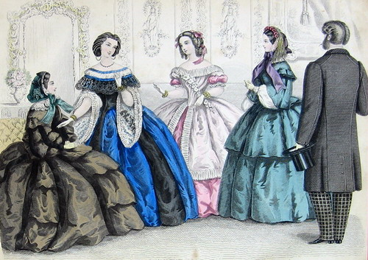](http://fotki.yandex.ru/users/notebenedesign/view/449481/)it gave way to the bustle. The bustle held its own until the 1890's, and became much smaller, going out altogether by the dawning of the twentieth entury. For men, following Beau Brummell's example, stove-pipe pants were the fashion at the beginning of the century. Their ties, known then as cravats, and the various ways they might be tied could change, the styles of shirts, jackets, and hats also, but trousers have remained. Throughout the century, it was stylish for men to wear facial hair of all sizes and descriptions. The clean shaven look of the Regency was out, and mustaches, mutton-chop sideburns, Piccadilly Weepers, full beards, and Van Dykes (worn by Napoleon III) were the order of the day. The "prudishness" and "repressiveness" that [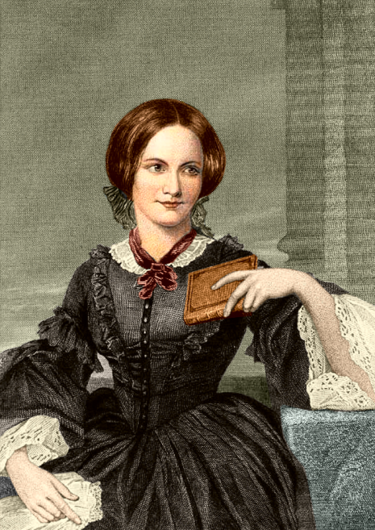](http://images.yandex.ru/yandsearch?source=wiz&fp=0&text=%D1%88%D0%B0%D1%80%D0%BB%D0%BE%D1%82%D1%82%D0%B0%20%D0%B1%D1%80%D0%BE%D0%BD%D1%82%D0%B5&noreask=1&pos=3&lr=213&rpt=simage&uinfo=ww-1263-wh-878-fw-1038-fh-598-pd-1&img_url=http%3A%2F%2Fwww.factroom.ru%2Fwp-content%2Fuploads%2F2011%2F06%2F132.jpg)we associate with this era is, I believe, a somewhat erroneous association. Though, people referred to arms and legs as limbs and extremities, and many other things that make us titter, it is, in my opinion, because they had a degree of modesty and a sense of propriety that we hardly understand today. The latest biographies of Queen Victoria describe her and her husband, Albert, of enjoying erotic art, and certainly we know enough about the Queen from [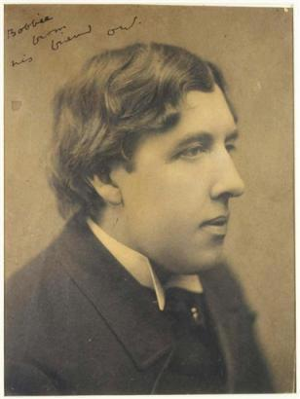](http://images.yandex.ru/yandsearch?text=%D0%BE%D1%81%D0%BA%D0%B0%D1%80%20%D0%B2%D0%B0%D0%B9%D0%BB&fp=0&pos=17&uinfo=ww-1263-wh-878-fw-1038-fh-598-pd-1&rpt=simage&img_url=http%3A%2F%2Fimg1.liveinternet.ru%2Fimages%2Fattach%2Fc%2F1%2F57%2F596%2F57596739_uayld9.JPG)the segment on her issue, to know that she did not in any way shy away from the marriage bed. The name sake of this period was hardly a prude, but having said that, it is necessary to understand that the strictures and laws for 19th Century Society were so much more narrow and defined that they are today, that we must see this era as very codified and strict. Naturally, to an era that takes more liberties, this would seem harsh and unnatural. Culturally, the novel continued to thrive through this time. Its importance to the era could easily be compared to the importance of the plays of Shakespeare for the Elizabethans. Some of the great novelists of the time were: Sir Walter Scott, Emily, Anne, and Charlotte Bronte, Anthony Trollope, George Eliot, Oscar Wilde, and, of course, Charles Dickens. That is not to say that poetry did not thrive - it did with the works of the Brownings, Alfred, Lord Tennyson, the verse of Lewis Carroll and Rudyard Kipling. An art movement indicative of this period was the Pre-Raphaelites, which included William Holman Hunt, Dante Gabriel Rossetti, Christina Rossetti, and John Everett Millais. Also during this period were the Impressionists, the Realists, and the Fauves, though the Pre-Raphaelites were distinctive for being a completely English movement. As stated in the beginning, the Victorian Age was an extremely diverse and complex period. It was, indeed, the precursor of the modern era. If one wishes to [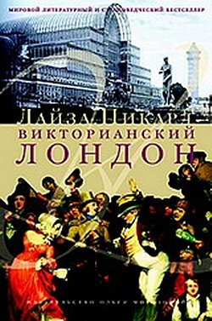](http://images.yandex.ru/yandsearch?source=wiz&fp=4&uinfo=ww-1263-wh-878-fw-1038-fh-598-pd-1&p=4&text=%D1%8D%D0%BF%D0%BE%D1%85%D0%B0%20%D0%92%D0%B8%D0%BA%D1%82%D0%BE%D1%80%D0%B8%D0%B8%20(%201837-1901%20)%20%D0%B2%20%D0%BA%D0%B0%D1%80%D1%82%D0%B8%D0%BD%D0%BA%D0%B0%D1%85&noreask=1&pos=146&rpt=simage&lr=213&img_url=http%3A%2F%2Fimg2.labirint.ru%2Fbooks%2F286302%2Fsmall.jpg)understand the world today in terms of society, culture, science, and ideas, it is imperative to study this era. Ilana Miller is from Santa Monica, California and has written short stories and journals since she was in the third grade. She has traveled all over the world, and has lived in the Middle East before settling back in Brentwood. At this point, she's not sure which one is more embattled. She had spent years working in the clothing business, with lawyers and other kinds of bosses before realizing she couldn't stand being bossed around. She, therefore, decided to teach Junior High School, so that she could start doing the bossing. When she got the hang of it (and stopped being bossed around by the kids) she realized that she was teaching the wrong things (English and Drama). She went back to get a Masters Degree in History at Pepperdine University in Malibu, which was her first love. She remained there as an Adjunct Professor of History for eight years. She also found it a lot easier to boss around college students than the junior high variety. Published in historical journals, Ilana is now trying her hand at an historical novel. She originally tried historical romances, but realized that she didn't want to put the romance before the history.

Love,

Yaroslava

Источники:

1. <http://chervonec78.ru/index.php?route=product/category&path=59_75_388>
2. <http://notebenedesign.ya.ru/replies.xml?item_no=34>
3. <http://bookmix.ru/news/index.phtml?id=5203>
4. <http://www.diary.ru/~beautynikole/?tag=5869>

<http://novostiliteratury.ru/2011/04/chto-chitat/lajza-pikard-viktorianskij-london-izdatelstvo-olgi-morozovoj-2011/>