**XI Международная дистанционная олимпиада «Эрудит»**

**Английский язык, 7 класс, II тур**

**THE TIME MACHINE JOURNEY**

[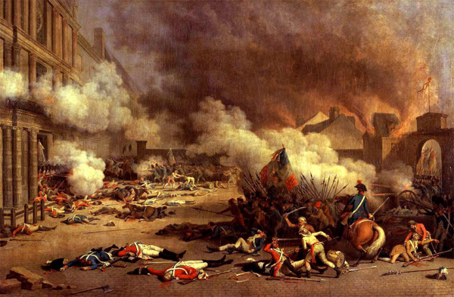](http://images.yandex.ru/yandsearch?text=%D0%B0%D0%BD%D0%B3%D0%BB%D0%B8%D0%B9%D1%81%D0%BA%D0%B0%D1%8F%20%D1%80%D0%B5%D0%B2%D0%BE%D0%BB%D1%8E%D1%86%D0%B8%D1%8F%20%D0%B2%20%D0%BA%D0%B0%D1%80%D1%82%D0%B8%D0%BD%D0%BA%D0%B0%D1%85&fp=0&pos=12&uinfo=ww-1263-wh-878-fw-1038-fh-598-pd-1&rpt=simage&img_url=http%3A%2F%2Fwww.powellhistory.com%2Fart%2FPainting%2FFrench_Revolution-1792-8-10_Paris_Commune.jpg)England,

12th February

Dear friend,

I’m writing you the whole story, which recently has happened with me.

[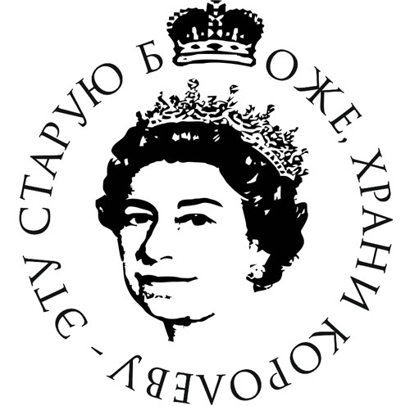](http://images.yandex.ru/yandsearch?text=%D0%B1%D0%BE%D0%B6%D0%B5%20%D0%BA%D0%BE%D1%80%D0%BE%D0%BB%D0%B5%D0%B2%D1%83%20%D1%85%D1%80%D0%B0%D0%BD%D0%B8%20%D0%B2%20%D0%BA%D0%B0%D1%80%D1%82%D0%B8%D0%BD%D0%BA%D0%B0%D1%85&fp=0&pos=6&uinfo=ww-1263-wh-878-fw-1038-fh-598-pd-1&rpt=simage&img_url=http%3A%2F%2Ff2.foto.rambler.ru%2Fpreview%2Fc%2F190x160%2F4863bceb-b90d-c78d-2802-977c911eed4d%2FGod_Save_The_Queen.jpg)One day I decided to try your time machine and went to the 17th century. I’m at the time of the English revolution. This is a civil war which began in 1640 and ended in 1660. Revolution lasted 10 years, but I have come to be there a week before the end. The people whom I was meeting told me everything that had happened. And I met with four people. It was the family of a father, a mother and 2 daughters. Father's name was John, mother is Polly, the elder daughter is Maria, the younger daughter is Molly. It turned out that after the revolution, nothing had changed, only in prayer replaced "God save the king" to "God save the protector".

Love,

Lena

Источники:

1. <http://lvphilosophy.ucoz.ru/load/urok_12_istorija_1_kurs/1-1-0-29>
2. <http://www.zvuki.ru/P/P/30257/>