X Международной дистанционной олимпиаде по английскому языку
для учащихся 6 класса.
Can you imagine a world without money, where you are free to do anything you want. How would you spend your time? Write 120 – 150 words on this topic. Be creative!
Nowadays money plays an important role in our life. People become think that if you have money you can buy everything.
Let’s imagine the world begins to live without money. I have three days to see something new. Firstly, I go to the deepest lake Baikal! I'm attracted by the beautiful surroundings, clean water and fresh air. Secondly, I'm sitting in the plane and flying to see the pyramids of Egypt. It’s very hot there, but the creation of the ancient people put me in a shock. Thirdly, I'm going to Spain to Rodeo and dance splendidly beautiful dances. Traveling around the world I found out that Moscow region is the best. The familiar fields planted with crops, forests full of white mushrooms. Sweet home and my family were waiting for me all these days! I’m very lucky to have such friendly relatives, because it’s my wealth.
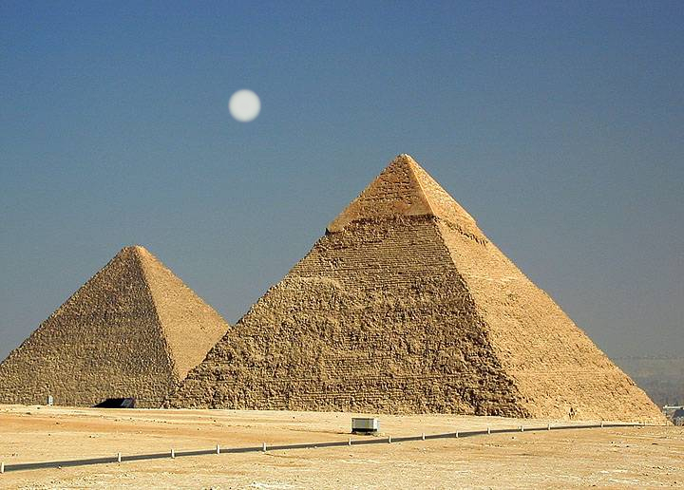

Источники

http://resources.woodlands-junior.kent.sch.uk/customs/questions/worksheets/money.htm
http://ru.wikipedia.org/wiki/%CF%FF%F2%FC%E4%E5%F1%FF%F2_%EF%E5%ED%F1%EE%E2_(%C2%E5%EB%E8%EA%EE%E1%F0%E8%F2%E0%ED%E8%FF)
http://www.valueincoins.com/silver-dollars/sacagawea-dollar/
http://lengish.com/tests/vocabulary+money+and+banking-155.html
http://www.homeenglish.ru/Proverbl.htm
http://ru.scribd.com/doc/13473909/The-Natural-Mind-Waking-Up-Volume-1
http://www.sky-net-eye.com/rus/english/proverbs/M_p/money-spent-on-the-brain-is-never-spent-in-vain
http://www.answers.com/topic/when-poverty-comes-in-at-the-door-love-flies-out-of-the-window
http://www.searchquotes.com/quotation/Money_spent_on_the_mind_is_never_spent_in_vain./19290/
http://www.themoneyquest.com/2008/09/10-reasons-why-you-need-savings-plan.html
http://www.hochstadt.com/cents-and-dollars
http://www.answers.com/topic/it-is-better-to-be-born-lucky-than-rich
http://www.englishclub.com/ref/esl/Sayings/M/Money_is_a_good_servant_but_a_bad_master_897.htm
http://www.rfcmd.com/index.php?option=com_content&view=article&id=1321:early-to-bed-and-early-to-rise-makes-a-man-healthy-wealthy-and-wise&catid=95:2008-10-24-11-41-37&Itemid=89
http://www.answers.com/topic/money-has-no-smell
http://www.searchquotes.com/search/When_Money_Speaks_The_Truth_Keeps_Silent/
http://webzametki.com/890
http://www.alftur24.ru/?news_id=248
http://comments.ua/world/226972-turistam-zakrili-dostup.html

