Services  -booking tickets for any kinds of transport;  -the organization of meetings and seeing offs at the airports and stations, including VIP-service;  -placing in hotels from budget to Deluxe categories with necessary infrastructure and technical equipment;  -transfer organization: for groups, individuals, VIP-guests;  -preparation of excursion, entertaining and cultural programs, organization of visit of the profile enterprises;  -catering services of tourists, development and menu order;  -interpreter services; | Our contacts  Phone number: (495) 786-3333  Web-site: free@way-tours.com  Fax: (495) 786-9933, (495) 786-9934  Address: 13, Karl Marks Street  Cheboksary 428023  Russia  Company works every day from Monday to Friday since 10:00 till 19:00 | Travel Company FreeWay  We will help you to have a good rest
Collaboration  Sweden  Dubai  Portugal  Greese  Israel  and many others  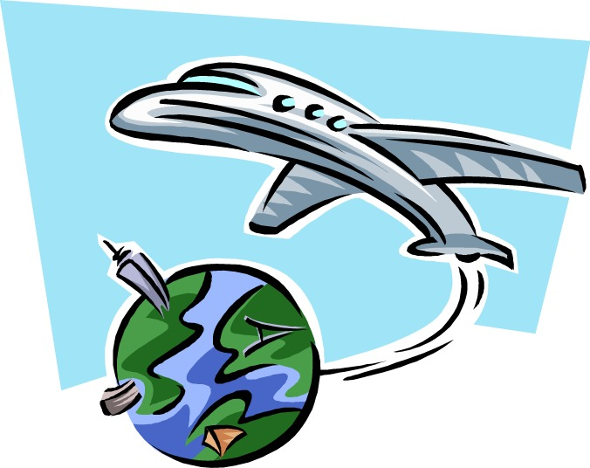 | The price of tickets are from 15000 rub | Hot Tours  Egypt – a large number of entertainments and impressions.  Thailand – the earth with ancient unique traditions and country of aromas of exotic flowers and fruit, soar in air.

