X Международной дистанционной олимпиаде по английскому языку
для учащихся 7 класса

MACY’S THANKSGIVING DAY PARADE

Hello, dear viewers! Kate Borisova and my cameraman David Derrick officially kick off the holiday season with the live broadcast of the annual MACY'S THANKSGIVING DAY PARADE from New York City. This holiday has a great history. Since 1924 Americans have held their most beloved procession marches in the holidays with dazzling doses of spectacle, enchantment and tradition.
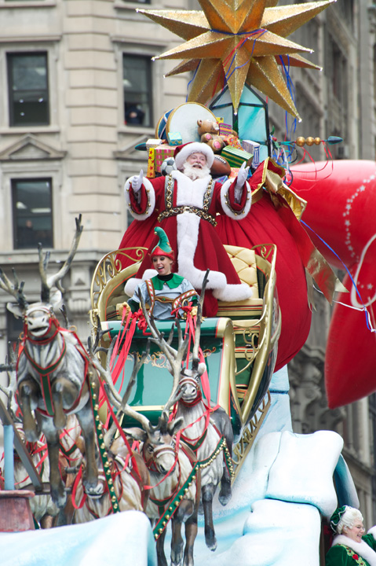
Where else can you find 50-foot balloons, floats, cheerleaders, dancers, performance groups, clowns, marching bands and, of course, celebrity performers? Thousands of participants take to the streets for the celebration - and it all caps off with the very first seasonal appearance of the jolly man in the red suit. Enjoyed for generations, it's a national pastime to be thankful for.
The weather is uncharacteristically warm for a Thanksgiving in New York City, so we don’t need our jackets — never mind warm hats, scarves, gloves or even the traditional hot cocoa. It’s very unusual for this time of the year because it’s Thursday today, November 22, 2012.

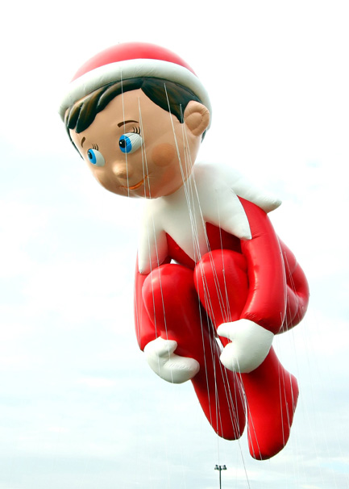
We’ve find a best viewing spot on 40th Street & 7th Avenue where we could see pretty much everything, including up-close visits by the famous Macy's clowns who stepped right up to say hello, throw some confetti, and get the crowd cheering!
Little by little, the children inch their way under the barricades when, suddenly, the entire area is filled with little munchkins sitting cross-legged just waiting to see Santa Claus!
The Elf on the Shelf is taking his first flight in the Macy’s Parade this Thanksgiving. Sent by Santa Claus to watch over good little boys and girls around the world, the Elf on the Shelf is taking his reporting duties to new heights, measuring 46-feet tall, 28-feet wide and 64-feet long in the Parade line-up.
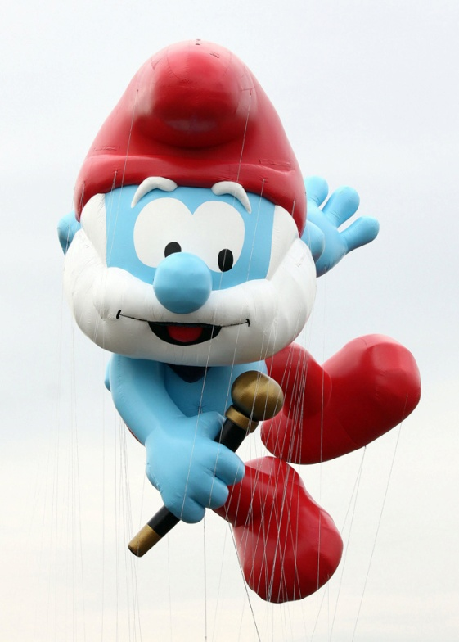
Papa Smurf is ready for his big debut on Thanksgiving, jumping for joy and dancing his way down the route. Sporting a festive bow tie and cane and clicking his heels to the holiday fun, Papa Smurf is sure to delight millions of fans who are eagerly anticipating his return in The Smurfs 2 set for the big screen next summer. Measuring 51-feet tall, 36-feet wide and 46-feet long, Papa Smurf is helping usher in a Happy Smurfgiving to one and all!
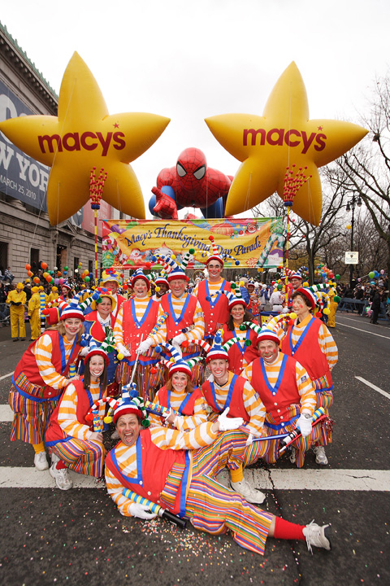
For the kids there is nothing but sheer delight as they see their favorite celebrities or bigger-than-life characters, such as Ronald McDonald, Snoop dog, Mickey Mouse, SpongeBob, Piggy Piggy and Spiderman, waving from high above.
Hundred of clowns, singers, magnificent bands, the film stars of American movie are taking part in parade.
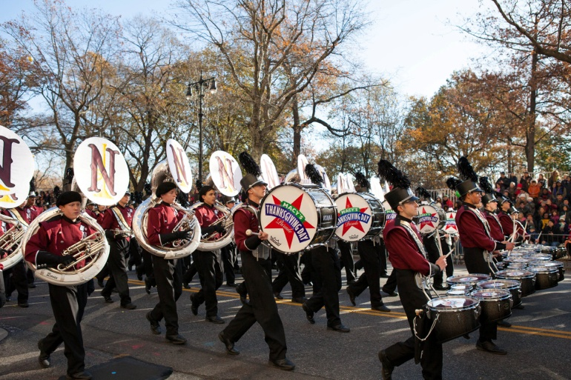
Now you can see Niceville High School Niceville, FL which consists of 295 Members, the Band Director is Daniel Wooten. They are playing a magnificent “Jazzy Jingle Bells”.
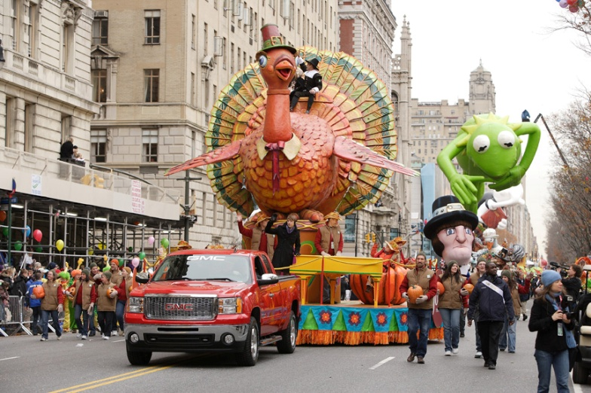
Even the police enjoyed the children's excitement. They’re gently tip-toeing through the children and even pat a few on their heads as they passed. It’s a special view for grownups to see their children happy.
The floats, giant balloons, and the festive atmosphere all contribute to the spark of magic reflected in their watchful eyes.
Happy Thanksgiving!

Использованные источники:
http://www.magicbulletmedia.com/MNR/MacysParade/Balloons/jpg/LOW/b1.JPG
http://www.slideshare.net/swamifox/timesaver-new-york
http://www.magicbulletmedia.com/MNR/MacysParade/Floats/
http://www.aviewoncities.com/nyc/unitednations.htm
http://www.aviewoncities.com/nyc/empirestate.htm
http://www.aviewoncities.com/nyc/statueofliberty.htm
http://www.aviewoncities.com/nyc/brooklynbridge.htm
http://www.aviewoncities.com/nyc/guggenheim.htm
http://www.aviewoncities.com/nyc/wallstreet.htm
http://www.aviewoncities.com/nyc/centralpark.htm
http://www.magicbulletmedia.com/MNR/MacysParade/pdfs/86th%20Annual%20Macy's%20Thanksgiving%20Day%20Parade-%20Overview%20release.pdf

