XI Международная дистанционная олимпиада «Эрудит»
Английский язык, 6 класс, II тур

In my free 24 hours, I will first get enough sleep. Then I’ll meet with my girlfriend and go for a walk and to the theatre.
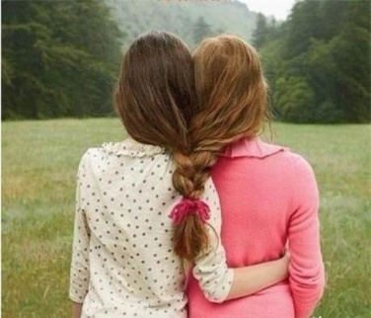

Evening I'll spend with my family. We’ll see a new film, go shopping and visit our friends. In the late evening we’ll gather together in the house and remember all the good and fun that’ll have happened and will make plans for the next day. I’ll fell comfort only with my family and every minute of my life I’ll spend with it because it’s the apple of my eye.

Источники
- http://images.yandex.ru/yandsearch?p=1&text=%D0%B4%D0%B5%D1%82%D0%B8%20%D0%B2%20%D0%BA%D0%B0%D1%80%D1%82%D0%B8%D0%BD%D0%BA%D0%B0%D1%85&fp=1&pos=37&uinfo=ww-1263-wh-878-fw-1038-fh-598-pd-1&rpt=simage&img_url=http%3A%2F%2Fwww.best-animation.ru%2Flanim%2Fdeti%2F5.gif
- http://images.yandex.ru/yandsearch?text=%D1%81%D0%B5%D0%BC%D1%8C%D1%8F%20%D0%B2%20%D0%BA%D0%B0%D1%80%D1%82%D0%B8%D0%BD%D0%BA%D0%B0%D1%85&uinfo=ww-1263-wh-878-fw-1038-fh-598-pd-1

