X Международной дистанционной олимпиаде по английскому языку для учащихся 5 класса

HOLIDAY PROGRAM
Guided tour of London and Britain
Dear children we can offer you an excursion tour of London and Britain. It is a country with a mild climate, although it’s little rainy. Here, in the Foggy Albion, tourists will a variety of tours offered. We will show you many tourist attractions.
Excursions about UK are quite various and it means that no one will misses during the trip. There are a lot of historical buildings, monuments, castles and other things in London. Our guides will tell you about the sights, the history of the city, answer all your questions.
Day 1

The Buckingham Palace.

Queen Elizabeth II has let tourists and ordinary people visit Buckingham Palace but only at night. So, we offer you a Night tour to it. You’ll see almost all residential premises, except the Queen’s bedrooms and some bathrooms.

Day 2

A cruise down the river Thames.
It starts in the center of London from Embankment pier. During the way you can enjoy magnificent views of London at night in, and will be able to enjoy Parliament House, and Big Ben, London Eye, St Paul's Cathedral and the City, the Tate Modern, Shakespeare’s Theatre "Globus", Tower Bridge, the Tower of London, the business district of Canary Waugh and Greenwich.
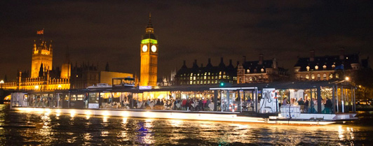
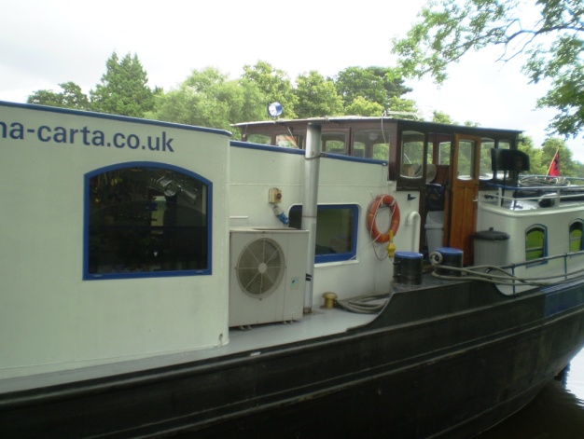

Day 3
Stratford-upon-Avon

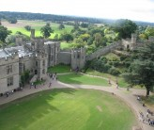
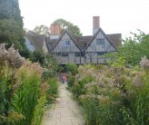
Stratford-upon-Avon is the birthplace of William Shakespeare, one of the most famous writers not only in England, but in the world. The charm of the River Avon, Tudor houses and violent street lives with different views are impressed any visitor.
We'll begin our tour with a walk along the River Avon, with its monuments, cafes, boats and a bridge that has survived from the 15th century. Further we’ll go to the Bancroft Gardens and see the Royal Shakespeare Theatre.
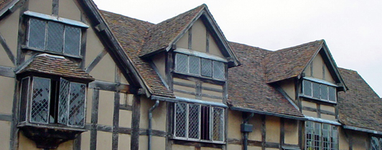

Day 4

A bus trip to the city Canterbury

Driving through Kent with its famous gardens, fields and picturesque villages, you find yourself in the medieval Canterbury (Canterbury) which is an old town, surrounded by medieval city wall (City Wall). You will be able to visit the main Gothic Cathedral in England (Canterbury Cathedral). During the tour you will also see the residence of the head of the Anglican Church, Archbishop of Canterbury, the central tower Harry Bell (Bell Harry) which was built in the XII century.
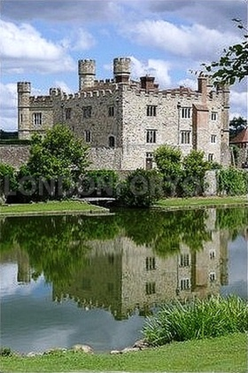
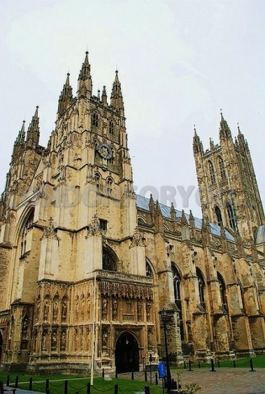
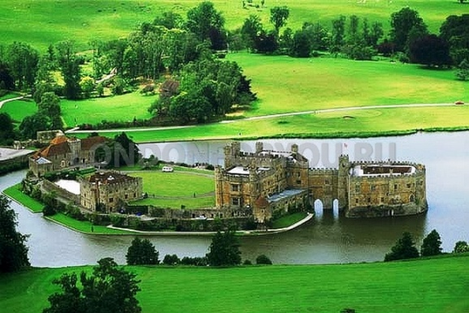

Day 5

Winchester

We start the day, going across the hills region Hampshire to Winchester. It’s a delightful city, which is full of beauty, antiquity and tranquility! You will see a mighty Cathedral of Winchester of the 11th century. Winchester was the main bulwarks against the Vikings. King Alfred the Great, who was buried at Winchester in 899, immortalized in the magnificent statue in the center of the city.
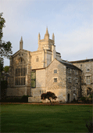
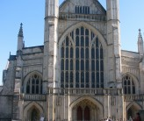
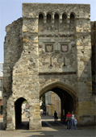
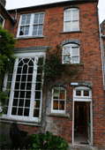

Day 6

Visit the British museum.

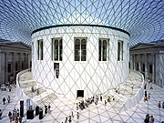
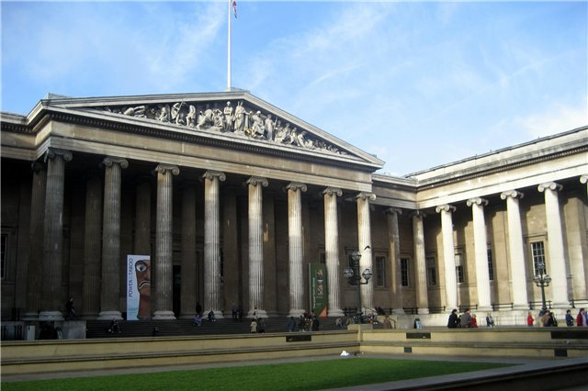
The British Museum is one of the best known and most famous museums in the world. Its area is more than 6 hectares, annual attendance is 5.2 million. You’ll see such masterpieces as The Rosetta Stone thanks to it Egyptian hieroglyphics have been deciphered, sculptures from the Acropolis, the central relief of the Parthenon, prints, coins, medals, different epochs and well-known British Library. Ancient Egyptian Museum collection includes more than 66,000 artifacts.

Day 7

The whole day excursion to Windsor by train

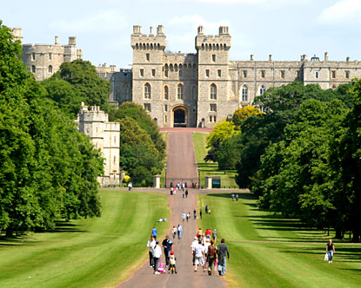
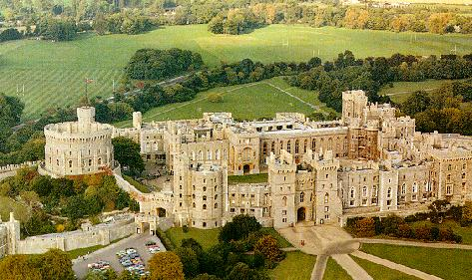
Windsor Castle is a medieval castle which is situated on the bank of the Thames for 900 years and now it’s the main summer residence of the British monarch. A wooden castle was begun to build in the time of King William the Conqueror in 1078. The brick castle with a round tower was build during the time of Henry II. The castle complex was reconstructed several times according the tastes of the ruling kings. The castle acquired its present appearance in 1820.
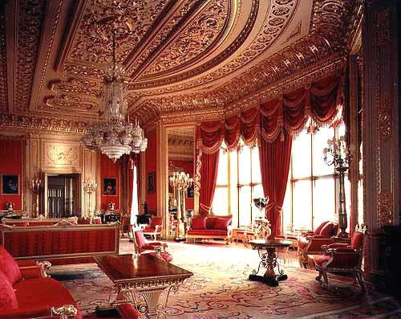

Источники:
http://gidox.ru/tour/individualnaya_ekskursiya_v_bukingemskiy_dvorets
http://www.otzyv.ru/read.php?id=146656
http://tourism-london.ru/services/88-kruiz-po-temze-s-uzhinom.html
http://london-england-excursions.co.uk/tours/stratford-upon-avon-and-warrick-castle/
http://gidox.ru/tour/ekskursiya_v_kenterberi_i_zamok_lids
http://www.londonforyou.ru/img/exc/cant/Canterbury-Cathedral.jpg
http://www.londonforyou.ru/img/exc/cant/leeds-castle-from-the-air.jpg
http://gidox.ru/tour/vinchester__stounhendj__bas
http://gidox.ru/tour/British_Museum___britanskiy_muzey
http://www.edemvlondon.ru/excursion/british-of-museum.html
http://www.gteurope.ru/upload/w/48e6420ab7cc8windsor_castle.jpg
http://www.gteurope.ru/upload/w/48e6420aa53e7windsorcastle.jpg
http://www.gteurope.ru/upload/s/48e6420acb54astate_apartments_windsor_castle.jpg

