XI Международная дистанционная олимпиада «Эрудит»
Английский язык, 6 класс, I тур
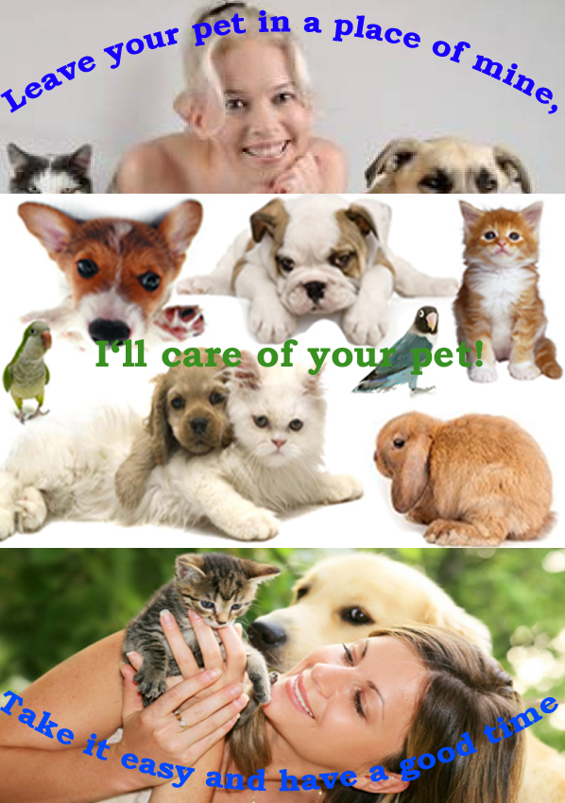
Pocket money is an acute problem for every teenager - I’m not an exception. I’m fond of animals but, unfortunately, I don’t have a pet because I don’t have enough time to take care of anyone. That’s why, I’d organize a summer hotel for pet owners who go on vacation and have nobody to leave their pets with. I’m free from school in summer so, I’d love to take someone’s pet for a week or two. Thanks to the Internet I could easily find those who’d be willing to pay for being sure that their animal is in safety.

I’d love to try to combine my love for animals with a good way to earn money.
Resources:

- http://kuponator.ru/volgograd/1114625/s_pitomtsem_vse_v_poryadke_pervichnyiy_osmotr_konsultatsiya_vracha_i_uzi_polovoy_sistemyi_koshek_i_sobak_ot_225_rub/
- http://www.kakprosto.ru/imageboard/175930-kartinka-po-teme-kak-zashchitit-zhivotnyh
- http://www.altayrealt.ru/articles/30345-prodazha-kvartiry-i-domashnie-pitomtsy-.html

