X Международная дистанционная олимпиада "Эрудит"
для учащихся 5 класса

HOLIDAY PROGRAM
London is a Great part of Great Britain
Day 1
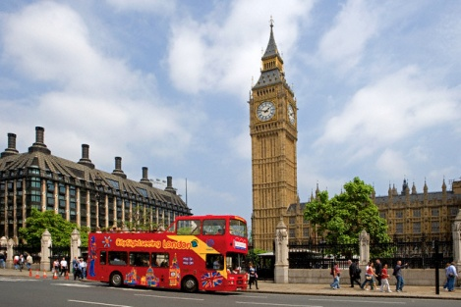
We offer you an excursion to Big Ben. It is a symbol of London, which is known all over the world. Today, only few people remember that the original Big Ben is the name of the great bell of the clock, and the nickname is used with respect to the clock, and the tower itself. London Tower is the third highest clock tower in the world. Due to its size, the clock once thought to be the largest in the world.
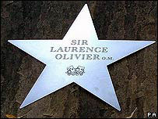
Day 2
We invite you to the venue which is part of the Gateshead Quays development, which also includes the BALTIC Centre for Contemporary Art and the Gateshead Millennium Bridge. It was opened in 2005 with hundreds of well-known names. Avenue of the Stars in London - this avenue, passing through the Gardens, Covent Garden and the Church of St. Paul. By the way, the church is also called "The Church of actors." Every celebrity presented a five-pointed star. And on the mall are the names of all the participants. The first star, who left his name on the Avenue of the Stars, was Jimmy Page, guitarist of Led Zeppelin
Day 3
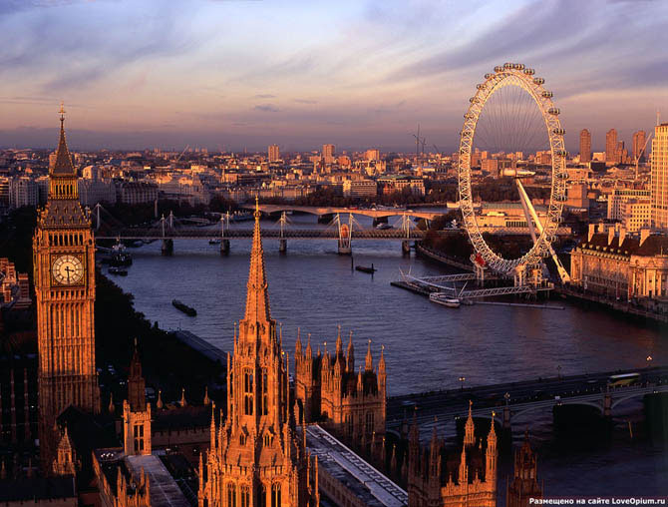
London Eye is Ferris wheel on the banks of the Thames, which became one of the symbols of the city and one of the favorite attractions in London. The wheel was launched in March 2000, becoming a metaphor that reflects changing centuries.

Day 4
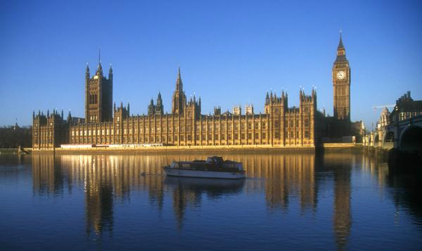
The Houses of Parliament is one of the most popular attractions in London. UK Parliament is the House of Lords and the House of Commons. The task of the Parliament is to control the work of the government, approve new laws, to participate in political debate and resolve current issues. Westminster Palace, which houses the parliament, considered one of the most beautiful buildings in the world. It stands for its pointed towers on the banks of the River Thames, as the undisputed city decoration and attracting millions of tourists every year. In addition, the parliament building holds many stories that are part of London life.
Day 5
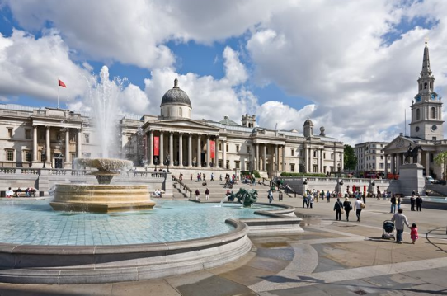
You will visit Trafalgar square with Nelson’s Column in the center. The square was named to commemorate the victory of British vice-admiral in 1805.

Day 6
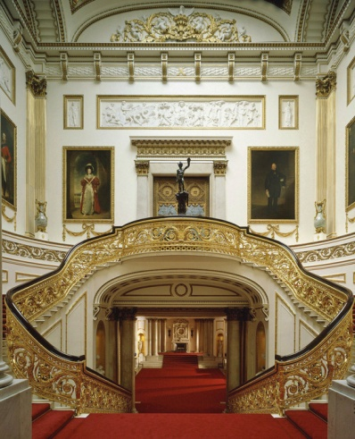
Buckingham Palace is one of the sights of London, as well as the official London residence of the Queen. Here the Queen accepts state guests, here are the official ceremonies and events of the Royal family. The palace is located between Green Park, Hyde Park and St. James, in the heart of London.
In the state rooms you can admire the real treasures of the royal family. Here are exhibited paintings and interesting French and English furniture.
Changing of the guard
Changing of the Guard takes place every day in the summer of 1130 and on some winter days in the palace courtyard. The ceremony lasts about 45 minutes to look at it for free.
Day 7
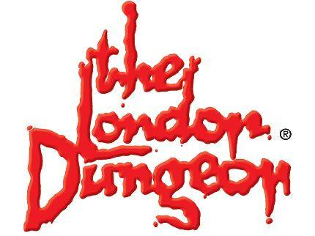
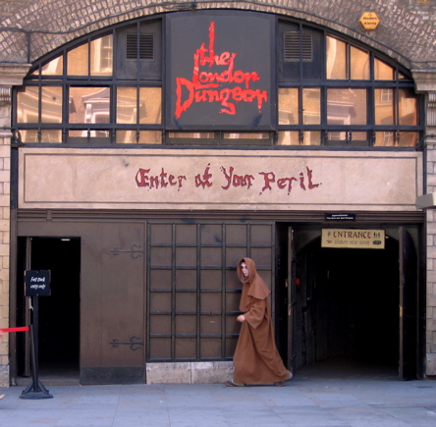
Popular London attraction is Panic Room. London Dungeon is an exhibition of torture and the horrors of the Middle Ages. It was conceived and opened in 1974 as the Museum of the "terrible stories", telling about the terrible life of the Middle Ages London, London Dungeon time partly changed its concept and turned into an online gallery, designed for a younger audience.You will walk through the dark streets of London, as they were in the time of the plague. The museum is located in the ground. The complete absence of windows and soft lighting make the atmosphere particularly scary and creepy. After the walk, live actors will take you through the inner rooms of the museum, telling and showing the horror stories from the life of the city. Look forward to the world's largest mirror maze, familiarity with maniacs medieval London and terrible trip in the dark.
Entertainment is not for the faint hearted!

Источники:
- http://images.yandex.ru/#!/yandsearch?text=%D0%B1%D0%B8%D0%B3%20%D0%B1%D0%B5%D0%BD%20%D1%84%D0%BE%D1%82%D0%BE&img_url=www.dubnatur.ru%2Fwp-content%2Fplugins%2Frss-poster%2Fcache%2F13a10_big-ben.jpg&pos=0&rpt=simage&lr=10747&noreask=1
- http://images.yandex.ru/#!/yandsearch?text=Avenue%20of%20the%20Stars%20in%20London%20%D1%84%D0%BE%D1%82%D0%BE&img_url=www.londoninfocus.com%2Fimages%2Fstories%2Fgoes%2FAvenue-Stars-London.jpg&pos=9&rpt=simage&lr=10747&noreask=1
- http://images.yandex.ru/#!/yandsearch?text=%D0%B1%D1%83%D0%BA%D0%B8%D0%BD%D0%B3%D0%B5%D0%BC%D1%81%D0%BA%D0%B8%D0%B9%20%D0%B4%D0%B2%D0%BE%D1%80%D0%B5%D1%86&img_url=img0.liveinternet.ru%2Fimages%2Fattach%2Fc%2F1%2F62%2F178%2F62178005_Bukingem.jpg&pos=12&rpt=simage&lr=10747&noreask=1
- http://images.yandex.ru/#!/yandsearch?text=London Dungeon&noreask=1&img_url=whatsonstage.londontheatredirect.com%2Fimg%2Feventgallery%2FLondonDungeon_450.jpg&pos=3&rpt=simage&lr=10747
http://images.yandex.ru/#!/yandsearch?text=London%20Dungeon&img_url=www.intravels.ru%2Fwp-content%2Fuploads%2F2012%2F02%2Farticle-2048133-022fb81300000578-482_634x557.jpg&pos=0&rpt=simage&lr=10747&noreask=1

