Муниципальное бюджетное общеобразовательное учреждение
Средняя общеобразовательная школа № 67
с углубленным изучением отдельных предметов

Конспект урока по английскому языку в 8 классе
"Знаменитые россияне"

Автор:
Ваторопина Елена Васильевна,
учитель английского языка

Екатеринбург
2012

Урок-конференция в 8-м классе посвящен знакомству с биографией и творчеством некоторых знаменитых деятелей российской науки и культуры. Воспитывает в школьниках патриотизм, любовь к своей Родине, гордость за нее, позволяет расширить содержание обучения английскому языку в общеобразовательных учреждениях, т.к. включает в себя изучение тем из других школьных предметов: литературы, истории, химии, МХК. На уроке используются результаты исследовательской и проектной деятельности.

People We Admire. Famous Russians

Цель урока : Патриотическое воспитание школьников.
Задачи урока:
- обучающие – активизация лексических единиц по теме, совершенствование грамматических навыков;
- развивающие – расширение кругозора, знакомство с выдающимися людьми нашей Родины, страницами их биографии и творчества, их ролью в мировой науке и культуре, развитие творческих способностей учащихся, формирование и развитие навыков аудирования, устной речи;
- воспитательные – воспитание чувства патриотизма и любви к Родине, гордости за своих соотечественников;
- развитие умений и навыков проектной деятельности, использование ее результатов для урока.

Ход урока:

Презентацию к данному уроку см.: http://festival.1september.ru/articles/586170/

I. Aims of the lesson.
Слайды 2-3.

II. Warming up. Topical vocabulary.
Слайды 4-5.
Учащиеся отвечают на вопросы учителя:
What famous Russians do you know? What do people admire them for?, etc.
- compatriot – соотечественник
- contemporary – современник
- generation – поколение
- contribution – вклад
- innovator – новатор
- scientist – ученый
- historical figure – исторический деятель
- designer – конструктор
- cosmonaut – космонавт
- artist – художник
- representative – представитель
- military leader – полководец
- outstanding - выдающийся
- essential – существенный
- emotional – эмоциональный
- ambitious – честолюбивый
- significant – значительный
- unpredictable – непредсказуемый
- realistic – реалистичный
- landscape – пейзаж
- title – звание, титул
- Nobel prize – Нобелевская премия
- politician – политический деятель
- unforgettable – незабываемый
- marvellous – изумительный
- charming – очаровательный
- success – успех
- successful – успешный
- to succeed – добиться успеха
- to be proud of – гордиться
- to investigate – исследовать
- to support – поддерживать
- to invent – изобретать
- to discover – открыть, исследовать
- to dеscribe – описывать
- to perform – исполнять, играть
- to perfect – совершенствовать
- to make an impression – произвести впечатление
- to enter – поступить
- to graduate from – окончить
- to admire – восхищаться
- the Periodic System of Elements – Периодическая система Менделеева
- heritage – наследие
- branches of science – области науки

III. Project work – presentation of pupil’s research projects.

Фрагменты проектных работ учащихся содержат интересную информацию о жизни, деятельности, творчестве знаменитых ученых, писателей, художников России, красочные иллюстрации, фотографии.
Слайды 6-42.
Учащиеся рассказывают о знаменитых россиянах, их жизни и творчестве, достижениях, прославивших Россию. Информация сопровождается показом слайдов. (Краткое содержание их выступлений приведено ниже.)
Mikhail Vasilyevich Lomonosov
- 1711 – Lomonosov was born in province of Arkhangelsk.
- He began to read when he was a little boy.
- 1730 – entered the Slavic-Greek-Latin Academy in Moscow
- 1736 – was sent abroad to complete his studies in chemistry and mining
- 1745 – published a catalogue of 3,000 minerals
- 1760 – explained the formation of icebergs
His achievements:
- made a telescope
- observed a lot of stars and planets with his telescope
- wrote the first scientific grammar of the Russian language
- wrote many poems
- built a factory near Petersburg where glass was produced
- was a founder of the first Russian University
- Moscow State University was renamed “M. V. Lomonosov Moscow State University’’ in his honor in 1940.
Dmitriy Ivanovich Mendeleev
- 1834 – D.I. Mendeleev was born in the village near Tobolsk.
- 1847 – entered the Gymnasium in Tobolsk
- 1855 – graduated from the Pedagogical Institute in Saint-Petersburg
- 1865 – became a Doctor of Science for his dissertation "On the Combinations of Water with Alcohol“
- 1905 – became a member of the Royal Swedish Academy of Sciences
- 1869 – created The periodic System of the chemical elements, founded the Russian Chemical Society
- 1892 – invented smokeless powder
- The radioactive mendelevium, is named after him.
Alexandr Pushkin
- He wrote about his experiences in the south in several romantic narrative poems.
- He started work on a novel in verse called Yevgeny Onegin . He did not finish it until 1833.
- This was to be his most famous work. It was used by many musicians including Tchaikovsky who made it into an opera. The poem shows typical Russian people in the society of his day.
- He wrote romantic poems using Russian tales of heroes and adventures. Ruslan and Ludmila was a poem that was later to be made into an opera by Glinka.
- Not so many people outside Russia read Pushkin’s poems. This is because his poetry is very hard to translate well into other languages because the words are full of special meanings in Russian culture.
Alexandr Grin
- His novels "Scarlet Sails", "A Golden Chair", "Walking on the Waves" have a great success with readers. The most famous of his novel is Scarlet Sails, written in 1923. It is a simple but powerful love story.
Anton Chekhov
- While he was at Moscow University, Chekhov wrote many short stories to pay for his schooling and to help his family.
- In 1886, one of the most famous newspapers in Russia, New Times, asked him to write stories for them.
- Soon, his stories started to get famous, and other writers read his work and liked it.
- He wrote a book of stories called At Dusk that won the Pushkin Prize, an award for good writing.
- He wrote one of his best stories there, including Ward No.6. While he was there, he helped the people who lived nearby. He brought them food and clothing, and medicine when they were sick.
- Since he was trained as a doctor, he knew how to take care of them.
Ivan Konstantinovich Aivazovsky “The Sea is my life…”
- His creative work is like a sea encyclopedia – 6000 paintings.
- The English writer W.Turner, renowned for his seascapes, devoted verses to Aivazovsky, in which he called him a genius.
Vasily Kandinsky – Russian and German artist, art theorist, poet, one of the founders of abstract art
- initiated abstract art
- liked to use the broken lines in his paintings
- created vivid dynamic compositions
- thought that people could portray their feelings on paper.
Kazimir Malevich – the founder of geometric art.

IV. Speaking.
Слайды 43-48.
Учащиеся задают вопросы выступающим.
Дискуссия на тему: «Is it easy to be successful? How to achieve outstanding results? What is more important: your own glory or your contribution in developing of science and culture?»
If you want to succeed, you’ll have to make it on your own: your own head, your own energy, your own ambitions.
If at first you don’t succeed, try, try and try again.
Обсуждаются и комментируются высказывания известных людей.
- I would rather have it said, “He lived useful” than “He died rich” …
Benjamin Franklin
- Genius is one per cent inspiration and ninety-nine per cent perspiration.
Edison
- I do not know what I may appear to the world; but to myself I seem to have been only like a boy playing on the seashore … while the great ocean of truth lay all undiscovered before me.
Isaac Newton
- I think and think, for months, for years, ninety-nine times the conclusion is false. The hundredth time I am right.
Albert Einstein

V. Crossword «Famous Russians».
Слайды 49-50.
Учащимся выдаются карточки с кроссвордами, которые они заполняют, используя лексику по данной теме. Проверяются ответы, подводятся итоги.
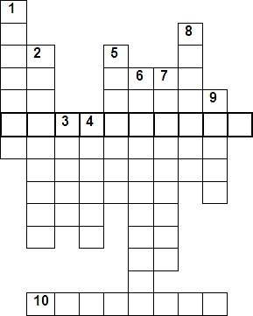

- Six Russians were given Nobel Prizes in ……… (science).
- The founder of the first Russian University.
- There is no Noble Prize in ……. (science, school subject).
- Russian physiologist – Nobel Prizewinner.
- The first cosmonaut in the world.
- «выдающийся» (in English).
- The first president of the USSR.
- Famous Russian figure-skater, Olympic champion of three Olimpiads.
- Bunin is Russian ……. Prizewinner in Literature.
- Korolev – …….. of the first Russian spaceship.
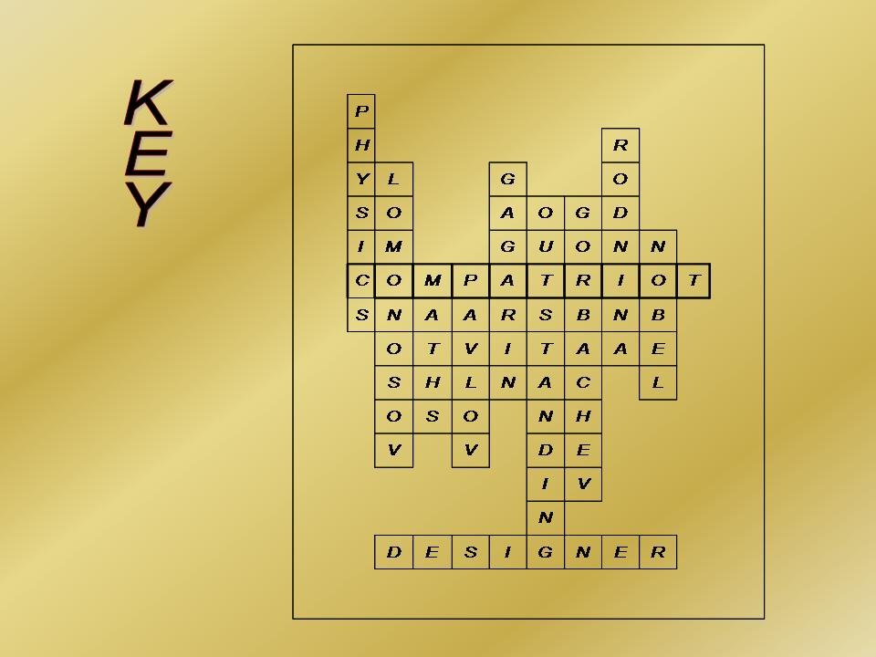

VI. Подведение итогов конференции. Выставление оценок.
ТСО: компьютер, мультимедийный проектор.

Литература
1. Ваторопина Е.В. People we admire. Famous Russians. Урок-конференция в 8 классе [Электронный ресурс]. – Режим доступа: http://festival.1september.ru/articles/586170/ (дата обращения 07.10.2012 г.).
2. Ваторопина Е.В. Метод проектов: урочная и внеклассная работа по английскому языку в основной школе. // Новое слово в методике: Сборник инновационных методических разработок: материалы международного методического форума, Екатеринбург, 7 ноября 2012 г. / «Урал. гос. пед. ун-т». – Екатеринбург, 2012. – № 6. – 210 с.

Для заметок

620017, г.Екатеринбург,
ул.Стачек, 20

Тел. (343) 352-16-76, 352-16-77

Е-mail: school_67@bk.ru;
elenavatoropina@yandex.ru

Сайт: 67школа.рф



