Reading Comprehension - Steve Jobs Biography

Develop your reading skills. Read the following text about summer and do the comprehension questions

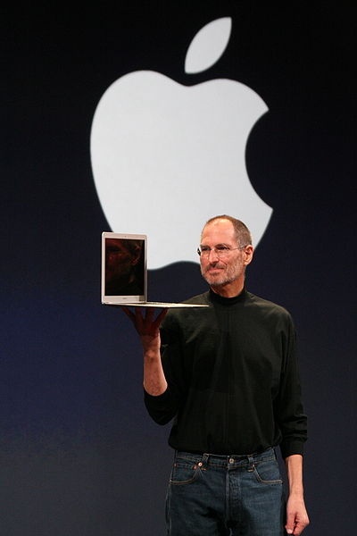
Steve Jobs, the American businessman and technology visionary who is best known as the co-founder, chairman, and chief executive officer of Apple Inc, was born on February 24, 1955. His parents were two University of Wisconsin graduate students, Joanne Carole Schieble and Syrian-born Abdulfattah Jandali. They were both unmarried at the time. Jandali, who was teaching in Wisconsin when Steve was born, said he had no choice but to put the baby up for adoption because his girlfriend's family objected to their relationship.
The baby was adopted at birth by Paul Reinhold Jobs (1922–1993) and Clara Jobs (1924–1986). Later, when asked about his "adoptive parents," Jobs replied emphatically that Paul and Clara Jobs "were my parents." He stated in his authorized biography that they "were my parents 1,000%." Unknown to him, his biological parents would subsequently marry (December 1955), have a second child, novelist Mona Simpson, in 1957, and divorce in 1962.
The Jobs family moved from San Francisco to Mountain View, California when Steve was five years old. The parents later adopted a daughter, Patti. Paul was a machinist for a company that made lasers, and taught his son rudimentary electronics and how to work with his hands. The father showed Steve how to work on electronics in the family garage, demonstrating to his son how to take apart and rebuild electronics such as radios and televisions. As a result, Steve became interested in and developed a hobby of technical tinkering. Clara was an accountant who taught him to read before he went to school.
Jobs's youth was riddled with frustrations over formal schooling. At Monta Loma Elementary school in Mountain View, he was a prankster whose fourth-grade teacher needed to bribe him to study. Calligraphy was one class that he enjoyed, and he said that it influenced his interest in design and the use of elegant fonts on Apple computers. Jobs tested so well, however, that administrators wanted to skip him ahead to high school—a proposal his parents declined. Jobs then attended Cupertino Junior High and Homestead High School in Cupertino, California. At age 13, he met one the most important persons in his life: 18-year-old Stephen Wozniak, an electronics wiz kid, and, like Steve, an incorrigible prankster. Following high school graduation in 1972, Jobs enrolled at Reed College in Portland, Oregon. Reed was an expensive college which Paul and Clara could ill afford. They were spending much of their life savings on their son's higher education. Jobs dropped out of college after six months and spent the next 18 months dropping in on creative classes.
He was more interested in eastern philosophy, fruitarian diets than in the classes he took. He moved to a hippie commune in Oregon where his main activity was cultivating apples.

In 1974 Steve goes on a spiritual trip to India with one of his friends.
In 1976, when Jobs was just 21, he and Wozniak started Apple Computers. The duo started in the Jobs family garage, and funded their entrepreneurial venture after Jobs sold his Volkswagen bus and Wozniak sold his beloved scientific calculator.
Through Apple, Jobs was widely recognized as a charismatic pioneer of the personal computer revolution and for his influential career in the computer and consumer electronics fields. Jobs also co-founded and served as chief executive of Pixar Animation Studios; he became a member of the board of directors of The Walt Disney Company in 2006, when Disney acquired Pixar.
Jobs died at his California home around 3 p.m. on October 5, 2011, due to complications from a relapse of his previously treated pancreatic cancer.
The memory of Steve Jobs is a source of inspiration. Since his death in 2011, countless pieces of art have been created in memory of Steve Jobs and his work at Apple, and the Steve’s Hand Monument in Odessa, Ukraine, is one of the neatest statues we’ve seen that has been dedicated to the Apple co-founder.
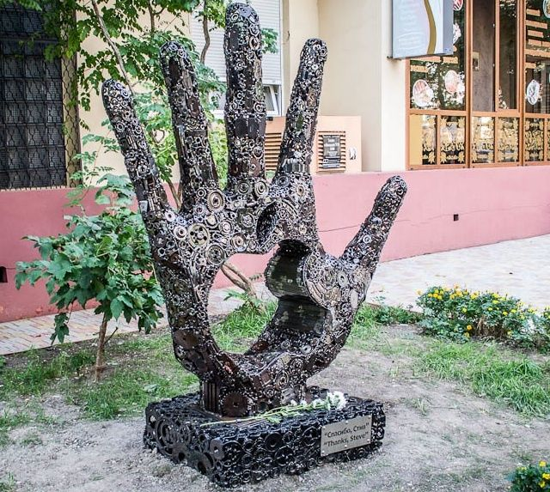

Comprehension Quiz:
- Steve Jobs, the American businessman and technology visionary who is best known as the co-founder, chairman, and chief executive officer of Apple Inc, was born on February 24, 1955in San Francisco, ……. (California, Philadelphia, Florida).
- His unwed biological …… (neighbors, parents, doctors) Joanne Schieble and Abdulfattah Jandali, put him up for adoption.
- As a boy, Jobs and his father would work on electronics in the family (garage, park, yard).
- His father demonstrated to his son how to take apart and rebuild electronics such as radios and …… (notebooks, televisions, cars).
- As a result, Steve became interested in and developed ……( a hobby, industry, ideas) of technical tinkering.
- Jobs's youth was riddled with frustrations over formal schooling but he was …… (a footballer, singer, a prankster) whose fourth-grade teacher needed to bribe him to study.
- Calligraphy was one class that he enjoyed, and he said that it influenced his interest in design and the use of elegant …… (fonts, letters, tunes) on Apple computers.
- At age 13, he met one the most important persons in his …… (childhood, youth, life) : 18-year-old Stephen Wozniak, an electronics wiz kid, and, like Steve, an incorrigible prankster.
- Reed was an expensive college which Paul and Clara could ill afford and they were spending much of their life …… (money, savings, leftovers) on their son's higher education.
- Steve spent only one semester at Reed, then dropped out, as he was more interested in eastern philosophy, fruitarian …… (foods, meals, diets).
- He moved to a hippie commune in Oregon where his main activity was cultivating ….. (cherries, pears, apples).
- In 1974 Steve goes on a spiritual trip to …… ( India, China, Japan) with one of his friends.
- In 1976, when Jobs was just …… (21, 31, 41) he and Wozniak started Apple Computers.
- The duo started in the Jobs family garage, and funded their entrepreneurial venture after Jobs sold his …… (Mercedes, Volkswagen, Volvo) bus and Wozniak sold his beloved scientific calculator.
- Through Apple, Jobs was widely recognized as a charismatic ….. (director, inventor, pioneer) of the personal computer revolution and for his influential career in the computer and consumer electronics fields.
- Steve Jobs died at his California home around 3 p.m. on October 5, 2011 from …… (leukemia, cancer, heart attack).
- The up given monument in Honor to Steve Jobs with the words “Thanks, Steve!” stands in ….. (Moscow, Odessa, Minsk).
- California
- parents
- garage
- televisions
- a hobby
- a prankster
- fonts
- life
- savings
- diets
- apples
- China
- 21
- Volkswagen
- pioneer
- cancer
- Odessa

Sources:
http://www.myenglishpages.com/site_php_files/reading-steve-jobs-biography.php#.U9yN_Pl_vX4

http://www.cultofmac.com/195066/giant-hand-monument-to-steve-jobs-unveiled-in-ukraine-gallery/

http://allaboutstevejobs.com/bio/shortbio.php

