Кроссворд
Remembrance Day

Английский язык
УМК Spotlight
Module 1 Celebrations
9 класс

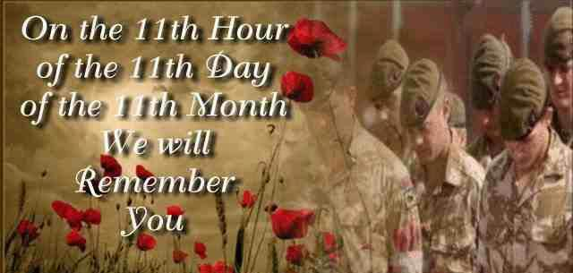

Автор:
Ольга Михайловна Степанова
учитель английского языка
Муниципальное образовательное учреждение
«Чадукасинская ООШ»
Красноармейского района
Чувашской Республики
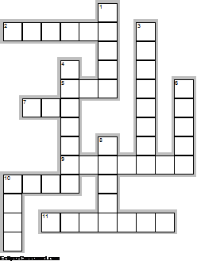

Across

2. The poppy is the ... of Remembrance Day because they are the only flowers that grew on the battlefields after World War I. (6)
5. Soldiers play another piece of musik 'The Rouse' to signal the ... of the two-minute service. (3)
7. Remembrance Day is on this date because World ... I ended in the 11th hour of the 11th day of the 11th month in 1918. (3)
9. People wear paper poppies to remember the millions who died for thier ... . (7)
10. They are very delicate flowers, too, and live for a short ... . (4)
11. At 11 am there is a two-minute ... . (7)

Down

1. Some people have also pointed out that fields of bright red poppies look like fields of ... . (5)
3. Old war veterans lay wreaths on the steps of the ... . (8)
4. The Royal Family and top politicians attend a special ... in London at the Cenotaph. (7)
6. Every year during the week before the 11th November people all over Britain wear a little red paper ... . (5)
8. A lone soldier plays a piece of musik called 'The Last post' on the ... to introduce the two-minute silence. (5)
10. The Cenjtaph means 'The Empty ....' in Greek. (4)

Ключи Keys
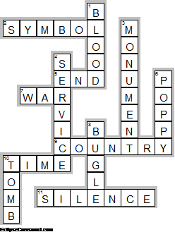

Across

2. SYMBOL—The poppy is the ... of Remembrance Day because they are the only flowers that grew on the battlefields after World War I.
5. END—Soldiers play another piece of musik 'The Rouse' to signal the ... of the two-minute service.
7. WAR—Remembrance Day is on this date because World ... I ended in the 11th hour of the 11th day of the 11th month in 1918.
9. COUNTRY—People wear paper poppies to remember the millions who died for thier ... .
10. TIME—They are very delicate flowers, too, and live for a short ... .
11. SILENCE—At 11 am there is a two-minute ... .

Down

1. BLOOD—Some people have also pointed out that fields of bright red poppies look like fields of ... .
3. MONUMENT—Old war veterans lay wreaths on the steps of the ... .
4. SERVICE—The Royal Family and top politicians attend a special ... in London at the Cenotaph.
6. POPPY—Every year during the week before the 11th November people all over Britain wear a little red paper ... .
8. BUGLE—A lone soldier plays a piece of musik called 'The Last post' on the ... to introduce the two-minute silence.
10. TOMB—The Cenjtaph means 'The Empty ....' in Greek.

