Live in Space!

Crossword

Английский язык
УМК Spotlight
9 класс

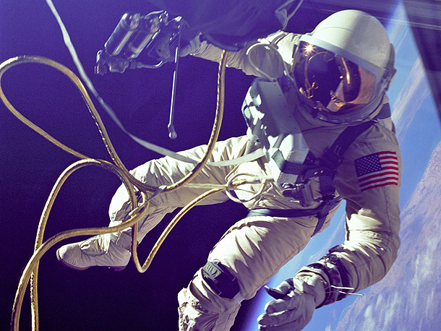

Автор:
Ольга Михайловна Степанова
учитель английского языка
МБОУ «Чадукасинская ООШ»
Красноармейского района
Чувашской Республики

2014
Цель - развитие осознанного чтения .
Задачи:
- развитие речи , обогащая её через лексику научно-популярного текста;
- расширение словарного запаса учащихся;
- развитие логического мышления, активизации языковой догадки;
- формирование уважительного отношения к профессии астронавтов и космонавтов;
- воспитывать интерес к чтению научно-популярной литературы;
Технология работы с кроссвордом: индивидуальная или групповая работа на уроке.
.
Краткая аннотация к материалу:
Привлекательное упражнение в виде кроссворда Live in Space! для работы на уроке английского языка в 9 классе по учебнику Spotlight облегчает работу с текстом как по запоминанию содержания текста, так и по активизации лексического материала по научно-популярной теме "Жизнь астронавтов в космосе", расширяя при этом общий кругозор детей по данной теме: Модуль 2, урок 2а, стр 26.

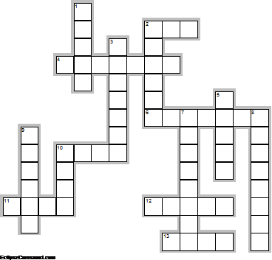
Across

2. It's important to cover the eyes to block out the light of the ... . (3)
4. When it comes to sleeping, there's no need for a ... . (7)
6. The astronauts put their dirty dishes and ... into plastic bags and send them back to the Earth. (7)
10. To stop thier meals from floating away when eating, astronauts have to post food packages into a special ... and then strap it to their legs. (4)
11. Astranauts have to use a vacuum ... to wash with. (4)
12. How would you like to live three hundred and sixty kilometres above the ... , flying at almost thirty thousand kilometres an hour through dark, airless space? (5)
13. The astronauts can sleep anywehre, but they can't risk bumping into any computer controls so they strap themselves into a sleeping bag on the ... . (4)

Down

1. The residents of the ISS actually spend two hours a day working out on exercise ... and rowing mashines. (5)
2. You can forget about having a nice hot ... in the morning, as the water droplets would simply float away. (6)
3. Living in zero ... means doing lots of things differently. (7)
5. The ISS is about the size of a football ... . (5)
7. In zero gravity dangerous ... grow quickly. (8)
8. There is no escape from ... chores opn the ISS. (8)
9. Most of all astronauts like to stare out of the ... and take pictures of their real hom, the Earth. (6)
10. When astronauts have free ... they often send Emails back home and read books or watch movies. (4)

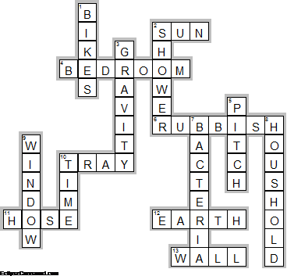

Across

2. SUN—It's important to cover the eyes to block out the light of the ... .
4. BEDROOM—When it comes to sleeping, there's no need for a ... .
6. RUBBISH—The astronauts put their dirty dishes and ... into plastic bags and send them back to the Earth.
10. TRAY—To stop thier meals from floating away when eating, astronauts have to post food packages into a special ... and then strap it to their legs.
11. HOSE—Astranauts have to use a vacuum ... to wash with.
12. EARTH—How would you like to live three hundred and sixty kilometres above the ... , flying at almost thirty thousand kilometres an hour through dark, airless space?
13. WALL—The astronauts can sleep anywehre, but they can't risk bumping into any computer controls so they strap themselves into a sleeping bag on the ... .

Down

1. BIKES—The residents of the ISS actually spend two hours a day working out on exercise ... and rowing mashines.
2. SHOWER—You can forget about having a nice hot ... in the morning, as the water droplets would simply float away.
3. GRAVITY—Living in zero ... means doing lots of things differently.
5. PITCH—The ISS is about the size of a football ... .
7. BACTERIA—In zero gravity dangerous ... grow quickly.
8. HOUSHOLD—There is no escape from ... chores opn the ISS.
9. WINDOW—Most of all astronauts like to stare out of the ... and take pictures of their real hom, the Earth.
10. TIME—When astronauts have free ... they often send Emails back home and read books or watch movies.

