Superstitions

Кроссворд составлен для использования на уроке английского языка в 9 классе по УМК Spotlight (урок №2, Модуль 1). Материал рекомендуется также использовать на занятиях по внеурочной работе по предмету.
Автор:
Ольга Михайловна Степанова
учитель английского языка
МБОУ «Чадукасинская ООШ»
Красноармейского района
Чувашской Республики

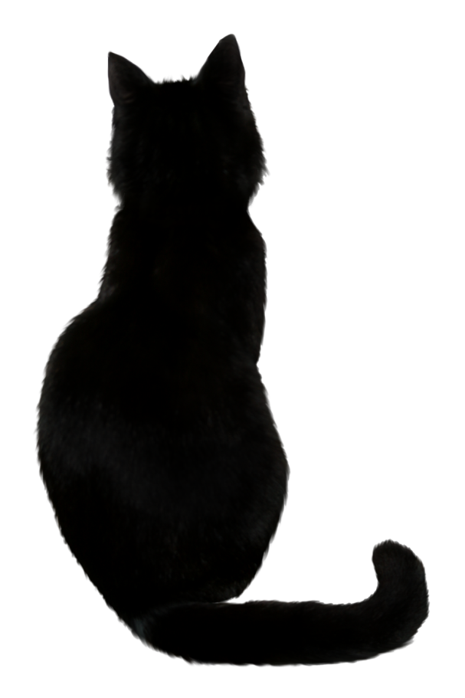
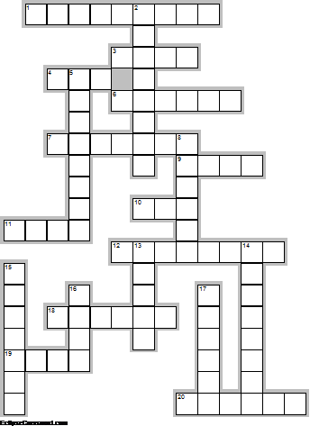
Across

1. Finding a ... – Good Luck (9)
3. Knock Twice on ... – Reverses Bad Luck (4)
4. Black ... Crossing Your Path is for bad luck (3)
6. Finding a four leaf ... is very good luck (6)
7. ... crossed for good luck (7)
9. Itchy ... – Good Luck (4)
10. Saying "... Bless You" – Good Luck (3)
11. Seeing a shooting ... is very good luck. (4)
12. Opening an ... Inside – Bad Luck (8)
18. Walking Under a ... – Bad Luck (6)
19. ... poop equals riches (4)
20. ... the 13th – Bad Luck (6)

Down

2. Throw salt over your ... to undo the bad luck (8)
5. Breaking ... causes seven years of bad luck (8)
8. Killing a ... is bad luck. (6)
13. If the left hand itches ... is going out (5)
14. If a ... lands on your hand it is good luck. (8)
15. Seeing a ... when it isn't raining is very good luck. (7)
16. If the right ... itches, money is coming in (4)
17. Breaking a ... causes seven years of bad luck (6)

Ответы:
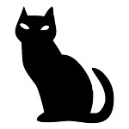
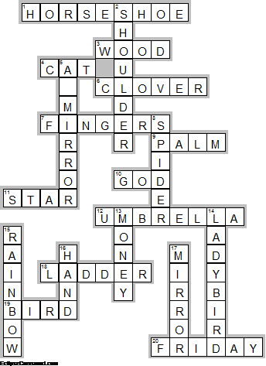
Across

1. HORSESHOE—Finding a ... – Good Luck
3. WOOD—Knock Twice on ... – Reverses Bad Luck
4. CAT—Black ... Crossing Your Path is for bad luck
6. CLOVER—Finding a four leaf ... is very good luck
7. FINGERS—... crossed for good luck
9. PALM—Itchy ... – Good Luck
10. GOD—Saying "... Bless You" – Good Luck
11. STAR—Seeing a shooting ... is very good luck.
12. UMBRELLA—Opening an ... Inside – Bad Luck
18. LADDER—Walking Under a ... – Bad Luck
19. BIRD—... poop equals riches
20. FRIDAY—... the 13th – Bad Luck

Down

2. SHOULDER—Throw salt over your ... to undo the bad luck
5. A MIRROR—Breaking ... causes seven years of bad luck
8. SPIDER—Killing a ... is bad luck.
13. MONEY—If the left hand itches ... is going out
14. LADYBIRD—If a ... lands on your hand it is good luck.
15. RAINBOW—Seeing a ... when it isn't raining is very good luck.
16. HAND—If the right ... itches, money is coming in
17. MIRROR—Breaking a ... causes seven years of bad luck

