Mr Potato
Кроссворд для учащихся 7-11 классов
Автор:
Ольга Михайловна Степанова
учитель английского языка
МБОУ «Чадукасинская ООШ»
Красноармейского района
Чувашской Республики
Across

2. One medium potato contains 45 percent of the daily recommended amount of ... C. (7)
5. On the South Atlantic Island of Tristan de Cunha, potatoes were once used as the country's unofficial ... . (8)
6. Thomas Jefferson is given credit for introducing French fries to ... . (7)
7. A potato is about 80% ... and 20% solid. (5)
9. Potato plants are usually pollinated by insects such as ... . (10)
13. Potatoes are the world's 4th food staple... after wheat, corn and ... . (4)
15. One medium sized potato has fewer calories than a grapefruit, more potassium than a ..., and more usable iron than any other vegetable. (6)
17. French Fries were introduced to the U.S. when Thomas ... served them in the White House during his Presidency of 1801-1809. (9)
18. ... is the world's largest potato producer. (5)
20. The largest potato - 18 pounds and 4 ounces - according to the Guinness Book of World Records was grown in ... in 1795. (7)
21. Mr. Potato Head is an American ... consisting of a plastic model of a potato, which can be decorated with a variety of plastic parts that can attach to the main body. (3)
22. Marie Antoinette made potatoes a fashion statement when she paraded through the French countryside wearing potato blossoms in her ... . (4)
23. About 20% of potato nutrition is found in the ... . (4)
24. In fact, potatoes provide one of the affordable and concentrated sources of ... – more than bananas, tomatoes, broccoli and oranges. (9)

Down

1. Folk remedy: Ease a sore ... by putting a slice of baked potato in a stocking and tying it around your throat. (6)
2. Contrary to popular myth and misconception, potatoes are an extremely nutrient-rich ... . (9)
3. Folk remedy: Help a toothache by carrying a potato in your ... . (6)
4. Religious leaders denounced the potato because it wasn't mentioned in the ... . (5)
5. The potato disease “Late Blight” was the principal ... of the Irish Potato Famine, which killed a half million people. (5)
8. One of the world's best Potato Museums is located in ... D.C. (10)
10. Folk remedy: Treat frostbite or ... by applying raw grated potato or potato juice to the affected area. (7)
11. Believe it or not — the potato was the first vegetable to be "grown" in ... . (5)
12. The Incas measured ... by how long it took for potatoes to cook. (4)
14. Potato skins contain lots of nutrients including fiber, iron, ..., zinc, phosphorous and B vitamins. (7)
16. The top potato producers of the USA are Idaho, Washington and ... . (9)
19. In 1778 Prussia and ... fought the Potato War in which each side tried to starve the other by consuming their potato crop. (7)

ANSWERS

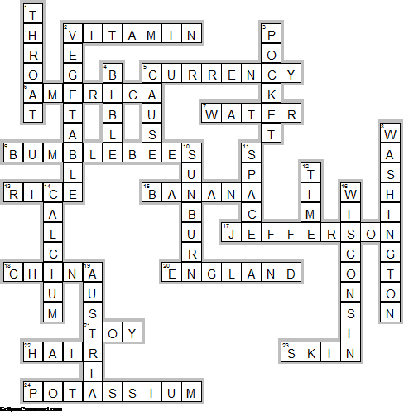

Across

2. VITAMIN—One medium potato contains 45 percent of the daily recommended amount of ... C.
5. CURRENCY—On the South Atlantic Island of Tristan de Cunha, potatoes were once used as the country's unofficial ... .
6. AMERICA—Thomas Jefferson is given credit for introducing French fries to ... .
7. WATER—A potato is about 80% ... and 20% solid.
9. BUMBLEBEES—Potato plants are usually pollinated by insects such as ... .
13. RICE—Potatoes are the world's 4th food staple... after wheat, corn and ... .
15. BANANA—One medium sized potato has fewer calories than a grapefruit, more potassium than a ..., and more usable iron than any other vegetable.
17. JEFFERSON—French Fries were introduced to the U.S. when Thomas ... served them in the White House during his Presidency of 1801-1809.
18. CHINA—... is the world's largest potato producer.
20. ENGLAND—The largest potato - 18 pounds and 4 ounces - according to the Guinness Book of World Records was grown in ... in 1795.
21. TOY—Mr. Potato Head is an American ... consisting of a plastic model of a potato, which can be decorated with a variety of plastic parts that can attach to the main body.
22. HAIR—Marie Antoinette made potatoes a fashion statement when she paraded through the French countryside wearing potato blossoms in her ... .
23. SKIN—About 20% of potato nutrition is found in the ... .
24. POTASSIUM—In fact, potatoes provide one of the affordable and concentrated sources of ... – more than bananas, tomatoes, broccoli and oranges.

Down

1. THROAT—Folk remedy: Ease a sore ... by putting a slice of baked potato in a stocking and tying it around your throat.
2. VEGETABLE—Contrary to popular myth and misconception, potatoes are an extremely nutrient-rich ... .
3. POCKET—Folk remedy: Help a toothache by carrying a potato in your ... .
4. BIBLE—Religious leaders denounced the potato because it wasn't mentioned in the ... .
5. CAUSE—The potato disease “Late Blight” was the principal ... of the Irish Potato Famine, which killed a half million people.
8. WASHINGTON—One of the world's best Potato Museums is located in ... D.C.
10. SUNBURN—Folk remedy: Treat frostbite or ... by applying raw grated potato or potato juice to the affected area.
11. SPACE—Believe it or not — the potato was the first vegetable to be "grown" in ... .
12. TIME—The Incas measured ... by how long it took for potatoes to cook.
14. CALCIUM—Potato skins contain lots of nutrients including fiber, iron, ..., zinc, phosphorous and B vitamins.
16. WISCONSIN—The top potato producers of the USA are Idaho, Washington and ... .
19. AUSTRIA—In 1778 Prussia and ... fought the Potato War in which each side tried to starve the other by consuming their potato crop.

