Meet
Miss the Moo
Кроссворд для учащихся 8-11 классов
Автор:
Ольга Михайловна Степанова
учитель английского языка
МБОУ «Чадукасинская ООШ»
Красноармейского района
Чувашской Республики
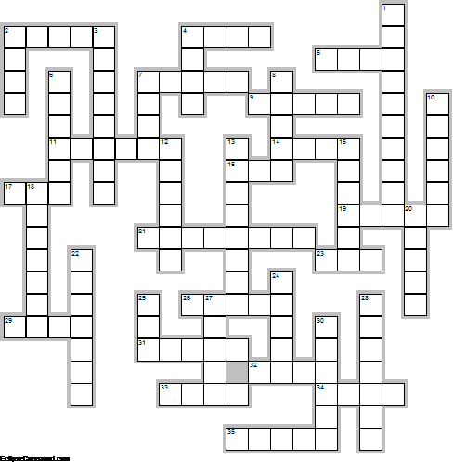
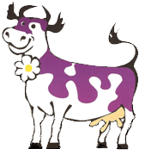
Across

2. Cows do not have ... on their upper jaws. (5)
4. The malicious cow disturbs the whole ... . Ukranian Proverb (4)
5. An adult male cow is called a ... . (4)
7. Wicked cows have short ... . Dutch Proverb (5)
9. Dogs bark and cows chew ... . Corsican Proverb (5)
11. What can you do with a good cow that gives a lot of milk and then kicks the ... over? Yiddish Proverb (6)
14. Condensed milk is wonderful. I don't see how they can get a cow to sit down on those little ... . ~Fred Allen (4)
16. The number of rings on the horns means approximate ... . (3)
17. Settling a dispute through the law is like losing a cow for the sake of a ... . Chinese Proverb (3)
19. I dont know why or how, God decided to make the cow with its belly oh so white and a ... thats not so bright (by Nathan the Awesome) (5)
21. Let every one mind his own ..., and the cows will be well tended. French Proverb (8)
23. The cow that's first up gets the first of the ... . British Proverb (3)
26. Every man to his ..., as the man said when he kissed his cow. Scottish Proverb (5)
29. The old cow forgets that she was once a ... . Finnish Proverb (4)
31. Cows can live up to 25 ... . (5)
32. Cows give us milk, leather and ... . (4)
33. A noisy cow gives little ... . Polish Proverb (4)
34. It is difficult to teach a cow to climb a . Lithuanian Proverb (4)
35. Milk the cow, but do not pull off the ... . (5)

Down

1. The state of ... produces the most milk in the US (10)
2. The cow does not know the value of her ... till she has lost it. Dutch Proverb (4)
3. The ... is mine and the cows are ours. Portuguese Proverb (8)
4. Greatness alone in not enough, or the cow would outrun the ... . (4)
6. You never know how a cow catches a ... . Dutch Proverb (6)
7. You can wait till the cows come ... . Polish Proverb (4)
8. IF you are buying a cow, make sure that the ... of the tail is included. Tamil Proverb (5)
10. Cows have almost total 360-degree panoramic ... . (6)
12. Cows actually do not bite grass; instead they curl their ... around it. (6)
13. In the ... all cows are black. Slovak Proverb (8)
15. First the ..., then the cow. Russian Proverb (6)
18. Cows first came to .. with pilgrims. (7)
20. ... is the place to be There cows are sacred. (5)
22. What is good for the ... is good for the cow. Vietnamese Proverb (7)
24. Building the ... , when the cows are all stole. Thai Proverb (5)
25. Cows say “moo” as a ... to communicate. (3)
27. A soft dropping ... brings milk to cows and sheep. Irish Proverb (5)
28. You don't milk a cow with your hands in your ... . Russian Proverb (7)
30. All is not ... that comes from the cow. Italian Proverb (6)

Answers:
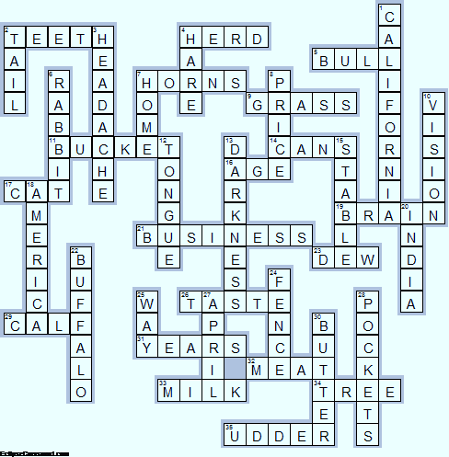 Across

2. TEETH—Cows do not have ... on their upper jaws.
4. HERD—The malicious cow disturbs the whole ... . Ukranian Proverb
5. BULL—An adult male cow is called a ... .
7. HORNS—Wicked cows have short ... . Dutch Proverb
9. GRASS—Dogs bark and cows chew ... . Corsican Proverb
11. BUCKET—What can you do with a good cow that gives a lot of milk and then kicks the ... over? Yiddish Proverb
14. CANS—Condensed milk is wonderful. I don't see how they can get a cow to sit down on those little ... . ~Fred Allen
16. AGE—The number of rings on the horns means approximate ... .
17. CAT—Settling a dispute through the law is like losing a cow for the sake of a ... . Chinese Proverb
19. BRAIN—I dont know why or how, God decided to make the cow with its belly oh so white and a ... thats not so bright (by Nathan the Awesome)
21. BUSINESS—Let every one mind his own ..., and the cows will be well tended. French Proverb
23. DEW—The cow that's first up gets the first of the ... . British Proverb
26. TASTE—Every man to his ..., as the man said when he kissed his cow. Scottish Proverb
29. CALF—The old cow forgets that she was once a ... . Finnish Proverb
31. YEARS—Cows can live up to 25 ... .
32. MEAT—Cows give us milk, leather and ... .
33. MILK—A noisy cow gives little ... . Polish Proverb
34. TREE—It is difficult to teach a cow to climb a . Lithuanian Proverb
35. UDDER—Milk the cow, but do not pull off the ... .

Down

1. CALIFORNIA—The state of ... produces the most milk in the US
2. TAIL—The cow does not know the value of her ... till she has lost it. Dutch Proverb
3. HEADACHE—The ... is mine and the cows are ours. Portuguese Proverb
4. HARE—Greatness alone in not enough, or the cow would outrun the ... .
6. RABBIT—You never know how a cow catches a ... . Dutch Proverb
7. HOME—You can wait till the cows come ... . Polish Proverb
8. PRICE—IF you are buying a cow, make sure that the ... of the tail is included. Tamil Proverb
10. VISION—Cows have almost total 360-degree panoramic ... .
12. TONGUE—Cows actually do not bite grass; instead they curl their ... around it.
13. DARKNESS—In the ... all cows are black. Slovak Proverb
15. STABLE—First the ..., then the cow. Russian Proverb
18. AMERICA—Cows first came to .. with pilgrims.
20. INDIA—... is the place to be There cows are sacred.
22. BUFFALO—What is good for the ... is good for the cow. Vietnamese Proverb
24. FENCE—Building the ... , when the cows are all stole. Thai Proverb
25. WAY—Cows say “moo” as a ... to communicate.
27. APRIL—A soft dropping ... brings milk to cows and sheep. Irish Proverb
28. POCKETS—You don't milk a cow with your hands in your ... . Russian Proverb
30. BUTTER—All is not ... that comes from the cow. Italian Proverb

