October

Кроссворд
для учащихся 8-11 классов,
влюбленных в английский язык

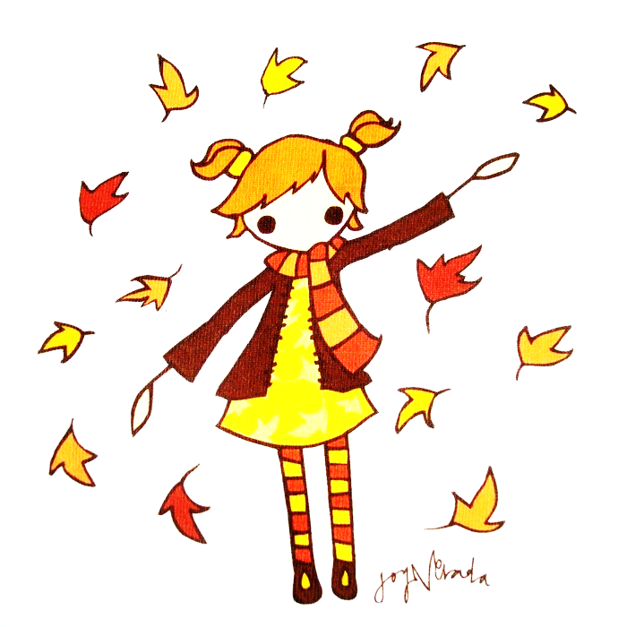
Автор:
Ольга Михайловна Степанова
учитель английского языка
МБОУ «Чадукасинская ООШ»
Красноармейского района
Чувашской Республики

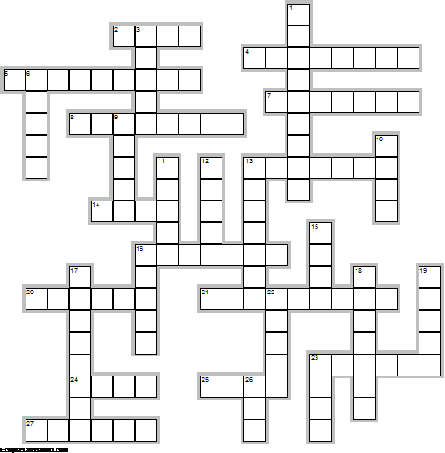
Across

2. The birthstones for October are the tourmaline and the ... . (4)
4. The USA celebrates ... Day on the second Monday of October. (8)
5. On October 4, 1957, the first artificial ... was launched by the Soviet Union. (9)
7. Ray Bradbury published a collection of short stories titled The October ... in 1955. (7)
8. First transcontinental ... sent, October 24, 1861. (8)
13. On October 12, 1492, Christopher Columbus landed in ... . (7)
14. "The stillness of October gold Went out like beauty from a ... ." - E. A. Robinson (4)
16. October’s ... are flaming torches lighting the way to winter. – Nova S. Blair (7)
20. "October's the month When the smallest breeze Gives us a ... Of autumn leaves. (6)
21. The birth flower for October is the ... . (9)
23. When berries are many in October beaware a hard ... . (6)
24. October 28th is ... Gates' Birthday. (4)
25. "And so by the fifteenth century, on October 8, the Europeans were looking for a new place to try to get to, and they came up with a new concept: the ... ." october quote by Dave Barry (4)
27. “Chicago is an October sort of city even in ... .” ? Nelson Algren, Chicago: City on the Make (6)

Down

1. And the very best part of October is celebrating ..., because it’s the most amazing sugar-fueled holiday of all! (9)
3. Alfred Nobel, Swedish philanthropist and founder of the Nobel ..., born October 21, 1833. (5)
6. On the 21st of October the United Kingdom celebrates ... Day. (5)
9. The zodiac signs for October are ... (September 23 - October 22) and Scorpio (October 23 - November 21). (5)
10. June has her blue days, jewels of delight, Set in the ivory of Alp-land white,— But October, October’s the ... o’ the year! Jessie Mackay (4)
11. Kids Free in October BadgeDuring the entire month of October, kids eat, stay and play for free throughout San ... . (5)
12. October in the Northern Hemisphere is similar to ... in the Southern Hemisphere. (5)
13. British ... Nelson was killed defeating the French and Spanish at Trafalgar, October 21, 1805. (7)
15. "The sweet calm sunshine of October, now Warms the low spot; upon its grassy mold The pur0ple oak-leaf falls; the birchen bough drops its bright spoil like arrow-heads of ... ." - William Cullen Bryant (4)
16. October gave a... . The leaves by hundreds came- The Chestnuts, Oaks, and Maples, And leaves of every name. The Sunshine spread a carpet, And everything was grand, Miss Weather led the dancing, Professor Wind the band." - George Cooper (5)
17. If the October moon comes without frost, expect no frost till the moon of ... . (8)
18. ... Roosevelt, wife of President Franklin D. Roosevelt, born October 11, 1884. (7)
19. The Hunt For Red October is the only film with October in its title to win an ... . (5)
22. October retained its name from the Greek and means "..." (5)
23. Rain in October means ... in December. (4)
26. October ... is a 1999 American biographical film directed by Joe Johnston, starring Jake Gyllenhaal, Chris Cooper, and Laura Dern. (3)

Учащимся будет интересно работать с этим кроссвордом в онлайн режиме, так как он одновременно помещается в интернете по адресу: file:///C:/Users/1/Desktop/October/October.html

Answers:
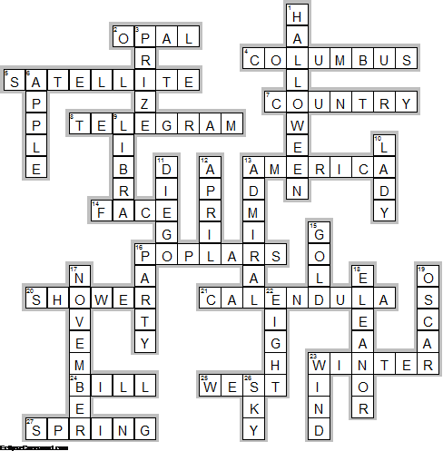
Across

2. OPAL—The birthstones for October are the tourmaline and the ... .
4. COLUMBUS—The USA celebrates ... Day on the second Monday of October.
5. SATELLITE—On October 4, 1957, the first artificial ... was launched by the Soviet Union.
7. COUNTRY—Ray Bradbury published a collection of short stories titled The October ... in 1955.
8. TELEGRAM—First transcontinental ... sent, October 24, 1861.
13. AMERICA—On October 12, 1492, Christopher Columbus landed in ... .
14. FACE—"The stillness of October gold Went out like beauty from a ... ." - E. A. Robinson
16. POPLARS—October’s ... are flaming torches lighting the way to winter. – Nova S. Blair
20. SHOWER—"October's the month When the smallest breeze Gives us a ... Of autumn leaves.
21. CALENDULA—The birth flower for October is the ... .
23. WINTER—When berries are many in October beaware a hard ... .
24. BILL—October 28th is ... Gates' Birthday.
25. WEST—"And so by the fifteenth century, on October 8, the Europeans were looking for a new place to try to get to, and they came up with a new concept: the ... ." october quote by Dave Barry
27. SPRING—“Chicago is an October sort of city even in ... .” ? Nelson Algren, Chicago: City on the Make

Down

1. HALLOWEEN—And the very best part of October is celebrating ..., because it’s the most amazing sugar-fueled holiday of all!
3. PRIZE—Alfred Nobel, Swedish philanthropist and founder of the Nobel ..., born October 21, 1833.
6. APPLE—On the 21st of October the United Kingdom celebrates ... Day.
9. LIBRA—The zodiac signs for October are ... (September 23 - October 22) and Scorpio (October 23 - November 21).
10. LADY—June has her blue days, jewels of delight, Set in the ivory of Alp-land white,— But October, October’s the ... o’ the year! Jessie Mackay
11. DIEGO—Kids Free in October BadgeDuring the entire month of October, kids eat, stay and play for free throughout San ... .
12. APRIL—October in the Northern Hemisphere is similar to ... in the Southern Hemisphere.
13. ADMIRAL—British ... Nelson was killed defeating the French and Spanish at Trafalgar, October 21, 1805.
15. GOLD—"The sweet calm sunshine of October, now Warms the low spot; upon its grassy mold The pur0ple oak-leaf falls; the birchen bough drops its bright spoil like arrow-heads of ... ." - William Cullen Bryant
16. PARTY—October gave a... . The leaves by hundreds came- The Chestnuts, Oaks, and Maples, And leaves of every name. The Sunshine spread a carpet, And everything was grand, Miss Weather led the dancing, Professor Wind the band." - George Cooper
17. NOVEMBER—If the October moon comes without frost, expect no frost till the moon of ... .
18. ELEANOR—... Roosevelt, wife of President Franklin D. Roosevelt, born October 11, 1884.
19. OSCAR—The Hunt For Red October is the only film with October in its title to win an ... .
22. EIGHT—October retained its name from the Greek and means "..."
23. WIND—Rain in October means ... in December.
26. SKY—October ... is a 1999 American biographical film directed by Joe Johnston, starring Jake Gyllenhaal, Chris Cooper, and Laura Dern.

