Кроссворд
September
для учащихся 8-11 классов,
влюбленных в английский язык

Автор:
Ольга Михайловна Степанова
учитель английского языка
МБОУ «Чадукасинская ООШ»
Красноармейского района
Чувашской Республики

2014

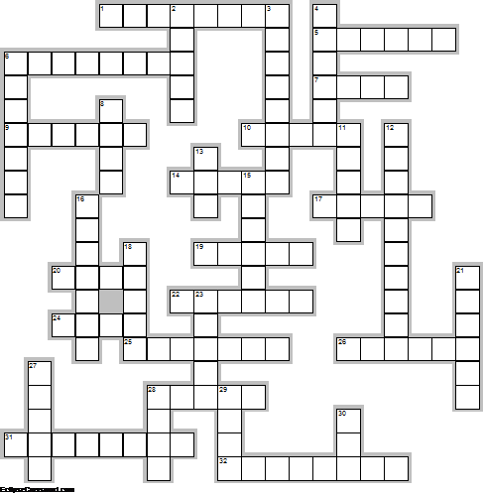

Across

1. The only film with ‘September’ in its title to win an Oscar was One Day In September about the murder of Israeli athletes at the 1972 ... . (8)
5. Cook in June and July, dish it out in ... and September. Sicilian Proverb (6)
6. September is the ninth month of the year in the Julian and Gregorian ... . (8)
7. Richard Saunders, the 17th century English astrologer and physician, said it was good to eat pomegranates and goats’ ... in September. (4)
9. On September 11, 2001, nearly 3,000 people were killed, 400 were police officers and firefighters, in the terrorist attacks at the World Trade ... in NYC, at the Pentagon building in Washington, D.C. (6)
10. The zodiac signs for September are Virgo (August 23 - September 22) and ... (September 23 - October 22) (5)
14. September 19th: The loveable Mickey ... made his first debut on this day in 1928! (5)
17. The mature ... is cooked in August and dished out in September. Sicilian Proverb (5)
19. We know that in September, we will wander through the warm winds of summer's wreckage. We will welcome summer's ... . Henry Rollins (5)
20. The Great ... of London occurred on September 2, 1666. (4)
22. The Anglo-Saxons also called this month Gerst Monath meaning ... month. (6)
24. Petra Linnea Paula Marklund better known as her stage ... September, is a Swedish singer-songwriter. (4)
25. September 23rd: In 1846, the planet ... was discovered! (7)
26. September 14th: On this day in 1814, the Star-Spangled ... was composed! (6)
28. What we learned on September 11 is that the unthinkable is now thinkable in the ... . John Ashcroft (5)
31. September starts on the same day of the week as ... every year. (8)
32. The only US president to have had a September ... was William Taft (president 1909-13). (8)

Down

2. September in the Northern Hemisphere is similar to ... in the Southern Hemisphere. (5)
3. The birthstone for September is the ... which means clear thinking. (8)
4. Rain in September is good for the ..., but poison to the vine growers. (6)
6. September is National ... Month as well as Cholesterol Awareness Month in America. (7)
8. September 9th is National Teddy ... Day. (4)
11. September brings ... and olives. Sicilian Proverb (5)
12. September 15th: Today in 1928, Alexander Fleming discovered the drug ... ! (10)
13. The 4th week of September is National ... Week in the USA. (3)
15. September is also a time when many students return to ...after the summer holiday in the Northern Hemisphere. (6)
16. Labor Day is the most well known ... in September and is observed every year on the first Monday in September. (7)
18. September kept its original name from the Roman calendar in which septem means “...” in Latin marking it as the seventh month. (5)
21. Wedded in September, widow or ... . Corsican Proverb (6)
23. September's birth flowers are the forget-me-not, morning glory and ... . (5)
27. "By all these lovely tokens September days are here, With summer’s best of weather And autumn’s best of ... ." - Helen Hunt Jackson (5)
28. Constitution ... takes place during the month of September in the USA. (4)
29. The poem "Mary had a Little ..." was published September 1st, 1830. (4)
30. September is often associated with fire because it was the month of the Roman ... Vulcan. (3)

Учащимся будет интересно работать с этим кроссвордом в онлайн режиме, так как он одновременно помещается в интернете по адресу:
file:///C:/Users/1/Desktop/september/September%20Crossword.html

Answers:

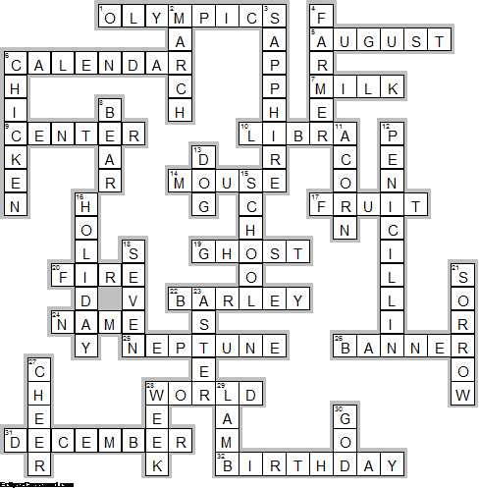
Across

1. OLYMPICS—The only film with ‘September’ in its title to win an Oscar was One Day In September about the murder of Israeli athletes at the 1972 ... .
5. AUGUST—Cook in June and July, dish it out in ... and September. Sicilian Proverb
6. CALENDAR—September is the ninth month of the year in the Julian and Gregorian ... .
7. MILK—Richard Saunders, the 17th century English astrologer and physician, said it was good to eat pomegranates and goats’ ... in September.
9. CENTER—On September 11, 2001, nearly 3,000 people were killed, 400 were police officers and firefighters, in the terrorist attacks at the World Trade ... in NYC, at the Pentagon building in Washington, D.C.
10. LIBRA—The zodiac signs for September are Virgo (August 23 - September 22) and ... (September 23 - October 22)
14. MOUSE—September 19th: The loveable Mickey ... made his first debut on this day in 1928!
17. FRUIT—The mature ... is cooked in August and dished out in September. Sicilian Proverb
19. GHOST—We know that in September, we will wander through the warm winds of summer's wreckage. We will welcome summer's ... . Henry Rollins
20. FIRE—The Great ... of London occurred on September 2, 1666.
22. BARLEY—The Anglo-Saxons also called this month Gerst Monath meaning ... month.
24. NAME—Petra Linnea Paula Marklund better known as her stage ... September, is a Swedish singer-songwriter.
25. NEPTUNE—September 23rd: In 1846, the planet ... was discovered!
26. BANNER—September 14th: On this day in 1814, the Star-Spangled ... was composed!
28. WORLD—What we learned on September 11 is that the unthinkable is now thinkable in the ... . John Ashcroft
31. DECEMBER—September starts on the same day of the week as ... every year.
32. BIRTHDAY—The only US president to have had a September ... was William Taft (president 1909-13).

Down

2. MARCH—September in the Northern Hemisphere is similar to ... in the Southern Hemisphere.
3. SAPPHIRE—The birthstone for September is the ... which means clear thinking.
4. FARMER—Rain in September is good for the ..., but poison to the vine growers.
6. CHICKEN—September is National ... Month as well as Cholesterol Awareness Month in America.
8. BEAR—September 9th is National Teddy ... Day.
11. ACORN—September brings ... and olives. Sicilian Proverb
12. PENICILLIN—September 15th: Today in 1928, Alexander Fleming discovered the drug ... !
13. DOG—The 4th week of September is National ... Week in the USA.
15. SCHOOL—September is also a time when many students return to ...after the summer holiday in the Northern Hemisphere.
16. HOLIDAY—Labor Day is the most well known ... in September and is observed every year on the first Monday in September.
18. SEVEN—September kept its original name from the Roman calendar in which septem means “...” in Latin marking it as the seventh month.
21. SORROW—Wedded in September, widow or ... . Corsican Proverb
23. ASTER—September's birth flowers are the forget-me-not, morning glory and ... .
27. CHEER—"By all these lovely tokens September days are here, With summer’s best of weather And autumn’s best of ... ." - Helen Hunt Jackson
28. WEEK—Constitution ... takes place during the month of September in the USA.
29. LAMB—The poem "Mary had a Little ..." was published September 1st, 1830.
30. GOD—September is often associated with fire because it was the month of the Roman ... Vulcan.

