Кроссворд
November
для учащихся 8-11 классов,
влюбленных в английский язык

Автор:
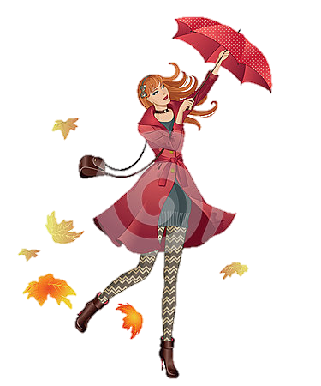
Ольга Михайловна Степанова
учитель
английского языка
МБОУ «Чадукасинская ООШ»
Красноармейского района
Чувашской Республики

Across

2. My Home Page November comes And November goes, With the last red ... And the first white snows. From the poem "November comes" by Clyde Watson (7)
3. ... and Sagittarius are the astrological signs for November. (7)
6. Buy ... Day is observed in November in some countries. (7)
7. "The wild November come at last Beneath a veil of rain; The night winds blows its folds aside, Her face is full of pain. The latest of her race, she takes The Autumn's vacant ...: She has but one short moon to live, And she must live alone." - Richard Henry Stoddard, November (6)
8. "November always seemed to me the ... of the year." - Emily Dickinson (6)
10. If months were marked by colors, November in New ... would be colored gray. Madeleine M. Kunin (7)
11. Cold wind where your voice was, Tears, tears where my heart was, And ever with me, Child, ever with me, Silence where ... was. From the poem "November" by Walter De La Mare (4)
13. THERE is wind where the rose was, Cold rain where sweet grass was, And clouds like sheep Stream o'er the steep Grey skies where the ... was. From the poem "November" by Walter De La Mare (4)
14. ... World Day when it is important to greet ten people on this day for peace is on the 21st of November. (5)
16. The flower for the month of November is the ... . (13)
21. A warm November is the sign of a bad ... . (6)
24. THANKSGIVING is celebrated on the fourth ... in the month. (8)
25. Observed during the second week in November, National Split ... Soup Week celebrates exactly what you’d think it does: that yummy green potage. (3)
26. "No shade, no shine, no butterflies, no bees, No fruits, no flowers, no leaves, no ...-- November! "Thomas Hood (5)
27. From a Sir Walter Scott poem: "November sky is chill and drear , November ... is red and sear" (4)

Down

1. "Dull November brings the ... , Then the leaves are whirling fast." - Sara Coleridge (5)
2. The Anglo-Saxons referred to November as the 'wind month' and the '... month' - probably because this is the month they killed their animals for food. (5)
3. November woods are bare and still; November days are clear and bright; Each noon burns up the morning's chill, The morning's ... is gone by night. Helen Hunt Jackson (4)
4. On the 30th of November Robert Louis Stevenson , author of 'Treasure ... ' was born. (6)
5. ... in November means winter will be late in coming and going. (7)
9. November the fifth is a special day in England - Guy Fawkes Day and it is also known as ... Night. (7)
12. In 1863, Abraham Lincoln, decleared the last Thursdayof November to be a National Day of ... . (12)
13. "All in November's soaking mist We stand and prune the naked tree, While all our ... and interest Seem quenched in the blue-nosed misery." - Ruth Pitter (4)
15. The end of November is very significant for ... because of St Andrews Day which is celebraated on the 30th of this month. (8)
17. November was the ninth month of the ancient Roman calendar and has retained its name from the Latin novem meaning ... . (4)
18. November is National Pomegranate ... in the USA. (5)
19. November in the Northern Hemisphere is similar to ... in the Southern Hemisphere. (3)
20. The US and ... celebrate the end of WWI every year on November 11. (6)
22. “If there’s ... in November to bear a duck, There’ll be nothing after but sludge and muck,” (Old weather saying). (3)
23. It is the orange-yellow ... that is the traditional birthstone for November. (5)

Учащимся будет интересно работать с этим кроссвордом в онлайн режиме, так как он одновременно помещается в интернете по адресу:
file:///C:/Users/1/Desktop/november%20crossword.html

Answers
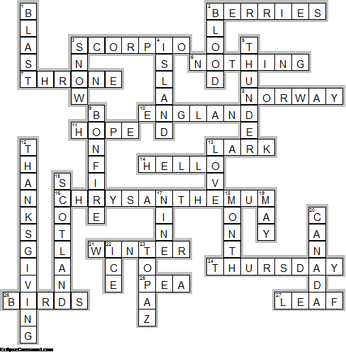

Across

2. BERRIES—My Home Page November comes And November goes, With the last red ... And the first white snows. From the poem "November comes" by Clyde Watson
3. SCORPIO—... and Sagittarius are the astrological signs for November.
6. NOTHING—Buy ... Day is observed in November in some countries.
7. THRONE—"The wild November come at last Beneath a veil of rain; The night winds blows its folds aside, Her face is full of pain. The latest of her race, she takes The Autumn's vacant ...: She has but one short moon to live, And she must live alone." - Richard Henry Stoddard, November
8. NORWAY—"November always seemed to me the ... of the year." - Emily Dickinson
10. ENGLAND—If months were marked by colors, November in New ... would be colored gray. Madeleine M. Kunin
11. HOPE—Cold wind where your voice was, Tears, tears where my heart was, And ever with me, Child, ever with me, Silence where ... was. From the poem "November" by Walter De La Mare
13. LARK—THERE is wind where the rose was, Cold rain where sweet grass was, And clouds like sheep Stream o'er the steep Grey skies where the ... was. From the poem "November" by Walter De La Mare
14. HELLO—... World Day when it is important to greet ten people on this day for peace is on the 21st of November.
16. CHRYSANTHEMUM—The flower for the month of November is the ... .
21. WINTER—A warm November is the sign of a bad ... .
24. THURSDAY—THANKSGIVING is celebrated on the fourth ... in the month.
25. PEA—Observed during the second week in November, National Split ... Soup Week celebrates exactly what you’d think it does: that yummy green potage.
26. BIRDS—"No shade, no shine, no butterflies, no bees, No fruits, no flowers, no leaves, no ...-- November! "Thomas Hood
27. LEAF—From a Sir Walter Scott poem: "November sky is chill and drear , November ... is red and sear"

Down

1. BLAST—"Dull November brings the ... , Then the leaves are whirling fast." - Sara Coleridge
2. BLOOD—The Anglo-Saxons referred to November as the 'wind month' and the '... month' - probably because this is the month they killed their animals for food.
3. SNOW—November woods are bare and still; November days are clear and bright; Each noon burns up the morning's chill, The morning's ... is gone by night. Helen Hunt Jackson
4. ISLAND—On the 30th of November Robert Louis Stevenson , author of 'Treasure ... ' was born.
5. THUNDER—... in November means winter will be late in coming and going.
9. BONFIRE—November the fifth is a special day in England - Guy Fawkes Day and it is also known as ... Night.
12. THANKSGIVING—In 1863, Abraham Lincoln, decleared the last Thursdayof November to be a National Day of ... .
13. LOVE—"All in November's soaking mist We stand and prune the naked tree, While all our ... and interest Seem quenched in the blue-nosed misery." - Ruth Pitter
15. SCOTLAND—The end of November is very significant for ... because of St Andrews Day which is celebraated on the 30th of this month.
17. NINE—November was the ninth month of the ancient Roman calendar and has retained its name from the Latin novem meaning ... .
18. MONTH—November is National Pomegranate ... in the USA.
19. MAY—November in the Northern Hemisphere is similar to ... in the Southern Hemisphere.
20. CANADA—The US and ... celebrate the end of WWI every year on November 11.
22. ICE—“If there’s ... in November to bear a duck, There’ll be nothing after but sludge and muck,” (Old weather saying).
23. TOPAZ—It is the orange-yellow ... that is the traditional birthstone for November.

