Кроссворд
July
для учащихся 8-11 классов,
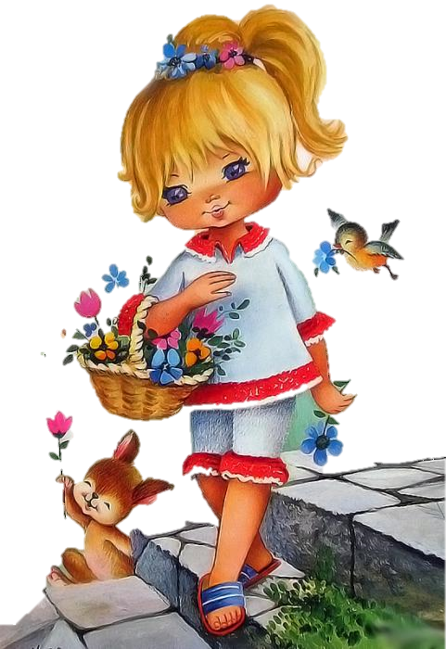
влюбленных в английский язык

Автор:
Ольга Михайловна Степанова

учитель английского
языка
МБОУ «Чадукасинская ООШ»
Красноармейского района
Чувашской Республики

2014

Across

2. In July, store the grain under the ... . Sicilian Proveerb (3)
4. Do not sell ... in July. Italian Proverb (3)
5. Cook in June and July, dish it out in ... and September. Sicilian Proverb (6)
8. Those who in July are wed, Must labor for their daily ... . Proverb (5)
10. The ... is the gem for July. (4)
11. U.S. astronaut Neil A. Armstrong became the first person to walk on the ..., July 20, 1969. (4)
13. It is sometimes called the ... month because the grass dries out due to a lack of rain and can be made into hay. (3)
16. Previously July had been called Quintilis which means fifth month in ... . (5)
17. July is similar to ... in the Southern Hemisphere. (7)
20. Prepare the sickles in May, use the sickles in June, and in July carry the sickles to the tool ... . Sicilian Proverb (4)
22. ... in July is good for nothing. Corsican Proverb (5)
23. If the first of July, it be rainy ... , ‘Twill rain, more or less, for four weeks together. Proverb (7)
25. April, as you see me; May, as I stay; June, as I am; by July, let ... fly. Sicilian Proverb (10)
27. Bow-wow dandy fly, Brew no ... in July. Proverb (4)
28. Midday late July Black walnuts touch the ... Timber Creek in dry By Robb A. Kopp (3)

Down

1. The zodiac signs for July are ... (June 21 - July 22) and Leo (July 23 - August 22) (6)
3. Sometimes the hot, long days of July are called the "... days of summer". (3)
6. Fog in March, ... in July (7)
7. No one's gonna give a damn in July if you lost a game in ... . Earl Weaver (5)
8. Don't worry, the fans don't start ... until July. Earl Weaver (6)
9. The month of July is named after Julius Caesar by a decision of the Roman Senate in 44BC as July was the month of his ... . (5)
11. In all parts of the UK July is on average the warmest ... of the year. (5)
12. A swarm in May is worth a load of hay; a swarm in June is worth a silver spoon; but a swarm in July is not worth a ... . Latin Proverb (3)
14. Hot July brings cooling showers, ... and gillyflowers. (8)
15. The birth flowers for July are the ... or the Water Lily . (8)
18. Whatever July and August do not boil, ... cannot fry. Proverb (9)
19. July starts on the same weekday as ... every year. (5)
21. The constancy of women is like ... in July. Sicilian Proverb (4)
24. The color for July is ... . (3)
26. As today.. tis 4th of July May Blessings come before Your ... All Praise and Glory be to God Almighty (4)

Учащимся будет интересно работать с этим кроссвордом в онлайн режиме, так как он одновременно помещается в интернете по адресу:
file:///C:/Users/1/Desktop/july%20crossword/July%20Crossword.html

Answers:
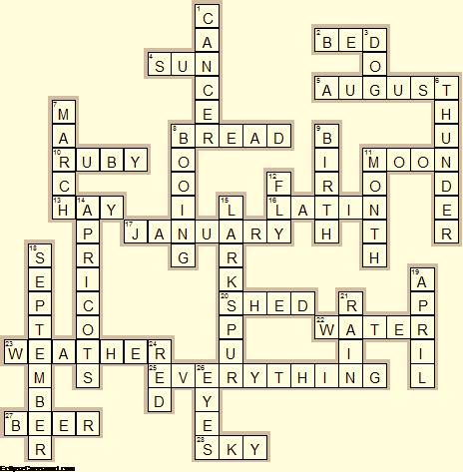
Across

2. BED—In July, store the grain under the ... . Sicilian Proveerb
4. SUN—Do not sell ... in July. Italian Proverb
5. AUGUST—Cook in June and July, dish it out in ... and September. Sicilian Proverb
8. BREAD—Those who in July are wed, Must labor for their daily ... . Proverb
10. RUBY—The ... is the gem for July.
11. MOON—U.S. astronaut Neil A. Armstrong became the first person to walk on the ..., July 20, 1969.
13. HAY—It is sometimes called the ... month because the grass dries out due to a lack of rain and can be made into hay.
16. LATIN—Previously July had been called Quintilis which means fifth month in ... .
17. JANUARY—July is similar to ... in the Southern Hemisphere.
20. SHED—Prepare the sickles in May, use the sickles in June, and in July carry the sickles to the tool ... . Sicilian Proverb
22. WATER—... in July is good for nothing. Corsican Proverb
23. WEATHER—If the first of July, it be rainy ... , ‘Twill rain, more or less, for four weeks together. Proverb
25. EVERYTHING—April, as you see me; May, as I stay; June, as I am; by July, let ... fly. Sicilian Proverb
27. BEER—Bow-wow dandy fly, Brew no ... in July. Proverb
28. SKY—Midday late July Black walnuts touch the ... Timber Creek in dry By Robb A. Kopp

Down

1. CANCER—The zodiac signs for July are ... (June 21 - July 22) and Leo (July 23 - August 22)
3. DOG—Sometimes the hot, long days of July are called the "... days of summer".
6. THUNDER—Fog in March, ... in July
7. MARCH—No one's gonna give a damn in July if you lost a game in ... . Earl Weaver
8. BOOING—Don't worry, the fans don't start ... until July. Earl Weaver
9. BIRTH—The month of July is named after Julius Caesar by a decision of the Roman Senate in 44BC as July was the month of his ... .
11. MONTH—In all parts of the UK July is on average the warmest ... of the year.
12. FLY—A swarm in May is worth a load of hay; a swarm in June is worth a silver spoon; but a swarm in July is not worth a ... . Latin Proverb
14. APRICOTS—Hot July brings cooling showers, ... and gillyflowers.
15. LARKSPUR—The birth flowers for July are the ... or the Water Lily .
18. SEPTEMBER—Whatever July and August do not boil, ... cannot fry. Proverb
19. APRIL—July starts on the same weekday as ... every year.
21. RAIN—The constancy of women is like ... in July. Sicilian Proverb
24. RED—The color for July is ... .
26. EYES—As today.. tis 4th of July May Blessings come before Your ... All Praise and Glory be to God Almighty

