Кроссворд
August
для учащихся 8-11 классов,
влюбленных в английский язык
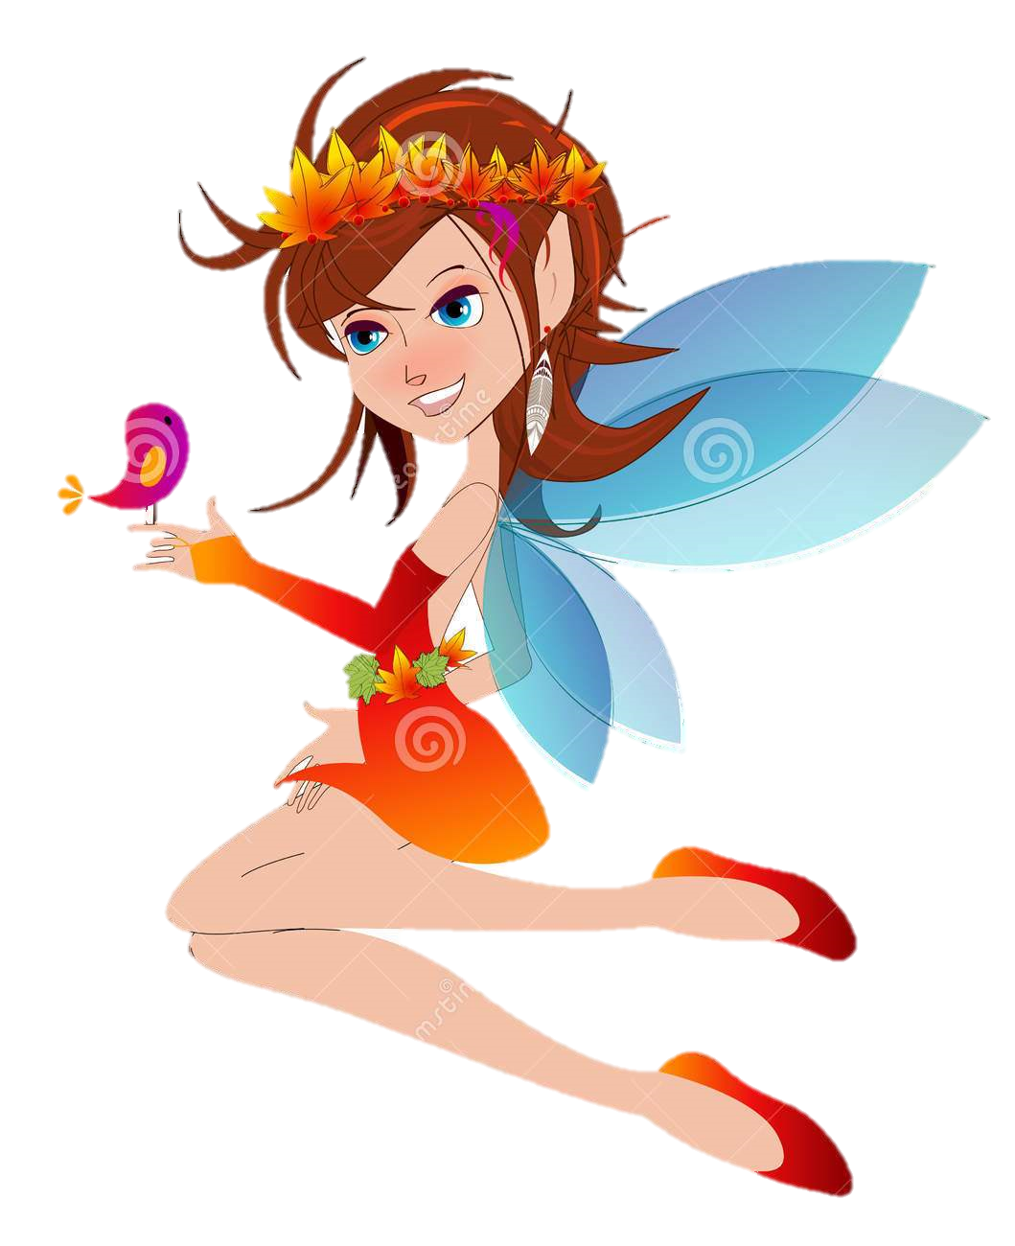

Автор:
Ольга Михайловна Степанова

учитель английского
языка
МБОУ «Чадукасинская ООШ»
Красноармейского района
Чувашской Республики

2014

Across

2. Many cultures call this month the ... month. (7)
5. Babies born in August are said to have extraordinary ... . (6)
7. In the Southern Hemisphere, August is the seasonal equivalent of ... in the Northern Hemisphere. (8)
8. When Julius Caesar reformed the ...August became the eighth month. (8)
9. "The Teahouse of the August ...' won both a Tony and a Pulitzer Prize. (4)
10. August bears the burden, September the ... . (5)
11. "I'm as corny as ... in August" is a line from a Rodgers and Hammerstein musical. (6)
13. August, the summer's last messenger of misery, is a hollow ... . Henry Rollins (5)
16. The zodiac signs for August are ... (July 23 - August 22) and Virgo (August 23 - September 22) (3)
17. August is said to be ... Happens Month in the USA. (9)
20. August ripens, ... gathers in. (9)
22. In August most of Europe goes on ... . Tony Visconti (7)
24. The flowers of August are gladiolus and ... . (5)
26. If the twenty-fourth of August be fair and clear, Then hope for a prosperous autumn that ... . (4)
28. In the United States August is National Goat ... Month. (6)

Down

1. When it rains in August, it rains honey and ... . (4)
3. Christopher Columbus set sail from Palos, Spain, on his first voyage across the ..., August 3, 1492. (8)
4. August babies are more likely to struggle at ... . (6)
5. The gemstones for August are peridot and .. . (8)
6. Poet's PagePoemsCommentsStatsBiographyMessage to the poetShare on FacebookShare on Twitter Poems by Jade Leven : 14 / 149 « As Long As I'm AroundBeautiful Nightmare (a song) » August August is the best month of the year we reflect on what's happened since we last stood here ... in our hair and our feet in the sand I wouldn't expect anyone else to understand. By Jade Leven (4)
12. August rain gives ..., wine, and saffron (5)
13. Kids born in August are sad to be talanted in the ... . (4)
14. Remember to be gentle with yourself and others. We are all children of chance and none can say why some fields will blossom while others lay brown beneath the August ... . Kent Nerburn (3)
15. The Philippines celebrates August as the "Month of Philippine ..." (9)
18. August is the eighth month, renamed by the Romans from Sextilis', meaning sixth, to honor their ... , Augustus (7)
19. A wet August never brings ... . (6)
21. August in Roman times was the sixth ... . (5)
23. If the first week of August be warm, the ... will be white and long. (6)
25. Edinburgh Festival is an internationally famous arts festival that takes ... during August. (5)
27. She dreams of August in the singing morning.. When all the little things come out to play, When every spider's ... is sticky, lacy, And every kid will have the pinkest day. By Donna Earle (3)

Учащимся будет интересно работать с этим кроссвордом в онлайн режиме, так как он одновременно помещается в интернете по адресу:
file:///C:/Users/1/Desktop/august%20crossword/August%20Crossword.html

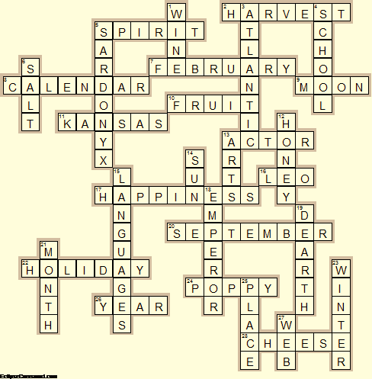

Across

2. HARVEST—Many cultures call this month the ... month.
5. SPIRIT—Babies born in August are said to have extraordinary ... .
7. FEBRUARY—In the Southern Hemisphere, August is the seasonal equivalent of ... in the Northern Hemisphere.
8. CALENDAR—When Julius Caesar reformed the ...August became the eighth month.
9. MOON—"The Teahouse of the August ...' won both a Tony and a Pulitzer Prize.
10. FRUIT—August bears the burden, September the ... .
11. KANSAS—"I'm as corny as ... in August" is a line from a Rodgers and Hammerstein musical.
13. ACTOR—August, the summer's last messenger of misery, is a hollow ... . Henry Rollins
16. LEO—The zodiac signs for August are ... (July 23 - August 22) and Virgo (August 23 - September 22)
17. HAPPINESS—August is said to be ... Happens Month in the USA.
20. SEPTEMBER—August ripens, ... gathers in.
22. HOLIDAY—In August most of Europe goes on ... . Tony Visconti
24. POPPY—The flowers of August are gladiolus and ... .
26. YEAR—If the twenty-fourth of August be fair and clear, Then hope for a prosperous autumn that ... .
28. CHEESE—In the United States August is National Goat ... Month.

Down

1. WINE—When it rains in August, it rains honey and ... .
3. ATLANTIC—Christopher Columbus set sail from Palos, Spain, on his first voyage across the ..., August 3, 1492.
4. SCHOOL—August babies are more likely to struggle at ... .
5. SARDONYX—The gemstones for August are peridot and .. .
6. SALT—Poet's PagePoemsCommentsStatsBiographyMessage to the poetShare on FacebookShare on Twitter Poems by Jade Leven : 14 / 149 « As Long As I'm AroundBeautiful Nightmare (a song) » August August is the best month of the year we reflect on what's happened since we last stood here ... in our hair and our feet in the sand I wouldn't expect anyone else to understand. By Jade Leven
12. HONEY—August rain gives ..., wine, and saffron
13. ARTS—Kids born in August are sad to be talanted in the ... .
14. SUN—Remember to be gentle with yourself and others. We are all children of chance and none can say why some fields will blossom while others lay brown beneath the August ... . Kent Nerburn
15. LANGUAGES—The Philippines celebrates August as the "Month of Philippine ..."
18. EMPEROR—August is the eighth month, renamed by the Romans from Sextilis', meaning sixth, to honor their ... , Augustus
19. DEARTH—A wet August never brings ... .
21. MONTH—August in Roman times was the sixth ... .
23. WINTER—If the first week of August be warm, the ... will be white and long.
25. PLACE—Edinburgh Festival is an internationally famous arts festival that takes ... during August.
27. WEB—She dreams of August in the singing morning.. When all the little things come out to play, When every spider's ... is sticky, lacy, And every kid will have the pinkest day. By Donna Earle

