Кроссворд
December
для учащихся 8-11 классов,
влюбленных в английский язык

Автор:
Ольга Михайловна Степанова

учитель английского
языка
МБОУ «Чадукасинская ООШ»
Красноармейского района
Чувашской Республики

2014

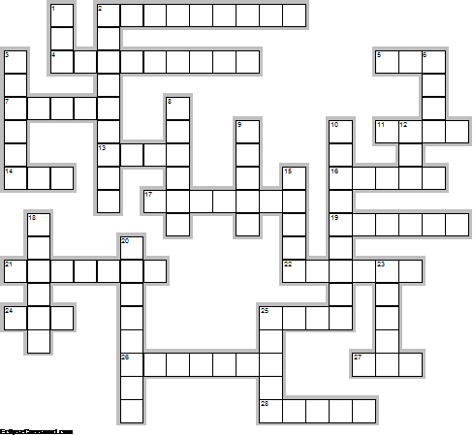
Across

2. Zodiac signs for December are Sagittarius (November 22 - December 21) and ... (December 22 - January 19). (9)
4. The birth flower of December is the ... . (9)
5. “Will you love me in December as you do in May, Will you love me in the good old fashioned ...? When my hair has all turned gray, Will you kiss me then and say, That you love me in December as you do in May?” BaylorBound James Walker quotes (3)
7. God gave us memory so that we might have ... in December. James M. Barrie (5)
11. We are nearer to Spring Than we were in September,' I heard a ... sing In the dark of December. Oliver Herford (4)
13. The sun that brief December day Rose cheerless over hills of gray, And, darkly circled, gave at noon A sadder light than waning ... . John Greenleaf Whittier (4)
14. Isaac Newton, English scientist who discovered the ... of gravitation, born December 25,1642. (3)
16. In December ... Prizes are awarded. (5)
17. Thunder in December presages fine ... . (7)
19. “Bright as ... in December” (6)
21. Iceland became a self-governing ... united with Denmark, December 1, 1918. (7)
22. December 17, 1903 the Wright Brothers made their first ... . (6)
24. 28 ecember is widely regarded as the unluckiest ... of the year, so don't do anything and certainly don't start anything on this day! (3)
25. As soon Seek roses in December, ice in ... . Lord Byron Quote (4)
26. If cold December gave you birth, The month of snow and ice and mirth, Place on your hand a Turquoise blue, ... will bless whate'er you do. Unknown author (7)
27. December cold, with snow, brings ... everywhere. (3)
28. December is the only month when ... comeswith lots ofpresents. (5)

Down

1. The name December comes from the Latin decem for “...”. (3)
2. On December 25th ... is celebrated by Christians as the birthday of Jesus Christ (9)
3. Remember, Remember, the ... of December! (6)
6. Go ask December Who Illustrates the bustling cities in green,gold and red? Go ask December What do you feel when the ... comes to an end? (4)
8. A mild December precedes a cold snap later in the ... . (6)
9. How much can come, how much can go When the December moon is bright, What worlds of play we’ll never know Sleeping away the cold white ... After a fall of snow. -May Sarton (5)
10. The three birthstones associated with December are ... , Zircon, and Turquoise (9)
12. ... in November brings mud in December. (3)
15. Marry on December third for all the ... you ever heard. (5)
18. December is the ... of the months. Unknown author (6)
20. ... Ludwig van Beethoven born December 16, 1770. (8)
23. The birth flower for December is ... . (5)
25. A Better December by Steve Estes, playful and tiny, this illustrated work would be a good gift for your unbelieving friends as it gently introduces ... during a month when they are more receptive. (5)

Учащимся будет интересно работать с этим кроссвордом в онлайн режиме, так как он одновременно помещается в интернете по адресу:
file:///C:/Users/1/Desktop/december%20crossword/DECEMBER%20crossword.html

Answers
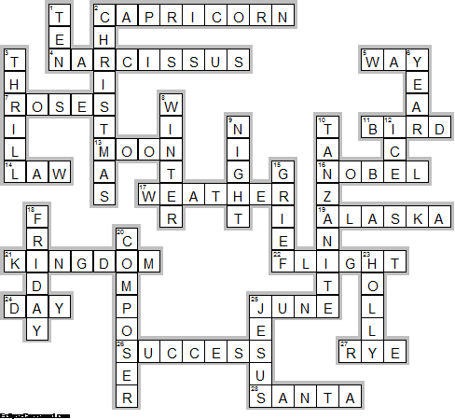
Across

2. CAPRICORN—Zodiac signs for December are Sagittarius (November 22 - December 21) and ... (December 22 - January 19).
4. NARCISSUS—The birth flower of December is the ... .
5. WAY—“Will you love me in December as you do in May, Will you love me in the good old fashioned ...? When my hair has all turned gray, Will you kiss me then and say, That you love me in December as you do in May?” BaylorBound James Walker quotes
7. ROSES—God gave us memory so that we might have ... in December. James M. Barrie
11. BIRD—We are nearer to Spring Than we were in September,' I heard a ... sing In the dark of December. Oliver Herford
13. MOON—The sun that brief December day Rose cheerless over hills of gray, And, darkly circled, gave at noon A sadder light than waning ... . John Greenleaf Whittier
14. LAW—Isaac Newton, English scientist who discovered the ... of gravitation, born December 25,1642.
16. NOBEL—In December ... Prizes are awarded.
17. WEATHER—Thunder in December presages fine ... .
19. ALASKA—“Bright as ... in December”
21. KINGDOM—Iceland became a self-governing ... united with Denmark, December 1, 1918.
22. FLIGHT—December 17, 1903 the Wright Brothers made their first ... .
24. DAY—28 ecember is widely regarded as the unluckiest ... of the year, so don't do anything and certainly don't start anything on this day!
25. JUNE—As soon Seek roses in December, ice in ... . Lord Byron Quote
26. SUCCESS—If cold December gave you birth, The month of snow and ice and mirth, Place on your hand a Turquoise blue, ... will bless whate'er you do. Unknown author
27. RYE—December cold, with snow, brings ... everywhere.
28. SANTA—December is the only month when ... comeswith lots ofpresents.

Down

1. TEN—The name December comes from the Latin decem for “...”.
2. CHRISTMAS—On December 25th ... is celebrated by Christians as the birthday of Jesus Christ
3. THRILL—Remember, Remember, the ... of December!
6. YEAR—Go ask December Who Illustrates the bustling cities in green,gold and red? Go ask December What do you feel when the ... comes to an end?
8. WINTER—A mild December precedes a cold snap later in the ... .
9. NIGHT—How much can come, how much can go When the December moon is bright, What worlds of play we’ll never know Sleeping away the cold white ... After a fall of snow. -May Sarton
10. TANZANITE—The three birthstones associated with December are ... , Zircon, and Turquoise
12. ICE—... in November brings mud in December.
15. GRIEF—Marry on December third for all the ... you ever heard.
18. FRIDAY—December is the ... of the months. Unknown author
20. COMPOSER—... Ludwig van Beethoven born December 16, 1770.
23. HOLLY—The birth flower for December is ... .
25. JESUS—A Better December by Steve Estes, playful and tiny, this illustrated work would be a good gift for your unbelieving friends as it gently introduces ... during a month when they are more receptive.

