Кроссворд
May
для учащихся 8-11 классов,
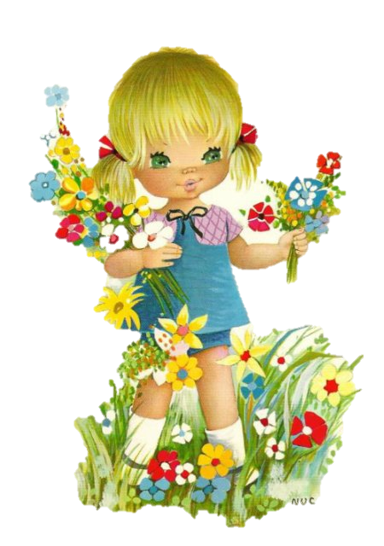
влюбленных в английский язык

Автор:
Ольга Михайловна Степанова

учитель английского
языка
МБОУ «Чадукасинская ООШ»
Красноармейского района
Чувашской Республики

2014
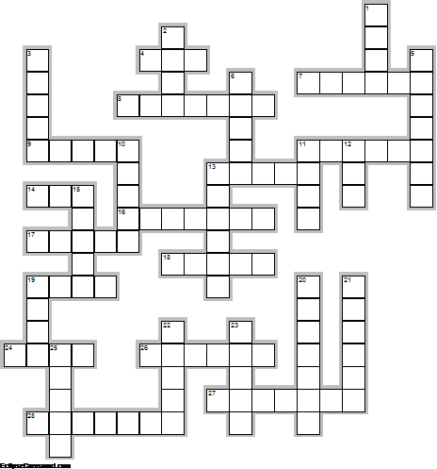
Across

4. A wet May makes a big load of ... . (3)
7. The ... comes in April, and stays the month of May; sings a song at midsummer, and then goes away. Traditional Proverb (6)
8. A cold ..., a warm May. - Welsh Proverb (7)
9. May was considered an unlucky ... particularly for getting married. (5)
11. May's a month of happy sounds, The hum of buzzing bees, The chirp of little baby birds And the song of a gentle ... . (6)
13. “As it fell upon a day In the merry month of May, Sitting in a pleasant ... Which a grove of myrtles made.” Richard Barnfield (5)
14. First thing in the morning on May 1st, young girls used to rush out into the garden to wash their faces in the May ... to remove freckles, spots and pimples. (3)
16. The birthstone for May is the ... . (7)
17. If you still have ... in the month of May, you'll have it the entire year. Sicilian Proverb (5)
18. "May! ... of blossoms, And fulfilling flowers, With what pretty music Shall we charm the hours?" Lord Edward Thurlow, May (5)
19. ... in May, heat in June makes harvest come right soon. (4)
24. Those who bathe in May will soon be laid in ... . (4)
26. April makes the flowers and the beauty, but May gets all the ... . Sicilian Proverb (6)
27. "You are as welcome as the ... in May." - Charles Macklin (7)
28. "When April steps aside for May, Like diamonds all the rain-drops glisten; Fresh ... open every day: To some new bird each hour we listen." - Lucy Larcom (7)

Down

1. Flowers before May bring bad ... . - Welsh Proverb (4)
2. A cold May is kindly and fills the ... finely. (4)
3. Never buy a ... in May orwash blankets. (5)
5. May is named after the Greek ..., Maia. (7)
6. He was as ... as is the month of May. Geoffrey Chaucer (5)
10. Hebe's here, May is here! The air is fresh and sunny; And the miser-bees are busy Hoarding golden ... . Thomas Bailey Aldric (5)
11. A swarm of ... in May is worth a load of hay. (4)
12. In Britain , as in most parts of Western Europe, May day marked the ... of the harsh winter months, welcomed the beginning of Summer. (3)
13. Cats born in May will not be good rodent catchers and even worse, will bring ... into the home. Superstition (6)
15. "Rough ... do shake the darling buds of May." - William Shakespeare (5)
19. April and May make ... for the whole year. Spanish Proverb (4)
20. If you wash a ... in May you will washone of the family away. (7)
21. Among the changing months, May stands confest The sweetest, and in fairest ... dressed. James Thomson (6)
22. The Anglo-Saxon name for may was Tri-Milchi, in recognition of the fact that with the lush new ... cows could be milked three times a day. (5)
23. The flower for May is the ... of the Valley. (5)
25. "Sweet ... showers Do spring May flowers." - Thomas Tusser (5)

Учащимся будет интересно работать с этим кроссвордом в онлайн режиме, так как он одновременно помещается в интернете по адресу:
file:///C:/Users/1/Desktop/May%20CROSSWORD.html

Answers
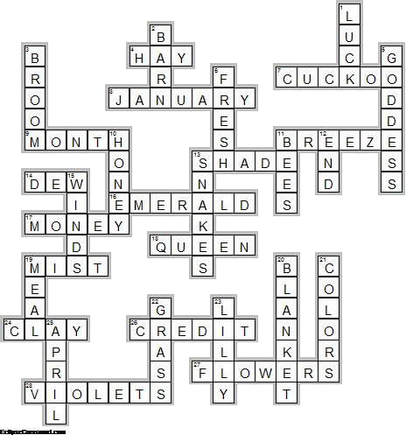
Across

4. HAY—A wet May makes a big load of ... .
7. CUCKOO—The ... comes in April, and stays the month of May; sings a song at midsummer, and then goes away. Traditional Proverb
8. JANUARY—A cold ..., a warm May. - Welsh Proverb
9. MONTH—May was considered an unlucky ... particularly for getting married.
11. BREEZE—May's a month of happy sounds, The hum of buzzing bees, The chirp of little baby birds And the song of a gentle ... .
13. SHADE—“As it fell upon a day In the merry month of May, Sitting in a pleasant ... Which a grove of myrtles made.” Richard Barnfield
14. DEW—First thing in the morning on May 1st, young girls used to rush out into the garden to wash their faces in the May ... to remove freckles, spots and pimples.
16. EMERALD—The birthstone for May is the ... .
17. MONEY—If you still have ... in the month of May, you'll have it the entire year. Sicilian Proverb
18. QUEEN—"May! ... of blossoms, And fulfilling flowers, With what pretty music Shall we charm the hours?" Lord Edward Thurlow, May
19. MIST—... in May, heat in June makes harvest come right soon.
24. CLAY—Those who bathe in May will soon be laid in ... .
26. CREDIT—April makes the flowers and the beauty, but May gets all the ... . Sicilian Proverb
27. FLOWERS—"You are as welcome as the ... in May." - Charles Macklin
28. VIOLETS—"When April steps aside for May, Like diamonds all the rain-drops glisten; Fresh ... open every day: To some new bird each hour we listen." - Lucy Larcom

Down

1. LUCK—Flowers before May bring bad ... . - Welsh Proverb
2. BARN—A cold May is kindly and fills the ... finely.
3. BROOM—Never buy a ... in May orwash blankets.
5. GODDESS—May is named after the Greek ..., Maia.
6. FRESH—He was as ... as is the month of May. Geoffrey Chaucer
10. HONEY—Hebe's here, May is here! The air is fresh and sunny; And the miser-bees are busy Hoarding golden ... . Thomas Bailey Aldric
11. BEES—A swarm of ... in May is worth a load of hay.
12. END—In Britain , as in most parts of Western Europe, May day marked the ... of the harsh winter months, welcomed the beginning of Summer.
13. SNAKES—Cats born in May will not be good rodent catchers and even worse, will bring ... into the home. Superstition
15. WINDS—"Rough ... do shake the darling buds of May." - William Shakespeare
19. MEAL—April and May make ... for the whole year. Spanish Proverb
20. BLANKET—If you wash a ... in May you will washone of the family away.
21. COLORS—Among the changing months, May stands confest The sweetest, and in fairest ... dressed. James Thomson
22. GRASS—The Anglo-Saxon name for may was Tri-Milchi, in recognition of the fact that with the lush new ... cows could be milked three times a day.
23. LILLY—The flower for May is the ... of the Valley.
25. APRIL—"Sweet ... showers Do spring May flowers." - Thomas Tusser

