Кроссворд
June
для учащихся 8-11 классов,
влюбленных в английский язык

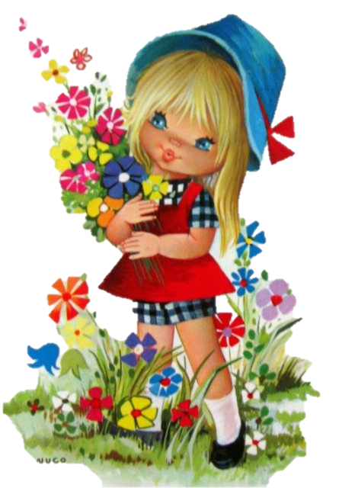

Автор:
Ольга Михайловна Степанова

учитель английского
языка
МБОУ «Чадукасинская ООШ»
Красноармейского района
Чувашской Республики

2014

Across

1. June is a beautiful month to sing And listen to loud wedding bells ring In this long awaited summer month The mood of ... is all June fronts. By Sylvia Chidi (9)
7. “It is the month of June, The month of leaves and roses, When pleasant sights salute the eyes, And pleasant scents the ... .” Nathaniel Parker Willis (5)
9. June in the Northern Hemisphere is similar to the month of ... in the Southern Hemisphere. (8)
11. Each year, the Americans celebrate June Dairy Month to honor America’s dairy farm families and the wholesome, nutritious ... they produce. (4)
12. poet Valerie DohrenPoet's PagePoemsCommentsStatsBiographyMessage to the poetShare on FacebookShare on Twitter Poems by Valerie Dohren : 126 / 244 « MorningMy Muse Returned To Stay » My Lovely June O come sweet June, my lovely June The month when first the roses bloom - A wondrous, colourful display By sunlight kissed throughout the ..., So chasing all my cares away. By Valerie Dohren (3)
14. "June brings ..., lilies, roses, Fills the children's hands with posies." - Sara Coleridge (6)
16. “Spring being a tough act to follow, ... created June.” Al Bernstein (3)
18. June is ... month in the Lower mainland in British Columbia, Canada (4)
20. “There are two seasons in Scotland: June and ... .” Billy Connolly (6)
21. At different times during June there are ceremonies called 'well dressings': springs and wells of fresh ... that come from the underground streams have always seem to be magical things, so some wells are honoured with decorations. (5)
22. “If a June night could talk, it would probably boast that it invented ... .” Bern Williams (7)
25. June is the month of dreams, I think; Gardeners watch their roses, pink. Birds leave the ... and try their wings And songbirds learn just how to sing. By Jooan Adams Burchell (4)
26. "A swarm of bees in May is worth a load of hay. A swarm of bees in June is worth a silver ... . A swarm of bees in July is not worth a fly." - English Saying (5)
28. “It is better to be a young June-bug than an old bird of ... .” Mark Twain (8)
31. "I wonder what it would be like to live in a ... where it was always June." - L. M. Montgomery (5)
33. Married in the month of Roses - June Life will be one long ... . (9)

Down

2. Dear June, I was so sad to hear You had fallen in a ... . Not only did you hurt yourself but I bet you felt a fool. By Ruth Street (4)
3. “As soon / Seek roses in December - ... in June. Lord Byron (3)
4. Some people consider June good ... to be married in this month. (4)
5. June damp and warm, does the farmer no ... . (4)
6. “To read a poem in January is as lovely as to go for a ... in June” Jean-Paul Sartre (4)
8. The June full moon is nicknamed the "... Moon" (10)
10. I am so excited that once again it is June When the sun is bright and the ... all sing in tune. By Randy McClave (5)
13. The JUNE BUG also known as June ..., is the name for several large beetles seen in the United States during May and June and they are usually seen at night, when the light attracts them. (6)
14. “There are three good reasons to be a ... - June, July, and August.” An Old Joke (7)
15. June ends on the same day of the week as ... in all years. (5)
16. It is often said that the name of June came from the Roman Juno, the ... of marriage and the wife of the supreme deity Jupiter. (7)
17. In Iceland, folklore says that if you bathe naked in the morning ... on the morning of June 24, you are supposed to keep aging at bay for longer. (3)
19. Sometimes the rains do not come in June Sometimes in June, darkness comes at noon The ... comes very dry And the inhabitants wonder why. By Mark Nyamekye Boadi (5)
23. Gems for June are the pearl, alexandrite, and ... . (9)
24. “He was but as the ... is in June, Heard, not regarded.” William Shakespeare (6)
27. “God gave His children memory that in life's ... there might be June roses in December”. By the English clergyman Geoffrey Anketall Studdert-Kennedy (6)
29. poet Sylvia ChidiPoet's PagePoemsCommentsStatsE-BooksBiographyMessage to the poetShare on FacebookShare on Twitter Poems by Sylvia Chidi : 335 / 409 « The magic in youThe Moon » The month of June In the month of June I composed a melodic tune Ahead of time before the clocks struck noon Later at night I waited to sing it out in full ... . By Sylvia Chidi (4)
30. In wiltshire there is a circle of huge stones at a place called Stonehenge , and hundreds of people go there to watch the ... rise on 21 June. (3)
32. The flower for the month of June is the ... . (4)

Учащимся будет интересно работать с этим кроссвордом в онлайн режиме, так как он одновременно помещается в интернете по адресу:
file:///C:/Users/1/Desktop/June%20Crossword%20web.html

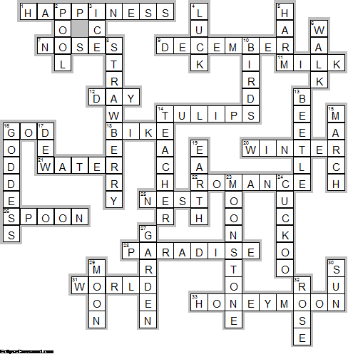

Across

1. HAPPINESS—June is a beautiful month to sing And listen to loud wedding bells ring In this long awaited summer month The mood of ... is all June fronts. By Sylvia Chidi
7. NOSES—“It is the month of June, The month of leaves and roses, When pleasant sights salute the eyes, And pleasant scents the ... .” Nathaniel Parker Willis
9. DECEMBER—June in the Northern Hemisphere is similar to the month of ... in the Southern Hemisphere.
11. MILK—Each year, the Americans celebrate June Dairy Month to honor America’s dairy farm families and the wholesome, nutritious ... they produce.
12. DAY—poet Valerie DohrenPoet's PagePoemsCommentsStatsBiographyMessage to the poetShare on FacebookShare on Twitter Poems by Valerie Dohren : 126 / 244 « MorningMy Muse Returned To Stay » My Lovely June O come sweet June, my lovely June The month when first the roses bloom - A wondrous, colourful display By sunlight kissed throughout the ..., So chasing all my cares away. By Valerie Dohren
14. TULIPS—"June brings ..., lilies, roses, Fills the children's hands with posies." - Sara Coleridge
16. GOD—“Spring being a tough act to follow, ... created June.” Al Bernstein
18. BIKE—June is ... month in the Lower mainland in British Columbia, Canada
20. WINTER—“There are two seasons in Scotland: June and ... .” Billy Connolly
21. WATER—At different times during June there are ceremonies called 'well dressings': springs and wells of fresh ... that come from the underground streams have always seem to be magical things, so some wells are honoured with decorations.
22. ROMANCE—“If a June night could talk, it would probably boast that it invented ... .” Bern Williams
25. NEST—June is the month of dreams, I think; Gardeners watch their roses, pink. Birds leave the ... and try their wings And songbirds learn just how to sing. By Jooan Adams Burchell
26. SPOON—"A swarm of bees in May is worth a load of hay. A swarm of bees in June is worth a silver ... . A swarm of bees in July is not worth a fly." - English Saying
28. PARADISE—“It is better to be a young June-bug than an old bird of ... .” Mark Twain
31. WORLD—"I wonder what it would be like to live in a ... where it was always June." - L. M. Montgomery
33. HONEYMOON—Married in the month of Roses - June Lifewill be one long ... .

Down

2. POOL—Dear June, I was so sad to hear You had fallen in a ... . Not only did you hurt yourself but I bet you felt a fool. By Ruth Street
3. ICE—“As soon / Seek roses in December - ... in June. Lord Byron
4. LUCK—Some people consider June good ... to be married in this month.
5. HARM—June damp and warm, does the farmer no ... .
6. WALK—“To read a poem in January is as lovely as to go for a ... in June” Jean-Paul Sartre
8. STRAWBERRY—The June full moon is nicknamed the "... Moon"
10. BIRDS—I am so excited that once again it is June When the sun is bright and the ... all sing in tune. By Randy McClave
13. BEETLE—The JUNE BUG also known as June ..., is the name for several large beetles seen in the United States during May and June and they are usually seen at night, when the light attracts them.
14. TEACHER—“There are three good reasons to be a ... - June, July, and August.” An Old Joke
15. MARCH—June ends on the same day of the week as ... in all years.
16. GODDESS—It is often said that the name of June came from the Roman Juno, the ... of marriage and the wife of the supreme deity Jupiter.
17. DEW—In Iceland, folklore says that if you bathe naked in the morning ... on the morning of June 24, you are supposed to keep aging at bay for longer.
19. EARTH—Sometimes the rains do not come in June Sometimes in June, darkness comes at noon The ... comes very dry And the inhabitants wonder why. By Mark Nyamekye Boadi
23. MOONSTONE—Gems for June are the pearl, alexandrite, and ... .
24. CUCKOO—“He was but as the ... is in June, Heard, not regarded.” William Shakespeare
27. GARDEN—“God gave His children memory that in life's ... there might be June roses in December”. By the English clergyman Geoffrey Anketall Studdert-Kennedy
29. MOON—poet Sylvia ChidiPoet's PagePoemsCommentsStatsE-BooksBiographyMessage to the poetShare on FacebookShare on Twitter Poems by Sylvia Chidi : 335 / 409 « The magic in youThe Moon » The month of June In the month of June I composed a melodic tune Ahead of time before the clocks struck noon Later at night I waited to sing it out in full ... . By Sylvia Chidi
30. SUN—In wiltshire there is a circle of huge stones at a place called Stonehenge , and hundreds of people go there to watch the ... rise on 21 June.
32. ROSE—The flower for the month of June is the ... .

