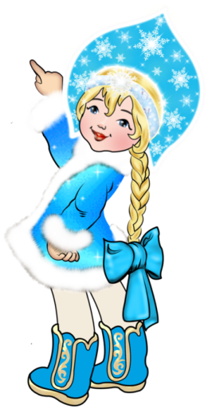
Кроссворд
January
для учащихся 8-11 классов,
влюбленных в английский язык

Автор:
Ольга Михайловна Степанова

учитель английского
языка
МБОУ «Чадукасинская ООШ»
Красноармейского района
Чувашской Республики

2014

Across

2. “Little January Tapped at my door today. And said, “Put on your winter wraps, And come ... to play.”- Winifred C. Marshall, January (8)
5. January chicks fill the ... house, August chicks fill the baskets. Sicilian Proverb (3)
8. It was named after the god Janus - Latin word for ... - who has two faces which allowed him to look both backwards into the old year and forwards into the new one at the same time. (4)
9. “There are two seasonal diversions that can ease the bite of any winter: one is the January ..., the other is the seed catalogues.” - Hal Borland (4)
11. “January brings the snow, Makes our feet and ... glow.” - Sara Coleridge, Pretty Lessons in Verse (7)
14. The ... of a January Day Warms the heart in everyway Trees in motion swaying and Swooping with a notion. By Melanie Dickie (6)
16. The Anglo-saxons called the first month ... Monath because these animals came into villages in search of food during this time. (4)
18. Babies born on 1st January is said to be the luckiest of all throughout their ... . (5)
19. At the beginning of January, take the ... to fields of heather. Corsican Proverb (4)
20. January's birthstone is the ... . (6)
21. January is International ... Gourmet Month. (6)
23. "Pale January lay In its ... day by day Dead or living, hard to say." - Alfred Austin, Primroses (6)
26. “In January it’s so nice while slipping on the sliding ice to sip hot chicken ... with rice.” - Maurice Sendak, In January (4)
27. Throw January ... in the garbage. Sicilian Proverb (8)
28. A warm January, a cold ... . Welsh Proverb (3)

Down

1. “January opens The ... of the year And brings out days That are bright and clear And brings out days That are cold and grey And shouts, “Come see What I brought today!” - Leland B. Jacobs, January (3)
3. Apart from leap years, January always begins on the same day as ... . (7)
4. “January, month of empty ...! Let us endure this evil month, anxious as a theatrical producer’s forehead.” - Colette (7)
5. In Finnish, the month is called tammikuu, meaning month of the oak, but the original meaning was the month of the ... of winter (5)
6. The January ... brightens like a clear day. Sicilian Proverb (4)
7. Don't marry a girl who wants ... in January. American Proverb (12)
10. Usually the snowdrop is generally regarded as January's flower, but for some it's the ... . (9)
12. Who in January sows oats, Gets ... and groats. (4)
13. A wet January, a wet ... . (6)
15. January Is A new month A new ... for me To learn new things To learn to let go of my anger. By Aldo Kraas (5)
16. "To read a poem in January is as lovely as to go for a ... in June." - Jean-Paul Sartre (4)
17. "... in January" is a Hallmark Channel Original Movie - the romance about a wedding stars Marilu Henner, Brooke D'Orsay and Wes Brown. (4)
22. If you see ... in January, Lock your grain in your granary (5)
24. In the Southern Hemisphere January is a summer month the equivalent of ... . (4)
25. In Czech this month is called leden, meaning ... month. (3)

Учащимся будет интересно работать с этим кроссвордом в онлайн режиме, так как он одновременно помещается в интернете по адресу:
file:///C:/Users/1/Desktop/January%20CROSSWORD.html

Answer
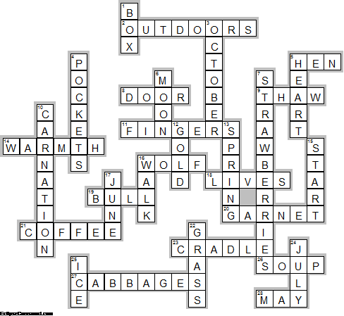
Across

2. OUTDOORS—“Little January Tapped at my door today. And said, “Put on your winter wraps, And come ... to play.”- Winifred C. Marshall, January
5. HEN—January chicks fill the ... house, August chicks fill the baskets. Sicilian Proverb
8. DOOR—It was named after the god Janus - Latin word for ... - who has two faces which allowed him to look both backwards into the old year and forwards into the new one at the same time.
9. THAW—“There are two seasonal diversions that can ease the bite of any winter: one is the January ..., the other is the seed catalogues.” - Hal Borland
11. FINGERS—“January brings the snow, Makes our feet and ... glow.” - Sara Coleridge, Pretty Lessons in Verse
14. WARMTH—The ... of a January Day Warms the heart in everyway Trees in motion swaying and Swooping with a notion. By Melanie Dickie
16. WOLF—The Anglo-saxons called the first month ... Monath because these animals came into villages in search of food during this time.
18. LIVES—Babies born on 1st January is said to be the luckiest of all throughout their ... .
19. BULL—At the beginning of January, take the ... to fields of heather. Corsican Proverb
20. GARNET—January's birthstone is the ... .
21. COFFEE—January is International ... Gourmet Month.
23. CRADLE—"Pale January lay In its ... day by day Dead or living, hard to say." - Alfred Austin, Primroses
26. SOUP—“In January it’s so nice while slipping on the sliding ice to sip hot chicken ... with rice.” - Maurice Sendak, In January
27. CABBAGES—Throw January ... in the garbage. Sicilian Proverb
28. MAY—A warm January, a cold ... . Welsh Proverb

Down

1. BOX—“January opens The ... of the year And brings out days That are bright and clear And brings out days That are cold and grey And shouts, “Come see What I brought today!” - Leland B. Jacobs, January
3. OCTOBER—Apart from leap years, January always begins on the same day as ... .
4. POCKETS—“January, month of empty ...! Let us endure this evil month, anxious as a theatrical producer’s forehead.” - Colette
5. HEART—In Finnish, the month is called tammikuu, meaning month of the oak, but the original meaning was the month of the ... of winter
6. MOON—The January ... brightens like a clear day. Sicilian Proverb
7. STRAWBERRIES—Don't marry a girl who wants ... in January. American Proverb
10. CARNATION—Usually the snowdrop is generally regarded as January's flower, but for some it's the ... .
12. GOLD—Who in January sows oats, Gets ... and groats.
13. SPRING—A wet January, a wet ... .
15. START—January Is A new month A new ... for me To learn new things To learn to let go of my anger. By Aldo Kraas
16. WALK—"To read a poem in January is as lovely as to go for a ... in June." - Jean-Paul Sartre
17. JUNE—"... in January" is a Hallmark Channel Original Movie - the romance about a wedding stars Marilu Henner, Brooke D'Orsay and Wes Brown.
22. GRASS—If you see ... in January, Lock your grain in your granary
24. JULY—In the Southern Hemisphere January is a summer month the equivalent of ... .
25. ICE—In Czech this month is called leden, meaning ... month.

