Кроссворд
February
для учащихся 8-11 классов,
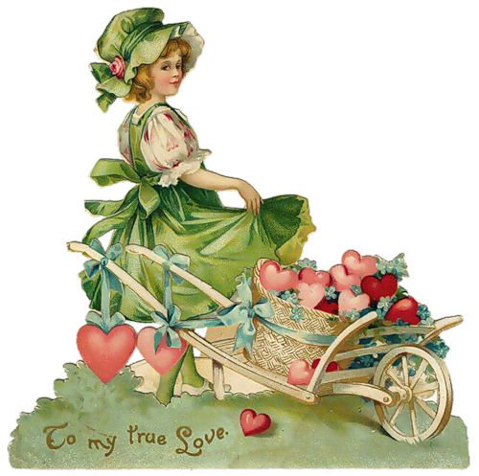
влюбленных в английский язык

Автор:
Ольга Михайловна
Степанова

учитель английского
языка
МБОУ
«Чадукасинская ООШ»
Красноармейского района
Чувашской Республики

2014

Across

3. If February gives much snow, A fine ... it doth foreshow (6)
5. President's Day is celebrated on the third ... in February. (6)
6. Abraham ... was born on February 12, 1809. (7)
7. If in February there be no rain, 'tis neither good for ... nor grain. (3)
9. February. Get ink. Weep. Write the heart out about it. Sing Another song of February While raucous slush burns black with ... . February. By Boris Pasternak (6)
14. In the Southern Hemisphere February is a summer month the equivalent of ... . (6)
16. February is also a time for families, especially in Canada, where ... Day is celebrated on the third Monday of the month in many provinces. (6)
18. February and poetry go together like ... and bread. (6)
21. February is International ... Language Momth. (6)
23. If the weather is fine and frosty at the beginning of February, there is more ... ahead than behind. (6)
25. The February birthstone amethyst is said to provide protective and healing qualities and also holds the meaning of .... . (5)
26. February was chosen as the month to observe Black ... because it is the birth month of abolitionist and writer Frederick Douglass (Feb. 14) and President Abraham Lincoln (Feb. 12). (7)
27. February makes a ..., and March breaks it. - George Herbert (6)
28. The flower for February babies is the ..., which coincides with the amethyst birthstone, as they both have a violet color. (6)

Down

1. Viola (plant) and the ... are the birth flowers. (8)
2. The gemstone of February is ... . (8)
3. "Late February days; and now, at last, Might you have thought that Winter's woe was past; So fair the ... was and so soft the air." - William Morris (3)
4. There's only the day the whole long year, That I hope and pray the sun won't appear. The second of February, you all know, The ... goes searching for his shadow. Author Unknown (9)
8. If it thunders in February, it will ... in April. (5)
10. During the month of February, Americans see the human heart as the symbol of love, that is why February is American ... Month, a time to show yourself the love. (5)
11. In February, what shall I do? I’ll make some ... for you. - Author Unknown (10)
12. Anglo-Saxon call February Solmonth (mud month) and Kale-month that means ... month. (7)
13. "Why, what's the matter, That you have such a February ..., So full of frost, of storm and cloudiness?" - William Shakespeare, Much Ado About Nothing (4)
15. When the cat lies in the ... in February She will creep behind the stove in March. (3)
17. The Anglo-Saxons called February Solmonath meaning month of ... . (3)
19. February is merely as long as is needed to pass the ... until March. - Dr. J. R. Stockton (4)
20. In February, don't postpone a ... . Corsican Proverb (4)
22. February has seven ... . Corsican Proverb (4)
24. The largest American sporting event of the year, the Super ..., is held in February. (4)
26. February, sweet days are here So far gone are the days of summer Snowflakes and snowmen are near So long to the sweat and ... of summer. By Christine Harazda (4)

Учащимся будет интересно работать с этим кроссвордом в онлайн режиме, так как он одновременно помещается в интернете по адресу:
file:///C:/Users/1/Desktop/february%20crossword/February%20CROSSWORD.html

Answers
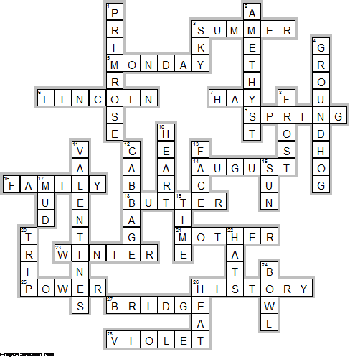
Across

3. SUMMER—If February gives much snow, A fine ... it doth foreshow
5. MONDAY—President's Day is celebrated on the third ... in February.
6. LINCOLN—Abraham ... was born on February 12, 1809.
7. HAY—If in February there be no rain, 'tis neither good for ... nor grain.
9. SPRING—February. Get ink. Weep. Write the heart out about it. Sing Another song of February While raucous slush burns black with ... . February. By Boris Pasternak
14. AUGUST—In the Southern Hemisphere February is a summer month the equivalent of ... .
16. FAMILY—February is also a time for families, especially in Canada, where ... Day is celebrated on the third Monday of the month in many provinces.
18. BUTTER—February and poetry go together like ... and bread.
21. MOTHER—February is International ... Language Momth.
23. WINTER—If the weather is fine and frosty at the beginning of February, there is more ... ahead than behind.
25. POWER—The February birthstone amethyst is said to provide protective and healing qualities and also holds the meaning of .... .
26. HISTORY—February was chosen as the month to observe Black ... because it is the birth month of abolitionist and writer Frederick Douglass (Feb. 14) and President Abraham Lincoln (Feb. 12).
27. BRIDGE—February makes a ..., and March breaks it. - George Herbert
28. VIOLET—The flower for February babies is the ..., which coincides with the amethyst birthstone, as they both have a violet color.

Down

1. PRIMROSE—Viola (plant) and the ... are the birth flowers.
2. AMETHYST—The gemstone of February is ... .
3. SKY—"Late February days; and now, at last, Might you have thought that Winter's woe was past; So fair the ... was and so soft the air." - William Morris
4. GROUNDHOG—There's only the day the whole long year, That I hope and pray the sun won't appear. The second of February, you all know, The ... goes searching for his shadow. Author Unknown
8. FROST—If it thunders in February, it will ... in April.
10. HEART—During the month of February, Americans see the human heart as the symbol of love, that is why February is American ... Month, a time to show yourself the love.
11. VALENTINES—In February, what shall I do? I’ll make some ... for you. - Author Unknown
12. CABBAGE—Anglo-Saxon call February Solmonth (mud month) and Kale-month that means ... month.
13. FACE—"Why, what's the matter, That you have such a February ..., So full of frost, of storm and cloudiness?" - William Shakespeare, Much Ado About Nothing
15. SUN—When the cat lies in the ... in February She will creep behind the stove in March.
17. MUD—The Anglo-Saxons called February Solmonath meaning month of ... .
19. TIME—February is merely as long as is needed to pass the ... until March. - Dr. J. R. Stockton
20. TRIP—In February, don't postpone a ... . Corsican Proverb
22. HATS—February has seven ... . Corsican Proverb
24. BOWL—The largest American sporting event of the year, the Super ..., is held in February.
26. HEAT—February, sweet days are here So far gone are the days of summer Snowflakes and snowmen are near So long to the sweat and ... of summer. By Christine Harazda

