Кроссворд
March
для учащихся 8-11 классов,
влюбленных в английский язык

Автор:
Ольга Михайловна Степанова

учитель английского
языка
МБОУ «Чадукасинская ООШ»
Красноармейского района
Чувашской Республики

2014

Across

4. In the Southern Hemisphere, March is the same as ... in the Northern Hemisphere. (9)
7. The birth flower for March is ... . (8)
11. March cold reaches even ...'s horns. Corsican Proverb (4)
12. If March is late in coming, ... will suffer. Sicilian Proverb (4)
13. He changed his ... from Frederick Bickel in a 1924 New Year's greeting: "This is 1924, I won't be Bickel any more; Fredric March is now my name, Wishing everyone the same, Happy New Year.” (4)
16. When it thunders in March, it brings ... . British Proverb (6)
18. Eat leeks in march, ... in may, all the rest of the year the doctors may play. English Proverb (6)
19. The new ... of March rules for six months. Sicilian Proverb (4)
20. When flies swarm in March, ... come to their death. Dutch Proverb (5)
23. A load of March ... is worth a ducat. German Proverb (4)
25. "Springtime is the land awakening. The March winds are the ... yawn." - Lewis Grizzard and Kathy Sue Loudermilk, I Love You (7)
26. "Where did Gabriel get a ..., In the month of March, When the green Is hardly seen On the early larch?" - Grace James (4)

Down

1. The name March comes from the Roman god of ..., Mars. (3)
2. "A light exists in ... Not present in the year at any other period When March is scarcely here." - Emily Dickinson (6)
3. For many years, March, being the start of spring, was also the start of the New ... . (4)
4. May problems with neighbors last only as long as ... in March. Corsican Proverb (4)
5. In the UK, March is National ... Month, run by The Sleep Council (www.sleepcouncil.org.uk). (3)
6. ... save us from the end of March and the beginning of April. Sicilian Proverb (3)
8. The birthstone for March is the ... . (10)
9. March comes in like a ..., and goes out like a lamb. Latin Proverb (4)
10. "It was one of those March days when the sun shines hot and the wind blows cold: when it is summer in the light, and ... in the shade." - Charles Dickens (6)
12. If you prune in March you're either a ... or crazy. Sicilian Proverb (7)
14. "March is a tomboy with tousled hair, a mischievous smile, mud on her shoes and a laugh in her ... ." - Hal Borland (5)
15. For every fog in March there's a ... in May. English Proverb (5)
16. When in March sun and water are taking turns with water and ..., the mules end up doing the carrying. Sicilian Proverb (3)
17. "Winds of March, we welcome you, There is work for you to do. Work and play and blow all day, Blow the Winter ... away." (4)
21. Swarms in March make good ... . Sicilian Proverb (5)
22. In the US, March 1 is National ... Day. (3)
24. "The March wind roars Like a Lion in the ..., And makes us shiver As he passes by. - Author Unknown (3)
25. So many mists in March, so many frosts in ... . German Proverb (3)

Учащимся будет интересно работать с этим кроссвордом в онлайн режиме, так как он одновременно помещается в интернете по адресу:
file:///C:/Users/1/Desktop/March%20Crossword.html
Answers
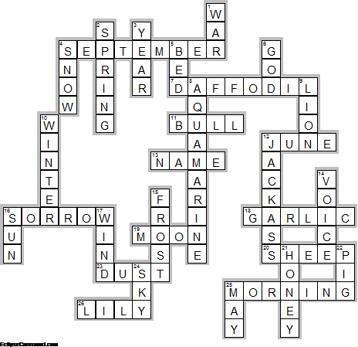

Across

4. SEPTEMBER—In the Southern Hemisphere, March is the same as ... in the Northern Hemisphere.
7. DAFFODIL—The birth flower for March is ... .
11. BULL—March cold reaches even ...'s horns. Corsican Proverb
12. JUNE—If March is late in coming, ... will suffer. Sicilian Proverb
13. NAME—He changed his ... from Frederick Bickel in a 1924 New Year's greeting: "This is 1924, I won't be Bickel any more; Fredric March is now my name, Wishing everyone the same, Happy New Year.”
16. SORROW—When it thunders in March, it brings ... . British Proverb
18. GARLIC—Eat leeks in march, ... in may, all the rest of the year the doctors may play. English Proverb
19. MOON—The new ... of March rules for six months. Sicilian Proverb
20. SHEEP—When flies swarm in March, ... come to their death. Dutch Proverb
23. DUST—A load of March ... is worth a ducat. German Proverb
25. MORNING—"Springtime is the land awakening. The March winds are the ... yawn." - Lewis Grizzard and Kathy Sue Loudermilk, I Love You
26. LILY—"Where did Gabriel get a ..., In the month of March, When the green Is hardly seen On the early larch?" - Grace James

Down

1. WAR—The name March comes from the Roman god of ..., Mars.
2. SPRING—"A light exists in ... Not present in the year at any other period When March is scarcely here." - Emily Dickinson
3. YEAR—For many years, March, being the start of spring, was also the start of the New ... .
4. SNOW—May problems with neighbors last only as long as ... in March. Corsican Proverb
5. BED—In the UK, March is National ... Month, run by The Sleep Council (www.sleepcouncil.org.uk).
6. GOD—... save us from the end of March and the beginning of April. Sicilian Proverb
8. AQUAMARINE—The birthstone for March is the ... .
9. LION—March comes in like a ..., and goes out like a lamb. Latin Proverb
10. WINTER—"It was one of those March days when the sun shines hot and the wind blows cold: when it is summer in the light, and ... in the shade." - Charles Dickens
12. JACKASS—If you prune in March you're either a ... or crazy. Sicilian Proverb
14. VOICE—"March is a tomboy with tousled hair, a mischievous smile, mud on her shoes and a laugh in her ... ." - Hal Borland
15. FROST—For every fog in March there's a ... in May. English Proverb
16. SUN—When in March sun and water are taking turns with water and ..., the mules end up doing the carrying. Sicilian Proverb
17. WIND—"Winds of March, we welcome you, There is work for you to do. Work and play and blow all day, Blow the Winter ... away."
21. HONEY—Swarms in March make good ... . Sicilian Proverb
22. PIG—In the US, March 1 is National ... Day.
24. SKY—"The March wind roars Like a Lion in the ..., And makes us shiver As he passes by. - Author Unknown
25. MAY—So many mists in March, so many frosts in ... . German Proverb

