Кроссворд
April
для учащихся 8-11 классов,
влюбленных в английский язык
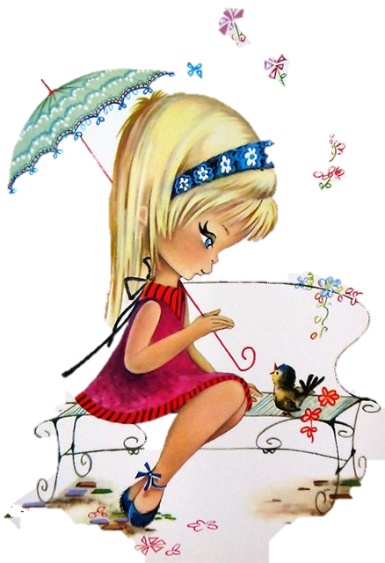

Автор:
Ольга Михайловна Степанова

учитель английского
языка
МБОУ «Чадукасинская ООШ»
Красноармейского района
Чувашской Республики

2014

Across

1. April cold with dropping rain Willows and ... brings again. Ralph Waldo Emerson (6)
4. Till April's dead, change not a ... . (6)
7. ... save us from the end of March and the beginning of April. Sicilian Proverb (3)
9. If the ... trees blossom in April, you'll have enough to collect them with barrels. Sicilian Proverb Sicilian Proverb (5)
14. During April rainfalls the pig gets butchered, the oxen gets fattened and the ... laughs. Sicilian Proverb (5)
15. If early April is foggy ... in June Will make lanes boggy. (4)
16. A cold April brings us ... and wine. (5)
17. An April flood carries away both the ... and his brood. (4)
18. A soft dropping April brings ... to cows and sheep. Irish Proverb (4)
20. "April, April Laugh thy girlish laughter; Then, the moment after, Weep thy girlish ... ." - Sir William Watson (5)
23. April is the time for sweet ..., don't take things off, don't put things on. Sicilian Proverb (5)
25. April is named for the Greek ... of love, Aphrodite. (7)
27. If you prune in April you'll fill your barrels not with wine, but with ... . Sicilian Proverb (5)
29. "In April, we cannot see sunflowers in ..., so we might say the sunflowers do not exist. - Thich Nhat Hanh (6)
30. "April prepares her green traffic ... and the world thinks Go." - Christopher Morley, John Mistletoe (5)
33. The ... sank on April 15, 1912 (7)
34. April and May make ... for the whole year. Spanish Proverb (4)
35. April showers bring forth ... flowers. French Proverb (3)

Down

2. April weather, woman's ..., rose-leaves, dice, and card-luck, change every moment. German Proverb (4)
3. The ... comes in April, and stays the month of May; sings a song at midsummer, and then goes away. Traditional Proverb (6)
4. A ... that doesn't flower in April, won't flower at all. Sicilian Proverb (4)
5. April 23rd is known as the Feast day of the Patron Saint of ... . (7)
6. poet Norah M. HollandPoet's PagePoemsCommentsStatsE-BooksBiographyShare on FacebookShare on Twitter Poems by Norah M. Holland : 2 / 8 « Cradle SongMy Dog and I » Home Thoughts from Abroad April in England–daffodils are growing By every wayside, golden, tall and fair; April–and all the little winds are blowing The scents of springtime through the sunny ... Norah M. Holland. (3)
8. The ... and the sweet pea are the flowers of the month. (5)
10. "How many million Aprils came before I ever knew how white a ... bough could be, a bed of squills, how blue.- Sara Teasdale, Blue Squills (6)
11. When April blows its ... 'Tis good for hay and corn. (4)
12. ... is the birthstone for April. (7)
13. The child's bottom and April ... are not to be trusted. Swedish Proverb (7)
19. We're told we should be thankful For the ... of April showers As it washes all the grass clean And prepares the soil for flowers.- Thomas Vaughan Jones, O' To Be in April (4)
21. April wet - good ... . (5)
22. Whoever goes on ... during April and May, goes on horseback the rest of the year. Sicilian Proverb (4)
24. "I have seen the Lady April bringing the ..., Bringing the springing grass and the soft warm April rain." - John Masefield (9)
26. "Winter's done, and April's in the skies, ..., look up with laughter in your eyes!" - Charles G. D. Roberts, An April Adoration (5)
28. April makes the flowers and the ... , but May gets all the credit. Sicilian Proverb (6)
31. Better April showers than the breadth of the ocean in ... . Irish Proverb (4)
32. A cold April the ... will fill. English Proverb (4)

Учащимся будет интересно работать с этим кроссвордом в онлайн режиме, так как он одновременно помещается в интернете по адресу:
file:///C:/Users/1/Desktop/April%20Crossword.html

Answers
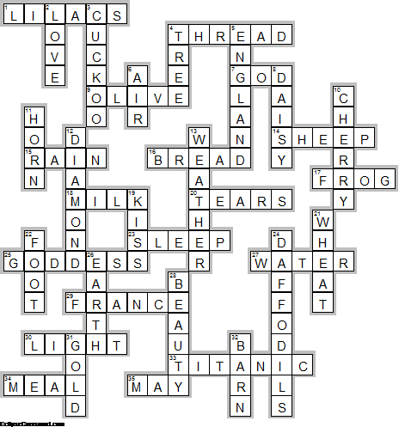
Across

1. LILACS—April cold with dropping rain Willows and ... brings again. Ralph Waldo Emerson
4. THREAD—Till April's dead, change not a ... .
7. GOD—... save us from the end of March and the beginning of April. Sicilian Proverb
9. OLIVE—If the ... trees blossom in April, you'll have enough to collect them with barrels. Sicilian Proverb Sicilian Proverb
14. SHEEP—During April rainfalls the pig gets butchered, the oxen gets fattened and the ... laughs. Sicilian Proverb
15. RAIN—If early April is foggy ... in June Will make lanes boggy.
16. BREAD—A cold April brings us ... and wine.
17. FROG—An April flood carries away both the ... and his brood.
18. MILK—A soft dropping April brings ... to cows and sheep. Irish Proverb
20. TEARS—"April, April Laugh thy girlish laughter; Then, the moment after, Weep thy girlish ... ." - Sir William Watson
23. SLEEP—April is the time for sweet ..., don't take things off, don't put things on. Sicilian Proverb
25. GODDESS—April is named for the Greek ... of love, Aphrodite.
27. WATER—If you prune in April you'll fill your barrels not with wine, but with ... . Sicilian Proverb
29. FRANCE—"In April, we cannot see sunflowers in ..., so we might say the sunflowers do not exist. - Thich Nhat Hanh
30. LIGHT—"April prepares her green traffic ... and the world thinks Go." - Christopher Morley, John Mistletoe
33. TITANIC—The ... sank on April 15, 1912
34. MEAL—April and May make ... for the whole year. Spanish Proverb
35. MAY—April showers bring forth ... flowers. French Proverb

Down

2. LOVE—April weather, woman's ..., rose-leaves, dice, and card-luck, change every moment. German Proverb
3. CUCKOO—The ... comes in April, and stays the month of May; sings a song at midsummer, and then goes away. Traditional Proverb
4. TREE—A ... that doesn't flower in April, won't flower at all. Sicilian Proverb
5. ENGLAND—April 23rd is known as the Feast day of the Patron Saint of ... .
6. AIR—poet Norah M. HollandPoet's PagePoemsCommentsStatsE-BooksBiographyShare on FacebookShare on Twitter Poems by Norah M. Holland : 2 / 8 « Cradle SongMy Dog and I » Home Thoughts from Abroad April in England–daffodils are growing By every wayside, golden, tall and fair; April–and all the little winds are blowing The scents of springtime through the sunny ... Norah M. Holland.
8. DAISY—The ... and the sweet pea are the flowers of the month.
10. CHERRY—"How many million Aprils came before I ever knew how white a ... bough could be, a bed of squills, how blue.- Sara Teasdale, Blue Squills
11. HORN—When April blows its ... 'Tis good for hay and corn.
12. DIAMOND—... is the birthstone for April.
13. WEATHER—The child's bottom and April ... are not to be trusted. Swedish Proverb
19. KISS—We're told we should be thankful For the ... of April showers As it washes all the grass clean And prepares the soil for flowers.- Thomas Vaughan Jones, O' To Be in April
21. WHEAT—April wet - good ... .
22. FOOT—Whoever goes on ... during April and May, goes on horseback the rest of the year. Sicilian Proverb
24. DAFFODILS—"I have seen the Lady April bringing the ..., Bringing the springing grass and the soft warm April rain." - John Masefield
26. EARTH—"Winter's done, and April's in the skies, ..., look up with laughter in your eyes!" - Charles G. D. Roberts, An April Adoration
28. BEAUTY—April makes the flowers and the ... , but May gets all the credit. Sicilian Proverb
31. GOLD—Better April showers than the breadth of the ocean in ... . Irish Proverb
32. BARN—A cold April the ... will fill. English Proverb

