Animal Camouflage
Level 6

ГБОУ СОШ № 2084, г. Москва
Камель Анастасия, 6 класс
kamelv@yandex.ru

Парасоцкая Ольга Николаевна,
учитель английского языка ГБОУ СОШ № 426 г. Москва
salchanka@yandex.ru
тел. 8-963-687-64-07

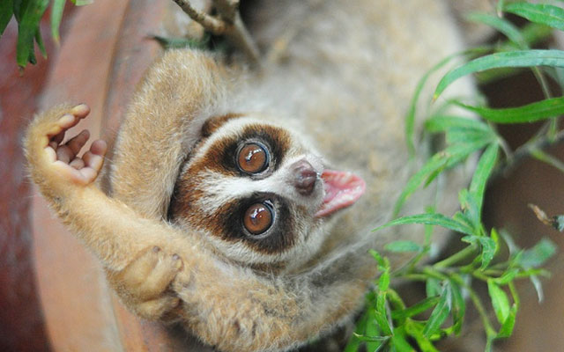
Lori

Lori is a night animal. It lives in the tropical forest of Southeast Asia. Loris have a long body which is about 35 centimeters. They eat different small animals, which they can catch. Also they drink juice of trees. Loris are very vulnerable to the enemy because they are small and slowness. Loris have original method of protection. Loris have poisonous glands on the elbows that makes them toxic animals. Moreover, they lick the poison and carry it throughout their fur. Females loris cover poison in the body their babies before they do hunting and leave babies along.
As animals lick poison, their bite become poisonous, so bite is painful and causes swelling. Some people died from anaphylactic shock after the bite of lori, thought this poison is not fatal for people and large animals.

Tasks.
- Where is lori from?
- Africa
- East
- Southeast Asia
- What does lori defend?
a-needles
b-poison
c-colour
- What juice does lori drink?
a-juice of trees
b-apple juice
c-juice of flours
- What does lori eat?
a-grass
b-insects
c-small animals

Task 2.
Some people think that loris are very dangerous, but others want to have lori as their pet. And what about you? Give your opinion on this problem. (Write about 80-100 words).

