Animal Camouflage
Level 6

ГБОУ СОШ № 2084, г. Москва
Колосова Дарья, 6 класс
anya.kolosova2012@yandex.ru

Парасоцкая Ольга Николаевна,
учитель английского языка ГБОУ СОШ № 426 г. Москва
salchanka@yandex.ru
тел. 8-963-687-64-07

Dwarf lemurs are suborders of primates’ family. It includes rat and mouse lemurs. Like all lemurs, this family is common for the Madagascar. Dwarf lemurs’ eyes are better skilled than the ears. They’ve got a compressed body, a short head, a rounded muzzle; their tail is slightly longer than the body and limbs. Other external differences of these small animals are big eyes, the ears are medium-naked and outside they’re covered with thin and sparse hair; they’ve got extraordinarily graceful limbs with short fingers, and their fur is gentle, soft, silky and partly undulating.
They live alone and in pairs, but in captivity they can be contained in large groups. They sleep, curled into a ball in tree holes or slots, made of grass, small branches and leaves. In the same condition they are in a period of hibernation, which flow in dry seasons. In favorable (rainy) period they accumulate fat in different parts of the body, especially at the base of the tail, and in a state of extended trance spend these fat reserves.
In captivity behave aggressively, but there is more docile nature.

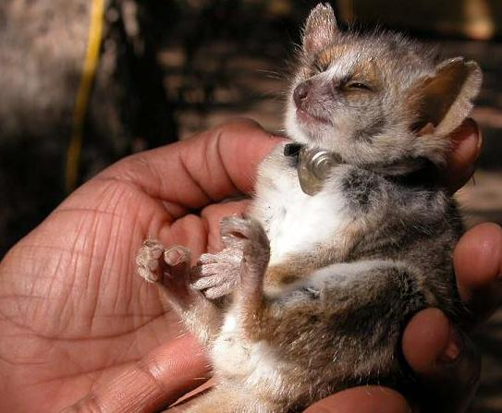
Questions:
1. Where do they live?
2. How do they look like?
3. What is their lifestyle?

Task 2.
Some people think that it’s very good to have dwarf lemurs as a pet. While others think that is bad. And what about you? Write down your opinion. (80-100 words will be enough).

