Wonderful Creature
the Goat
Кроссворд
для учащихся 8-11 классов,
влюбленных в английский язык

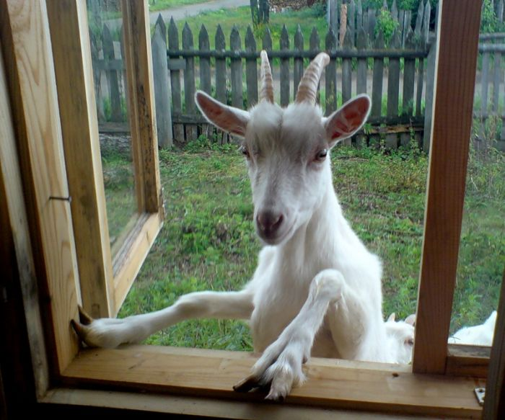

Автор:
Ольга Михайловна Степанова

учитель английского языка

МБОУ «Цивильская СОШ №2»
города Цивильск
Чувашской Республики

2014

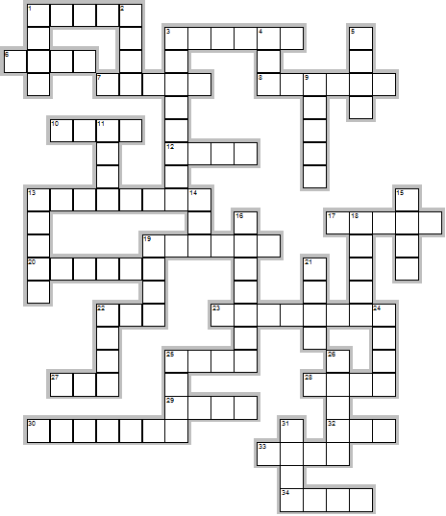
Across

1. The early explorers used goat skins for ... bottles when they traveled. (5)
3. When the goat goes to ... , he does not stop till he gets to the altar. Irish Proverb (6)
6. The goat is not big in a cow ... . Vai proverb (4)
7. If the goat rejects the grass, its ... is full. African Proverb (5)
8. If a beard were all, the goat would be the ... . Danish Proverb (6)
10. Goats were the first animals to be used for ... by humans. (4)
12. Because a man has injured your goat, do not go out and kill his ... . Kenyan Proverb (4)
13. Where there are no sheep, they call the goat ... . Turkish proverb (8)
17. The quarrel of the ... doesn't concern the goats. African Proverb (5)
19. No one ever saw a goat dead of ... . Italian Proverb (6)
20. Goat's discovered ... beans. (6)
22. A baby goat is called a “... .” (3)
23. A prudent man does not make the goat his ... . Hungarian Proverb (8)
25. Cooked ... is not sold for goats. Kikuyu Proverb (4)
27. Carl Sandburg loved his goats so much that when Life Magazine (1938 issue) asked him to pose for a picture with his favorite ... he insisted the picture be taken with his goats. (3)
28. Put ... on a goat, and it's still a goat. Irish Proverb (4)
29. Speak like a parrot; meditate like a swan; ... like a goat; and bathe like an elephant. Indian Proverb (4)
30. He confides the ... to the goat. Hungarian Proverb (7)
32. If the goat would not jump around, she wouldn't break her ... . American Proverb (3)
33. By candle-light a goat looks like a ... . French Proverb (4)
34. If the goat had a longer ... he could wipe the stars clean. Czech Proverb (4)

Down

1. Its no use going to the goat's house to look for ... . Irish Proverb (4)
2. The older the goat the tighter the ... . Lithuanian Proverb (4)
3. Goats were first brought to America by ... in 1493. (8)
4. The ... with no tail can only depend on goats to rid himself of flies. African Proverb (3)
5. The goat that stayed with a ... learned farting (Ethiopia). (4)
9. The female goat is called a “doe” or “... .” (5)
11. Only a goat that is tired of life invites a ... to dinner. African Proverb (4)
13. A goat does not always graze in the same ... . African Proverb (5)
14. The goat which has many owners will be left to die in the ... . Haitian Proverb (3)
15. The eye of the leopard is on the goat, and the eye of the goat is on the ... . Ethiopian Proverb (4)
16. When will the goat be strong enough to kill a ... . Nigerian Proverb (7)
18. Abraham Lincoln’s sons had two goats that lived in the white ... with them. (5)
19. Goats cannot live in a ... of leopards. African Proverb (4)
21. When the big ... falls, the goat eats its leaves. African Proverb (4)
22. If wisdom is measured by the size of the beard then the goat is a philosopher ... . African Proverb (4)
24. The goat that climbs up the ... also has to go down. Creole Proverb (4)
25. The frowning ... of a goat doesn't prevent it being taken to market. African Proverb (4)
26. The male goat is called a “buck” or “... .” (5)
31. Even on old goat likes to lick ... . Hungarian Proverb (4)

Учащимся будет интересно работать с этим кроссвордом в онлайн режиме, так как он одновременно помещается в интернете по адресу:

file:///C:/Users/1/Desktop/%D1%83%D1%87%D0%BF%D0%BE%D1%80%D1%82%D1%84%20%D0%B4%D0%BB%D1%8F%20%D0%BE%D1%82%D0%BF%D1%80%D0%B0%D0%B2%D0%BA%D0%B8/goats/This%20Wonderful%20Creature%20the%20Goat.html
Answers are given on the next page.
Ответы даны ниже.

Answers:
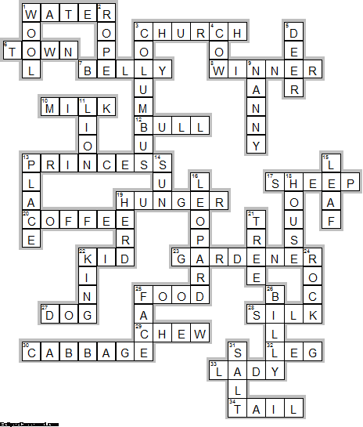
Across

1. WATER—The early explorers used goat skins for ... bottles when they traveled.
3. CHURCH—When the goat goes to ... , he does not stop till he gets to the altar. Irish Proverb
6. TOWN—The goat is not big in a cow ... . Vai proverb
7. BELLY—If the goat rejects the grass, its ... is full. African Proverb
8. WINNER—If a beard were all, the goat would be the ... . Danish Proverb
10. MILK—Goats were the first animals to be used for ... by humans.
12. BULL—Because a man has injured your goat, do not go out and kill his ... . Kenyan Proverb
13. PRINCESS—Where there are no sheep, they call the goat ... . Turkish proverb
17. SHEEP—The quarrel of the ... doesn't concern the goats. African Proverb
19. HUNGER—No one ever saw a goat dead of ... . Italian Proverb
20. COFFEE—Goat's discovered ... beans.
22. KID—A baby goat is called a “... .”
23. GARDENER—A prudent man does not make the goat his ... . Hungarian Proverb
25. FOOD—Cooked ... is not sold for goats. Kikuyu Proverb
27. DOG—Carl Sandburg loved his goats so much that when Life Magazine (1938 issue) asked him to pose for a picture with his favorite ... he insisted the picture be taken with his goats.
28. SILK—Put ... on a goat, and it's still a goat. Irish Proverb
29. CHEW—Speak like a parrot; meditate like a swan; ... like a goat; and bathe like an elephant. Indian Proverb
30. CABBAGE—He confides the ... to the goat. Hungarian Proverb
32. LEG—If the goat would not jump around, she wouldn't break her ... . American Proverb
33. LADY—By candle-light a goat looks like a ... . French Proverb
34. TAIL—If the goat had a longer ... he could wipe the stars clean. Czech Proverb

Down

1. WOOL—Its no use going to the goat's house to look for ... . Irish Proverb
2. ROPE—The older the goat the tighter the ... . Lithuanian Proverb
3. COLUMBUS—Goats were first brought to America by ... in 1493.
4. COW—The ... with no tail can only depend on goats to rid himself of flies. African Proverb
5. DEER—The goat that stayed with a ... learned farting (Ethiopia).
9. NANNY—The female goat is called a “doe” or “... .”
11. LION—Only a goat that is tired of life invites a ... to dinner. African Proverb
13. PLACE—A goat does not always graze in the same ... . African Proverb
14. SUN—The goat which has many owners will be left to die in the ... . Haitian Proverb
15. LEAF—The eye of the leopard is on the goat, and the eye of the goat is on the ... . Ethiopian Proverb
16. LEOPARD—When will the goat be strong enough to kill a ... . Nigerian Proverb
18. HOUSE—Abraham Lincoln’s sons had two goats that lived in the white ... with them.
19. HERD—Goats cannot live in a ... of leopards. African Proverb
21. TREE—When the big ... falls, the goat eats its leaves. African Proverb
22. KING—If wisdom is measured by the size of the beard then the goat is a philosopher ... . African Proverb
24. ROCK—The goat that climbs up the ... also has to go down. Creole Proverb
25. FACE—The frowning ... of a goat doesn't prevent it being taken to market. African Proverb
26. BILLY—The male goat is called a “buck” or “... .”
31. SALT—Even on old goat likes to lick ... . Hungarian Proverb

