Кроссворд
Sunday
для учащихся 8-11 классов,
влюбленных в английский язык

Автор:
Ольга Михайловна Степанова

учитель английского
языка
МБОУ «Чадукасинская ООШ»
Красноармейского района
Чувашской Республики

2014
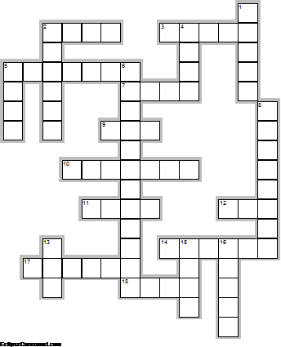
Across

2. A Sunday well-spent brings a ... of content. (Traditional Proverb) (4)
3. To burn ... on Sunday brings bad luck.Kentucky Superstitions. (5)
5. A new moon on Sunday predicts bad ... and even worse luck everywhere. (7)
7. It brings bad luck to count ... on Sunday.Kentucky Superstitions. (4)
9. Sunday is associated with the ... . (3)
10. Sunday is a good day to start the ... . (7)
11. You will have good ... if you are born on Sunday. (4)
12. Don’t turn your bed or mattress on Sunday; in fact, it’s unlucky to make your ... on this day.Superstition. (3)
14. He that sings on ... will weep on Sunday. Romanian Proverb (6)
17. A man who always wears his best ... has no Sunday clothes. (Japanese Proverb) (6)
18. Collecting ... on Sunday is devils work.Superstition. (4)

Down

1. The man of many trades begs his ... on Sunday. Romanian Proverb (5)
2. Married on Monday, married for health / Married on Sunday, hitched for ... . (6)
4. “Oh dear sunday, I want to sleep in your ... and have fun day.” Santosh Kalwar (4)
5. If you want a fine ... , don't pick her on a Sunday. (Spanish Proverb) (4)
6. In Russian the word for Sunday is Voskreseniye meaning "...". (12)
8. Sunday is the day of the week following ... but before Monday. (8)
13. Tell a ... on Saturday and you will be ashamed on Sunday. (Turkish Proverb) (3)
15. Sunday is a day of ... in most Western countries. (4)
16. It brings good luck to wear a new ... on Sunday. Kentucky Superstition. (5)

Ответы наследующей странице.

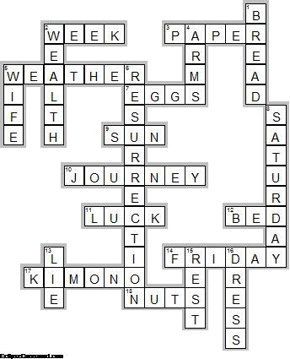

Across

2. WEEK—A Sunday well-spent brings a ... of content. (Traditional Proverb)
3. PAPER—To burn ... on Sunday brings bad luck.Kentucky Superstitions.
5. WEATHER—A new moon on Sunday predicts bad ... and even worse luck everywhere.
7. EGGS—It brings bad luck to count ... on Sunday.Kentucky Superstitions.
9. SUN—Sunday is associated with the ... .
10. JOURNEY—Sunday is a good day to start the ... .
11. LUCK—You will have good ... if you are born on Sunday.
12. BED—Don’t turn your bed or mattress on Sunday; in fact, it’s unlucky to make your ... on this day.Superstition.
14. FRIDAY—He that sings on ... will weep on Sunday. Romanian Proverb
17. KIMONO—A man who always wears his best ... has no Sunday clothes. (Japanese Proverb)
18. NUTS—Collecting ... on Sunday is devils work.Superstition.

Down

1. BREAD—The man of many trades begs his ... on Sunday. Romanian Proverb
2. WEALTH—Married on Monday, married for health / Married on Sunday, hitched for ... .
4. ARMS—“Oh dear sunday, I want to sleep in your ... and have fun day.” Santosh Kalwar
5. WIFE—If you want a fine ... , don't pick her on a Sunday. (Spanish Proverb)
6. RESURRECTION—In Russian the word for Sunday is Voskreseniye meaning "...".
8. SATURDAY—Sunday is the day of the week following ... but before Monday.
13. LIE—Tell a ... on Saturday and you will be ashamed on Sunday. (Turkish Proverb)
15. REST—Sunday is a day of ... in most Western countries.
16. DRESS—It brings good luck to wear a new ... on Sunday. Kentucky Superstition.

