Кроссворд
Monday
для учащихся 8-11 классов,
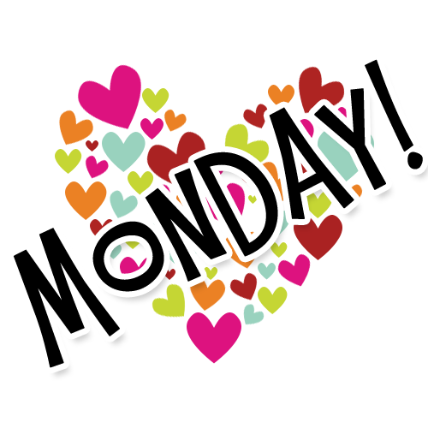
влюбленных в английский язык

Автор:
Ольга Михайловна Степанова

учитель английского
языка
МБОУ «Цивильская СОШ №2»
города Цивильск
Чувашской Республики

2014

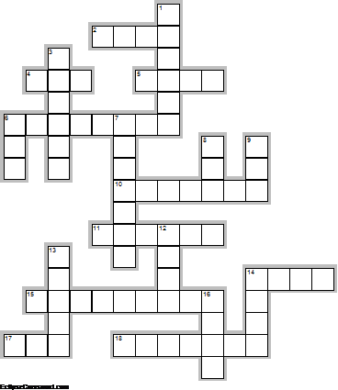
Across

2. The name of Monday is derived from Old English Monandжg and Middle English Monenday , which means " ... day". (4)
4. Monday is the ... day of the week. Scottish Proverb (3)
5. Wednesdays are like Mondays in the middle of the ... ! ~Lee Fox Williams (4)
6. Several holidays always fall on a Monday such as Labor Day, Memorial Day, ... Day and Veteran’s Day. (8)
10. Monday is the day of the week between Sunday and ... . (7)
11. In Thailand, the color associated with Monday is ... . (6)
14. A couple married on Monday is headed for a ... . Sicilian Proverb (4)
15. Monday is like a math problem. Add the irritation, subtract the sleep, multiply the problems, divide the ... . Author Unknown (9)
17. Monday flit, never ... . (3)
18. “Monday is the day of ... , day of the whole white mung bean, which is sacred to the moon.” Chitra Banerjee Divakaruni, The Mistress of Spices (7)

Down

1. In the Eastern Orthodox Church Mondays are days in which ... are commemorated. (6)
3. Tuesday is for health, Monday is for ... . (6)
6. It is said that Monday is the best day to buy a ... . (3)
7. Monday is Sunday's ... . (7)
8. I'm convinced that ... gave us Mondays to punish us for the things we did over the weekend. Author Unknown (3)
9. There is a band named the Happy Mondays and an American pop punk band ... Monday. (3)
12. One seventh of your ... is spent on Monday. (4)
13. Monday is your first chance in the week to have a great ... ! (5)
14. In the folk rhyme, "Monday's child is fair of ... ". (4)
16. "I Don't Like Mondays" is a ... written by Bob Geldof and performed by The Boomtown Rats. (4)

Учащимся будет интересно работать с этим кроссвордом в онлайн режиме, так как он одновременно помещается в интернете по адресу:
file:///C:/Users/1/Desktop/%D1%83%D1%87%D0%BF%D0%BE%D1%80%D1%82%D1%84%20%D0%B4%D0%BB%D1%8F%20%D0%BE%D1%82%D0%BF%D1%80%D0%B0%D0%B2%D0%BA%D0%B8/Monday/monday.html
Ответы на следующей странице

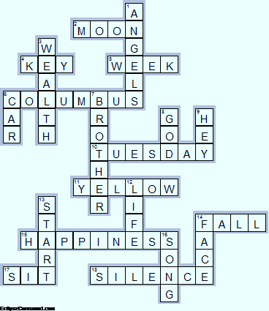

Across

2. MOON—The name of Monday is derived from Old English Monandжg and Middle English Monenday , which means " ... day".
4. KEY—Monday is the ... day of the week. Scottish Proverb
5. WEEK—Wednesdays are like Mondays in the middle of the ... ! ~Lee Fox Williams
6. COLUMBUS—Several holidays always fall on a Monday such as Labor Day, Memorial Day, ... Day and Veteran’s Day.
10. TUESDAY—Monday is the day of the week between Sunday and ... .
11. YELLOW—In Thailand, the color associated with Monday is ... .
14. FALL—A couple married on Monday is headed for a ... . Sicilian Proverb
15. HAPPINESS—Monday is like a math problem. Add the irritation, subtract the sleep, multiply the problems, divide the ... . Author Unknown
17. SIT—Monday flit, never ... .
18. SILENCE—“Monday is the day of ... , day of the whole white mung bean, which is sacred to the moon.” Chitra Banerjee Divakaruni, The Mistress of Spices

Down

1. ANGELS—In the Eastern Orthodox Church Mondays are days in which ... are commemorated.
3. WEALTH—Tuesday is for health, Monday is for ... .
6. CAR—It is said that Monday is the best day to buy a ... .
7. BROTHER—Monday is Sunday's ... .
8. GOD—I'm convinced that ... gave us Mondays to punish us for the things we did over the weekend. Author Unknown
9. HEY—There is a band named the Happy Mondays and an American pop punk band ... Monday.
12. LIFE—One seventh of your ... is spent on Monday.
13. START—Monday is your first chance in the week to have a great ... !
14. FACE—In the folk rhyme, "Monday's child is fair of ... ".
16. SONG—"I Don't Like Mondays" is a ... written by Bob Geldof and performed by The Boomtown Rats.

