Кроссворд
Thursday
для учащихся 8-11 классов,
влюбленных в английский язык

Автор:
Ольга Михайловна Степанова

учитель английского
языка
МБОУ «Цивильская СОШ №2»
города Цивильск
Чувашской Республики

2014

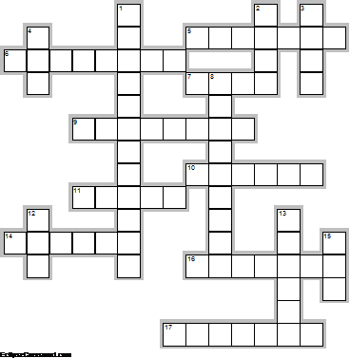
Across

5. Thursday is ruled by the Planet ... . (7)
6. In the United States, Thursday nights are held for prime time television broadcasts of college and NFL professional ... games. (8)
7. Never spin ... on Thursday. (4)
9. Thursday is the best day for ... transactions. (8)
10. Thursday is the day of the week following Wednesday and before ... . (6)
11. Sweet Thursday is a ... by John Steinbeck. (5)
14. On the First Thursday of every month, over 150 galleries in east ... come together and run free events, exhibitions, talks, workshops, and private views during a special late opening. (6)
16. 1st Thursday is an evening of art and culture in downtown Santa ... . (7)
17. You should eat ... on any day of the week but Thursday. Superstition. (7)

Down

1. In the United States, ... Day is an annual festival celebrated on the fourth Thursday in November. (12)
2. Sneezing on a Thursday is a ... of better things to come. (4)
3. Many Germans believe that Thursday is the unluckiest day of the ... . (4)
4. It is rather unwise to start a new ... on a Thursday. Superstition. (3)
8. In ... , most cinema movies premieres are held on Thursdays. (9)
12. In most Romance languages, the day is named after the Roman god Jupiter, who was the ... of sky and thunder. (3)
13. In the Thai solar calendar, the colour associated with Thursday is ... . (6)
15. Gabriel Syme, the main character, was given the title of Thursday in G. K. Chesterton's novel "The ... Who Was Thursday". (3)

Учащимся будет интересно работать с этим кроссвордом в онлайн режиме, так как он одновременно помещается в интернете по адресу:
file:///C:/Users/1/Desktop/%D1%83%D1%87%D0%BF%D0%BE%D1%80%D1%82%D1%84%20%D0%B4%D0%BB%D1%8F%20%D0%BE%D1%82%D0%BF%D1%80%D0%B0%D0%B2%D0%BA%D0%B8/Thursday/Thursday.html

Ответы на следующей странице

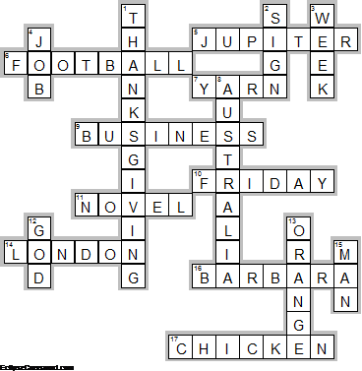

Across

5. JUPITER—Thursday is ruled by the Planet ... .
6. FOOTBALL—In the United States, Thursday nights are held for prime time television broadcasts of college and NFL professional ... games.
7. YARN—Never spin ... on Thursday.
9. BUSINESS—Thursday is the best day for ... transactions.
10. FRIDAY—Thursday is the day of the week following Wednesday and before ... .
11. NOVEL—Sweet Thursday is a ... by John Steinbeck.
14. LONDON—On the First Thursday of every month, over 150 galleries in east ... come together and run free events, exhibitions, talks, workshops, and private views during a special late opening.
16. BARBARA—1st Thursday is an evening of art and culture in downtown Santa ... .
17. CHICKEN—You should eat ... on any day of the week but Thursday. Superstition.

Down

1. THANKSGIVING—In the United States, ... Day is an annual festival celebrated on the fourth Thursday in November.
2. SIGN—Sneezing on a Thursday is a ... of better things to come.
3. WEEK—Many Germans believe that Thursday is the unluckiest day of the ... .
4. JOB—It is rather unwise to start a new ... on a Thursday. Superstition.
8. AUSTRALIA—In ... , most cinema movies premieres are held on Thursdays.
12. GOD—In most Romance languages, the day is named after the Roman god Jupiter, who was the ... of sky and thunder.
13. ORANGE—In the Thai solar calendar, the colour associated with Thursday is ... .
15. MAN—Gabriel Syme, the main character, was given the title of Thursday in G. K. Chesterton's novel "The ... Who Was Thursday".

