Кроссворд
Friday
для учащихся 8-11 классов,
влюбленных в английский язык

Автор:
Ольга Михайловна Степанова

учитель английского
языка
МБОУ «Цивильская СОШ №2»
города Цивильск
Чувашской Республики

2014

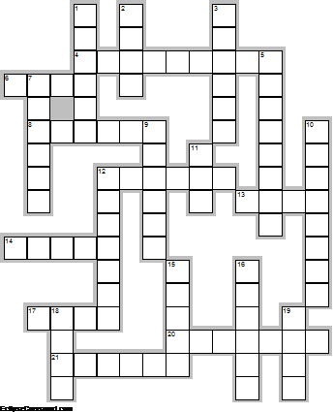
Across

4. In the United States, Black Friday is also the nickname of the day after Thanksgiving, the first day of the traditional ... shopping season. (9)
6. Traditionally, Roman Catholics were obliged to refrain from eating the ... of land animals on Fridays. (4)
8. Sneeze on a Friday and ... will follow. Superstition. (6)
12. Anyone who laughs on Friday will cry on ... . Superstition. (6)
13. Never get your ... cut on Good Friday. Superstition. (4)
14. Casual Friday is a relaxation of the formal ... code employed by some corporations for that one day of the week. (5)
17. In Thailand, the color associated with Friday is ... . (4)
20. Don't do ... on Friday because as the rhyme states, Wash on Friday, wash in need Wash on Saturday, a slut indeed (7)
21. There is a superstition saying that it is unlucky to begin a ... on a Friday. (6)

Down

1. ... visits should never happen on a Friday, as death may follow. Superstition. (6)
2. POETS Day is a term used by workers in the United Kingdom and Australia to refer to Friday being the last day of the ... week. (4)
3. In modern times, Friday the 13th is considered to be especially unlucky, due to the conjunction of Friday with the unlucky ... thirteen. (6)
5. Friday is longer than ... . Hungarian Proverb (8)
7. In Christianity Good Friday is the Friday before ... . (6)
9. It is bad luck to fall out of a thirteenth story ... on Friday. American Proverb (6)
10. Friday is the day after ... which precedes Saturday. (8)
11. Because the ... was given no meat, he said it was Friday. Armenian Proverb (3)
12. The cat which did not reach the ... said: Anyhow it is Friday. Georgian Proverb (7)
15. Many believe that it was on a Friday that Eve convinced Adam to eat that ... . (5)
16. In astrology, Friday is connected with the ... Venus. (6)
18. Friday is associated in many cultures with the ... goddess Venus. (4)
19. In ... , Friday is the only weekend day. (4)

Учащимся будет интересно работать с этим кроссвордом в онлайн режиме, так как он одновременно помещается в интернете по адресу:
file:///C:/Users/1/Desktop/%D1%83%D1%87%D0%BF%D0%BE%D1%80%D1%82%D1%84%20%D0%B4%D0%BB%D1%8F%20%D0%BE%D1%82%D0%BF%D1%80%D0%B0%D0%B2%D0%BA%D0%B8/Friday/Friday%20Crossword.html

Ответы на следующей странице

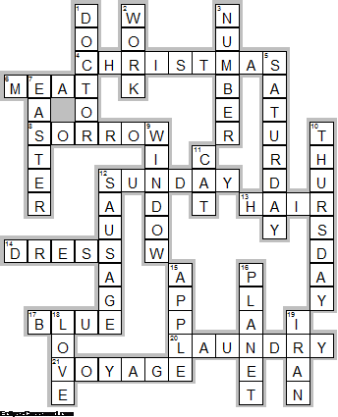
Across

4. CHRISTMAS—In the United States, Black Friday is also the nickname of the day after Thanksgiving, the first day of the traditional ... shopping season.
6. MEAT—Traditionally, Roman Catholics were obliged to refrain from eating the ... of land animals on Fridays.
8. SORROW—Sneeze on a Friday and ... will follow. Superstition.
12. SUNDAY—Anyone who laughs on Friday will cry on ... . Superstition.
13. HAIR—Never get your ... cut on Good Friday. Superstition.
14. DRESS—Casual Friday is a relaxation of the formal ... code employed by some corporations for that one day of the week.
17. BLUE—In Thailand, the color associated with Friday is ... .
20. LAUNDRY—Don't do ... on Friday because as the rhyme states, Wash on Friday, wash in need Wash on Saturday, a slut indeed
21. VOYAGE—There is a superstition saying that it is unlucky to begin a ... on a Friday.

Down

1. DOCTOR—... visits should never happen on a Friday, as death may follow. Superstition.
2. WORK—POETS Day is a term used by workers in the United Kingdom and Australia to refer to Friday being the last day of the ... week.
3. NUMBER—In modern times, Friday the 13th is considered to be especially unlucky, due to the conjunction of Friday with the unlucky ... thirteen.
5. SATURDAY—Friday is longer than ... . Hungarian Proverb
7. EASTER—In Christianity Good Friday is the Friday before ... .
9. WINDOW—It is bad luck to fall out of a thirteenth story ... on Friday. American Proverb
10. THURSDAY—Friday is the day after ... which precedes Saturday.
11. CAT—Because the ... was given no meat, he said it was Friday. Armenian Proverb
12. SAUSAGE—The cat which did not reach the ... said: Anyhow it is Friday. Georgian Proverb
15. APPLE—Many believe that it was on a Friday that Eve convinced Adam to eat that ... .
16. PLANET—In astrology, Friday is connected with the ... Venus.
18. LOVE—Friday is associated in many cultures with the ... goddess Venus.
19. IRAN—In ... , Friday is the only weekend day.

The End

