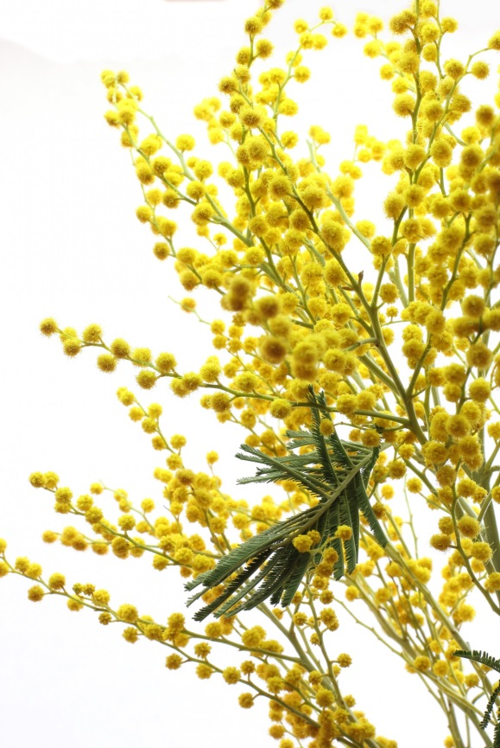
Acacia
the Wattle

Автор:
Ольга Михайловна Степанова

учитель английского
языка
МБОУ «Цивильская СОШ №2»
города Цивильск

2014
Чувашской Республики
Across

1. Today, acacia ... is very popular and one can find many items made using its timber. (9)
4. Acacia has short ... : most species live between 15 to 30 years. (8)
8. It is said that smoke from acacia bark is thought to keep demons and ghosts away and to put the gods in a good ... . (4)
9. The acacia tree is native to Australia, and it is widely considered that its ... was first introduced in Europe in 1601 (4)
10. Wattle has graced Australia's ... of Arms for 100 years (4)
11. Today, acacia is mostly used for the production of floorings, furniture, toys, ... and tools. (7)
12. Leaves of acacia are important source of ... for camels, goats, giraffes and cattle. (4)
13. The Australian aboriginals use a blossoming branch of the acacia to offer it to the ... of their choice as a declaration of their love. (4)
14. Acacia is a type of shrub or deciduous tree that belongs to the ... family. (3)
17. The kangaroo thorn (Acacia paradoxa) of Australia is grown for ... displays. (6)
21. More than half of the Acacia species grow in Australia where the tree is commonly referred to as "... ." (6)
23. Aboriginal people have a strong traditional relationship with a number of wattle species, which have been used by them for food, fuel, ... and various woodcrafts. (8)
25. in spring, the most delicate feathery yellow of plumes and plumes and plumes and trees and bushes of wattle, as if angels had flown right down out of the softest gold regions of ... to settle here, in the Australian bush. D. H. Lawrence, Kangaroo. (6)
27. arious extracts from the bark and the leaves or phyllodes have been and continue to be used by Australian Aborigines for a wide variety of medicinal purposes such as relieving ... or colds or applying to wounds and burns. (9)
29. In 1992, 1 September was formally declared "National Wattle ... ". (3)
31. Flowers of acacia are used in the industry of perfumes and ... . (9)
32. Wattles have long had special meanings for Australians, and in 1988 the Golden Wattle (Acacia pycnantha) was officially gazetted as Australia's national floral ... . (6)

Down

1. Prime Minister Andrew ... changed Australia’s Coat of Arms in 1912 to include more relevant Australian symbols and made a spray of wattle the background feature. (6)
2. You can find your space in the meeting place There will always be ... Where the Wattles Bloom. (From an Australian Song) (4)
3. The flowers are characteristically yellow, although sometimes white, and typically have five sepals and petals, many stamens, and a single ... . (6)
5. Wattle celebrations first arose as occasions when earlier generations of Australians stood up and said: "I am from this land. This place is ... ." (4)
6. Mostly the seeds are ground into a flour and cooked like damper although some are eaten raw or made into a ... . (8)
7. The Golden Wattle Award is an honorary ... of the achievements of an Australian whose contributions in the past 12 months deserve special acknowledgement by Australians. (11)
9. The first celebration of Wattle Day was held on 1 September 1910 in ... , Melbourne and Adelaide. (6)
13. Americans like to consume ... made of flowers of acacia. (7)
15. Some types of acacia can reach 70 ... in height and 3 feet in diameter. (4)
16. The almost countless stamens give the flower clusters a soft, fuzzy, golden appearance and make the plant an attractive ... . (10)
18. September 1 is ‘National Wattle Day’ — a time when the smells of Spring are in the ... as well as Australia's vivid gold blossom, writes history editor Dr Glenn Davies. (3)
19. ... Hitchcock, known as The Wattle Lady, is responsible for gazettal of Acacia pycnantha as Australia's National Floral Emblem and gazettal of National Wattle Day on 1st September each year. (5)
20. The bark of various Australian species, known as wattles, is very rich in tannin and forms an important article of ... . (6)
22. Acacia usually grows to the ... of 40 feet. (6)
24. There are about 500 species, some 300 of which are found in Australia and on the islands of the ... . (7)
26. Acacia are a good ... of pollen making some species popular with bee-keepers. (6)
28. Wattle sprigs were sold to raise ... during the First World War (5)
30. Fruit of acacia is dry ... . (3)

Учащимся будет интересно работать с этим кроссвордом в интерактивном режиме на онлайн, так как он одновременно помещается в интернете по адресу:
file:///C:/Users/1/Desktop/%D1%83%D1%87%D0%BF%D0%BE%D1%80%D1%82%D1%84%20%D0%B4%D0%BB%D1%8F%20%D0%BE%D1%82%D0%BF%D1%80%D0%B0%D0%B2%D0%BA%D0%B8/Acacia%20web.html

Ответы на следующей странице

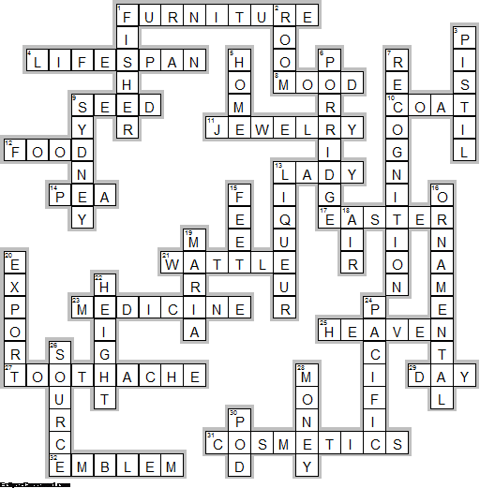
Across

1. FURNITURE—Today, acacia ... is very popular and one can find many items made using its timber.
4. LIFESPAN—Acacia has short ... : most species live between 15 to 30 years.
8. MOOD—It is said that smoke from acacia bark is thought to keep demons and ghosts away and to put the gods in a good ... .
9. SEED—The acacia tree is native to Australia, and it is widely considered that its ... was first introduced in Europe in 1601
10. COAT—Wattle has graced Australia's ... of Arms for 100 years
11. JEWELRY—Today, acacia is mostly used for the production of floorings, furniture, toys, ... and tools.
12. FOOD—Leaves of acacia are important source of ... for camels, goats, giraffes and cattle.
13. LADY—The Australian aboriginals use a blossoming branch of the acacia to offer it to the ... of their choice as a declaration of their love.
14. PEA—Acacia is a type of shrub or deciduous tree that belongs to the ... family.
17. EASTER—The kangaroo thorn (Acacia paradoxa) of Australia is grown for ... displays.
21. WATTLE—More than half of the Acacia species grow in Australia where the tree is commonly referred to as "... ."
23. MEDICINE—Aboriginal people have a strong traditional relationship with a number of wattle species, which have been used by them for food, fuel, ... and various woodcrafts.
25. HEAVEN—in spring, the most delicate feathery yellow of plumes and plumes and plumes and trees and bushes of wattle, as if angels had flown right down out of the softest gold regions of ... to settle here, in the Australian bush. D. H. Lawrence, Kangaroo.
27. TOOTHACHE—arious extracts from the bark and the leaves or phyllodes have been and continue to be used by Australian Aborigines for a wide variety of medicinal purposes such as relieving ... or colds or applying to wounds and burns.
29. DAY—In 1992, 1 September was formally declared "National Wattle ... ".
31. COSMETICS—Flowers of acacia are used in the industry of perfumes and ... .
32. EMBLEM—Wattles have long had special meanings for Australians, and in 1988 the Golden Wattle (Acacia pycnantha) was officially gazetted as Australia's national floral ... .

Down

1. FISHER—Prime Minister Andrew ... changed Australia’s Coat of Arms in 1912 to include more relevant Australian symbols and made a spray of wattle the background feature.
2. ROOM—You can find your space in the meeting place There will always be ... Where the Wattles Bloom. (From an Australian Song)
3. PISTIL—The flowers are characteristically yellow, although sometimes white, and typically have five sepals and petals, many stamens, and a single ... .
5. HOME—Wattle celebrations first arose as occasions when earlier generations of Australians stood up and said: "I am from this land. This place is ... ."
6. PORRIDGE—Mostly the seeds are ground into a flour and cooked like damper although some are eaten raw or made into a ... .
7. RECOGNITION—The Golden Wattle Award is an honorary ... of the achievements of an Australian whose contributions in the past 12 months deserve special acknowledgement by Australians.
9. SYDNEY—The first celebration of Wattle Day was held on 1 September 1910 in ... , Melbourne and Adelaide.
13. LIQUEUR—Americans like to consume ... made of flowers of acacia.
15. FEET—Some types of acacia can reach 70 ... in height and 3 feet in diameter.
16. ORNAMENTAL—The almost countless stamens give the flower clusters a soft, fuzzy, golden appearance and make the plant an attractive ... .
18. AIR—September 1 is ‘National Wattle Day’ — a time when the smells of Spring are in the ... as well as Australia's vivid gold blossom, writes history editor Dr Glenn Davies.
19. MARIA—... Hitchcock, known as The Wattle Lady, is responsible for gazettal of Acacia pycnantha as Australia's National Floral Emblem and gazettal of National Wattle Day on 1st September each year.
20. EXPORT—The bark of various Australian species, known as wattles, is very rich in tannin and forms an important article of ... .
22. HEIGHT—Acacia usually grows to the ... of 40 feet.
24. PACIFIC—There are about 500 species, some 300 of which are found in Australia and on the islands of the ... .
26. SOURCE—Acacia are a good ... of pollen making some species popular with bee-keepers.
28. MONEY—Wattle sprigs were sold to raise ... during the First World War
30. POD—Fruit of acacia is dry ... .

The End

Использованные источники

http://www.softschools.com/facts/plants/acacia_facts/1047/
http://www.buzzle.com/articles/acacia-tree-facts.html
http://farah.expertscolumn.com/article/interesting-facts-about-acacia-tree-facts
http://www.anbg.gov.au/acacia/
http://tsdav.asn.au/news/wattle-day-whats-it-all-about-1
http://www.aph.gov.au/About_Parliament/Parliamentary_Departments/Parliamentary_Library/Publications_Archive/CIB/cib9596/96cib1
http://www.nma.gov.au/exhibitions/symbols_of_australia/wattle
http://wattleday.com/
https://independentaustralia.net/australia/australia-display/the-spirit-of-national-wattle-day,5681
http://www.wattleday.asn.au/

