Кроссворд
Who Wants
to be
a Top Turkey?
для учащихся 8-11 классов,
влюбленных в английский язык
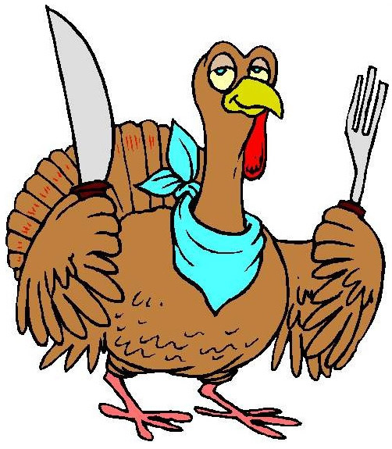

Автор:
Ольга Михайловна Степанова

учитель английского
языка
МБОУ «Цивильская СОШ №2»
города Цивильск
Чувашской Республики

2014
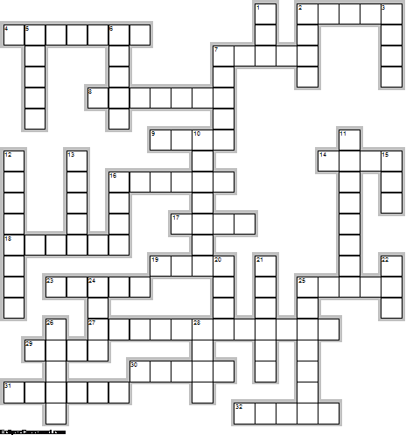

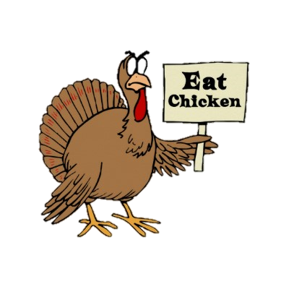

Across

2. A group of turkeys is called a ... . (5)
4. The gizzard is a part of the ... that contains tiny stones, which helps the turkey grind up food for digestion. (7)
7. Turkeys do not like ... and the cold. (5)
8. A male turkey is called a tom or a ... . (7)
9. Benjamin Franklin wanted to make the wild turkey, not the Bald Eagle, the national ... of the United States. (4)
14. A dust bathe is turkeys' method of practicing bodily hygiene the same as a water ... is for humans. (4)
16. They were first domesticated in ... and brought to Europe in the 16th century. (6)
17. ild turkeys can run fast---up to 25 miles per ... . (4)
18. The costume that "Big Bird"wears on Sesame ... is rumored to be made of turkey feathers. (6)
19. ... is National Turkey Lover’s Month. (4)
23. The original word in French, coq d’Inde, meant rooster of ... , and has since shortened to dinde. (5)
25. If turkeys thought, they'd run away, A week before Thanksgiving Day. But turkeys can't anticipate, And so there's turkey on my ... ! Jack Prelutsky (5)
27. "Let's talk turkey" means "Let' have a serious ... ." (12)
29. First, let’s get the facts on the two turkeys. The word turkey has been used to refer to “land occupied by the Turks” since the 1300s and was even used by Chaucer in The ... of the Duchess. (4)
30. The Idiom 'go cold turkey' means to suddenly and completely stop doing something, especially a bad ... . (5)
31. In nature, young turkeys stay with, and learn from their ... for as long as five months (6)
32. A young male is called Jake while a young female is called ... . (5)

Down

1. Turkey is low in ... and high in protein. (3)
2. Since 1947, the National Turkey Federation has presented a live turkey and two dressed turkeys to the President. The President does not eat the live turkey. He "pardons"it and allows it to live out its days on a historical ... . (4)
3. Henry VIII was the first English ... to enjoy turkey. (4)
5. There once was a turkey named Chummy, Mom thought that he might be quite yummy. He waddled away On Thanksgiving Day -- But still ended up in my ... ! (5)
6. The bare skin on the throat and head can change ... from flat gray to shades of red, white and blue when the turkey becomes distressed or excited. (5)
7. Turkey mothers are among the most protective mothers in the ... . (5)
10. The worst predator of the wild turkey is the ... . (7)
11. The wild turkey is the official game bird of Alabama, Massachusetts and South ... . (8)
12. A turkey is a large bird related to a ... . (8)
13. The ballroom ... known as the Turkey Trot was named for the short, jerky steps a turkey makes. (5)
15. A female turkey is called a ... . (3)
16. The Native Americans hunted wild turkey for its sweet, juicy ... as early as 1000 A.D. (4)
20. Turkeys have great hearing , but no external ... . (4)
21. We call the bright red thing that hangs under a turkey's chin as a ... . (6)
22. As the story goes, President Lincoln spared the life of a turkey out of love and loyalty to his son, Tad, who wanted to keep it as a ... . (3)
24. I am a big, fat turkey You can't have my head. I'll sit with you at dinner. We'll eat a ... instead! (4)
25. Turkey has more ... than chicken or beef. (7)
26. Turkey skins can be tanned and used to make cowboy ... and belts. (5)
28. The best time to see a turkey is on a warm clear day or in a light ... . (4)

Учащимся будет интересно работать с этим кроссвордом в онлайн режиме, так как он одновременно помещается в интернете по адресу:
file:///C:/Users/1/Desktop/Who%20Wants%20to%20be%20a%20Top%20Turkey.html

Answers are given on the next page

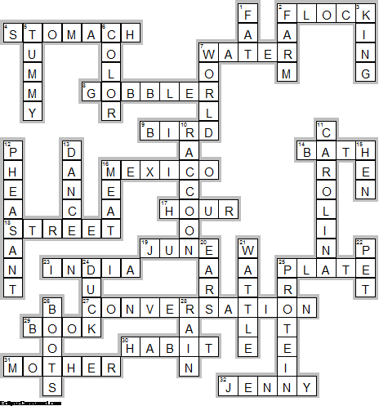
Across

2. FLOCK—A group of turkeys is called a ... .
4. STOMACH—The gizzard is a part of the ... that contains tiny stones, which helps the turkey grind up food for digestion.
7. WATER—Turkeys do not like ... and the cold.
8. GOBBLER—A male turkey is called a tom or a ... .
9. BIRD—Benjamin Franklin wanted to make the wild turkey, not the Bald Eagle, the national ... of the United States.
14. BATH—A dust bathe is turkeys' method of practicing bodily hygiene the same as a water ... is for humans.
16. MEXICO—They were first domesticated in ... and brought to Europe in the 16th century.
17. HOUR—ild turkeys can run fast---up to 25 miles per ... .
18. STREET—The costume that "Big Bird"wears on Sesame ... is rumored to be made of turkey feathers.
19. JUNE—... is National Turkey Lover’s Month.
23. INDIA—The original word in French, coq d’Inde, meant rooster of ... , and has since shortened to dinde.
25. PLATE—If turkeys thought, they'd run away, A week before Thanksgiving Day. But turkeys can't anticipate, And so there's turkey on my ... ! Jack Prelutsky
27. CONVERSATION—"Let's talk turkey" means "Let' have a serious ... ."
29. BOOK—First, let’s get the facts on the two turkeys. The word turkey has been used to refer to “land occupied by the Turks” since the 1300s and was even used by Chaucer in The ... of the Duchess.
30. HABIT—The Idiom 'go cold turkey' means to suddenly and completely stop doing something, especially a bad ... .
31. MOTHER—In nature, young turkeys stay with, and learn from their ... for as long as five months
32. JENNY—A young male is called Jake while a young female is called ... .

Down

1. FAT—Turkey is low in ... and high in protein.
2. FARM—Since 1947, the National Turkey Federation has presented a live turkey and two dressed turkeys to the President. The President does not eat the live turkey. He "pardons"it and allows it to live out its days on a historical ... .
3. KING—Henry VIII was the first English ... to enjoy turkey.
5. TUMMY—There once was a turkey named Chummy, Mom thought that he might be quite yummy. He waddled away On Thanksgiving Day -- But still ended up in my ... !
6. COLOR—The bare skin on the throat and head can change ... from flat gray to shades of red, white and blue when the turkey becomes distressed or excited.
7. WORLD—Turkey mothers are among the most protective mothers in the ... .
10. RACCOON—The worst predator of the wild turkey is the ... .
11. CAROLINA—The wild turkey is the official game bird of Alabama, Massachusetts and South ... .
12. PHEASANT—A turkey is a large bird related to a ... .
13. DANCE—The ballroom ... known as the Turkey Trot was named for the short, jerky steps a turkey makes.
15. HEN—A female turkey is called a ... .
16. MEAT—The Native Americans hunted wild turkey for its sweet, juicy ... as early as 1000 A.D.
20. EARS—Turkeys have great hearing , but no external ... .
21. WATTLE—We call the bright red thing that hangs under a turkey's chin as a ... .
22. PET—As the story goes, President Lincoln spared the life of a turkey out of love and loyalty to his son, Tad, who wanted to keep it as a ... .
24. DUCK—I am a big, fat turkey You can't have my head. I'll sit with you at dinner. We'll eat a ... instead!
25. PROTEIN—Turkey has more ... than chicken or beef.
26. BOOTS—Turkey skins can be tanned and used to make cowboy ... and belts.
28. RAIN—The best time to see a turkey is on a warm clear day or in a light ... .

The End

