Those Wise Owls
Кроссворд Для учащихся 8-11 классов,
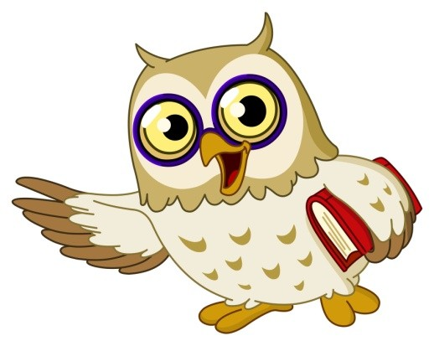
влюбленных в английский язык

Автор:
Ольга Михайловна Степанова
учитель английского языка
МБОУ «Цивильская СОШ №2»
города Цивильск
Чувашской Республики

2015

Успехи в учёбе наблюдаются тогда, когда на нужном уровне поставлена внеклассная работа по предмету. Эта мысль Сухомлинского как никогда звучит актуально, когда внедряется ФГОС. Кроссворд представляет интересные факты про красивую и мудрую птицу - про сову - на английском языке и предназначен для развития языка, обогащения лексического потенциала и является хорошим материалом для развития чтения. В кроссворд включены факты о совах, пословицы и цитаты, которые содержат слово "сова". Рекомендуется использовать при проведении внеклассных мероприятий по английскому языку с учащимися 8-11 классов. Актуальность кроссворда в том. что 2015-ый год – год Белого Филина , то есть год совы. Ценность кроссворда в том, что он одновременно помещается как интерактивный материал - его можно решить в онлайн режиме по адресу
file:///C:/Users/1/Desktop/Those%20Wise%20Owls.html

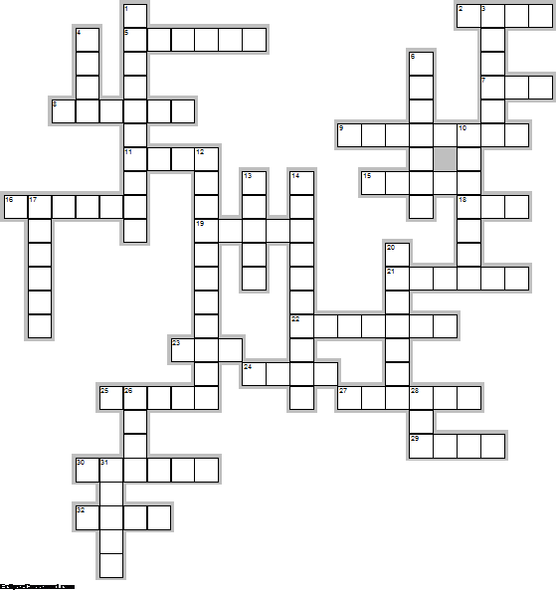

Across

2. There was an Old Man with a owl, Who continued to bother and howl; He sat on a ... And imbibed bitter ale, Which refreshed that Old Man and his owl. Limerick. (4)
5. Bring owls to ... meansTo undertake a pointless venture, one that is redundant, unnecessary, superfluous, or highly uneconomical. (6)
7. I saw an owl. He sat in a tree. He opened one ... . He winked at me. A poem for kids. (3)
8. Owls do not produce any kind of sound while ... . (6)
9. In 1991 Hedwig was purchased from Eeylops Owl Emporium and was gifted to Harry from Rubeus Hagrid on his eleventh ... . (8)
11. Many younger readers learn about great horned owls in Owl ... . (4)
15. The owl is the wisest of all ... because the more it sees, the less it talks. ~ African Proverb (5)
16. The owl sees in his son a ... . Proverb. (6)
18. Among early English folk cures, alcoholism was treated with Owl ... . (3)
19. Barn owls can be recognized by their ... shaped face. (5)
21. Baby owls are called ... . (6)
22. Owls in China were associated with ... and lightning. (7)
23. A wise owl lived in an ... . The more he saw, the less he spoke. The less he spoke, the more he heard. Why can’t we all be like that wise old bird? Edward Hershey Richards (3)
24. In parts of northern England it is good ... to see an Owl. (4)
25. All owls lay the same color egg, which is ... . (5)
27. Both the Greek and Roman goddesses of ... , Pallas Athene and Minerva were often pictured in the company of an owl. (6)
29. A single barn owl can eat over 1,000 mice in a ... . (4)
30. The name of Harry Potter's pet owl is ... . (6)
32. Owls have powerful talons (claws) which help them catch and kill ... . (4)

Down

1. A group of owls is called a ... . (10)
3. In Greek mythology, the owl was associated with the goddess ..., the goddess of wisdom. (6)
4. The owls of Harry Potter deliver ... . (4)
6. If an Owl flew over Greek Soldiers before a battle, they took it as a sign of ... . (7)
10. Long ago in Europe, a dead owl was thought to ward away lightning, hail and ... . (7)
12. The Owl and the ... is a twelfth- or thirteenth-century Middle English poem detailing a debate between an owl and him. (11)
13. Some North American Indian tribes considered owls to be an omen of ... . (5)
14. Owls are found in all different habitats and there are different owl species found on all continents except ... . (10)
17. The owl of Winnie-the-Pooh gives ... . (6)
20. In Greek mythology, the owl was associated with the goddess Athena, the ... of wisdom. (7)
26. Unlike most birds, owls eyes are on the front of the ... . (4)
28. Owls sleep during the ... and emerge at night to hunt small prey. (3)
31. Over 200 types of owls live on the ... . (5)

Ответы:

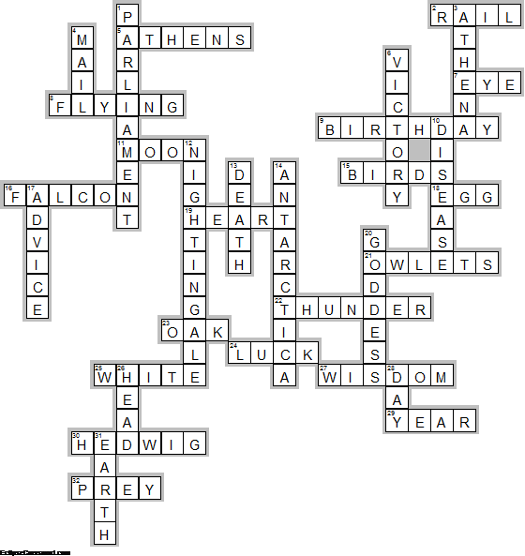

Across

2. RAIL—There was an Old Man with a owl, Who continued to bother and howl; He sat on a ... And imbibed bitter ale, Which refreshed that Old Man and his owl. Limerick.
5. ATHENS—Bring owls to ... meansTo undertake a pointless venture, one that is redundant, unnecessary, superfluous, or highly uneconomical.
7. EYE—I saw an owl. He sat in a tree. He opened one ... . He winked at me. A poem for kids.
8. FLYING—Owls do not produce any kind of sound while ... .
9. BIRTHDAY—In 1991 Hedwig was purchased from Eeylops Owl Emporium and was gifted to Harry from Rubeus Hagrid on his eleventh ... .
11. MOON—Many younger readers learn about great horned owls in Owl ... .
15. BIRDS—The owl is the wisest of all ... because the more it sees, the less it talks. ~ African Proverb
16. FALCON—The owl sees in his son a ... . Proverb.
18. EGG—Among early English folk cures, alcoholism was treated with Owl ... .
19. HEART—Barn owls can be recognized by their ... shaped face.
21. OWLETS—Baby owls are called ... .
22. THUNDER—Owls in China were associated with ... and lightning.
23. OAK—A wise owl lived in an ... . The more he saw, the less he spoke. The less he spoke, the more he heard. Why can’t we all be like that wise old bird? Edward Hershey Richards
24. LUCK—In parts of northern England it is good ... to see an Owl.
25. WHITE—All owls lay the same color egg, which is ... .
27. WISDOM—Both the Greek and Roman goddesses of ... , Pallas Athene and Minerva were often pictured in the company of an owl.
29. YEAR—A single barn owl can eat over 1,000 mice in a ... .
30. HEDWIG—The name of Harry Potter's pet owl is ... .
32. PREY—Owls have powerful talons (claws) which help them catch and kill ... .

Down

1. PARLIAMENT—A group of owls is called a ... .
3. ATHENA—In Greek mythology, the owl was associated with the goddess ..., the goddess of wisdom.
4. MAIL—The owls of Harry Potter deliver ... .
6. VICTORY—If an Owl flew over Greek Soldiers before a battle, they took it as a sign of ... .
10. DISEASE—Long ago in Europe, a dead owl was thought to ward away lightning, hail and ... .
12. NIGHTINGALE—The Owl and the ... is a twelfth- or thirteenth-century Middle English poem detailing a debate between an owl and him.
13. DEATH—Some North American Indian tribes considered owls to be an omen of ... .
14. ANTARCTICA—Owls are found in all different habitats and there are different owl species found on all continents except ... .
17. ADVICE—The owl of Winnie-the-Pooh gives ... .
20. GODDESS—In Greek mythology, the owl was associated with the goddess Athena, the ... of wisdom.
26. HEAD—Unlike most birds, owls eyes are on the front of the ... .
28. DAY—Owls sleep during the ... and emerge at night to hunt small prey.
31. EARTH—Over 200 types of owls live on the ... .

Использованная литература:

http://birding.about.com/od/birdprofiles/a/20-Fun-Facts-About-Owls.htm
http://www.sciencekids.co.nz/sciencefacts/animals/owl.html
http://easyscienceforkids.com/all-about-owls/
http://animalstime.com/owl-facts-for-kids-owl-habitat-diet/
http://idahoptv.org/dialogue4kids/season12/owls/facts.cfm
http://www.owlpages.com/articles.php?section=Owl+Mythology&title=Myth+and+Culture
http://www.activityvillage.co.uk/owls

