Demis Roussos the Legend
Памяти легендарного певца посвящается
Кроссворд Для учащихся 8-11 классов,
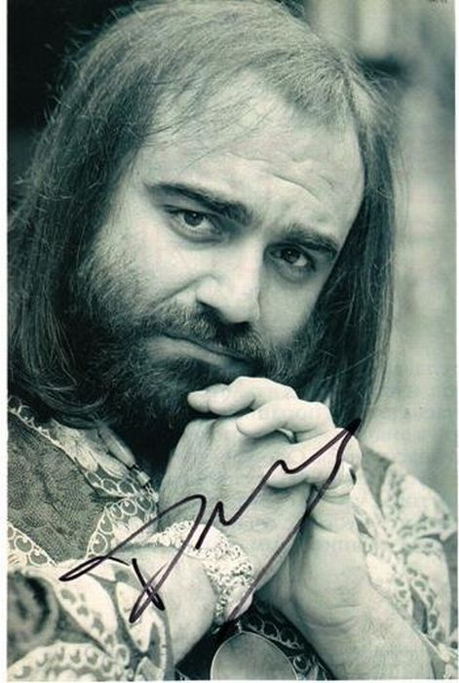
влюбленных в английский язык

Автор:
Ольга Михайловна Степанова
учитель английского языка
МБОУ «Цивильская СОШ №2»
города Цивильск
Чувашской Республики
2015

Успехи в учёбе наблюдаются тогда, когда на нужном уровне поставлена внеклассная работа по предмету. Эта мысль Сухомлинского как никогда звучит актуально, когда внедряется ФГОС. Кроссворд посвящается памяти легендарного певца Демиса Руссоса и представляет реальные факты из его жизни на английском языке. В процессе ознакомления с биографией певца, учащиеся развивают язык, обогащают лексический потенциал и развивают грамматические структуры языка, а также совершенствуют навыки чтения, в ходе чего у них формируется языковая догадка. Рекомендуется использовать при проведении внеклассных мероприятий по английскому языку с учащимися 9-11 классов, а также на уроках при прохождении разделов на данную тематику. Ценность кроссворда в том, что он одновременно помещается как интерактивный материал - его можно решить в онлайн режиме по адресу file:///C:/Users/1/Desktop/Demis%20Roussos.html

Across

5. His ... "Forever and Ever" was No. 1 in the UK Singles Chart in 1976. (6)
8. He spent his 39th birthday on the hijacked plane and when released unharmed, thanked his captors, at a press conference, for giving him a birthday ... . (4)
9. Attracted to singing, he joined the choir of the Greek Byzantine ... with which he sang for five years as a soloist. (6)
10. He was raised there until his ... moved to Greece in the early 60s after losing their possessions during the Suez crisis. (7)
11. In Italy he was awarded a gold ... after selling 150 000 copies of his album ‘Universum’. (4)
13. His first UK single to chart was in 1975: "Happy to Be on an ... in the Sun" written by an Englishman David Lewis. (6)
16. In 1978, he decided to keep a lower profile and moved to Malibu Beach in the US, where he shed much of the weight that had seen him routinely mocked by comedians like Freddie ... . (5)
17. Roussos’ fondness for kaftans saw him dubbed “the Kaftan ...” and he often wore them for his performances on shows such as Top of the Pops. (4)
18. BBC TV producer John King made a ... entitled "The Roussos Phenomenon" in 1976. (11)
21. At the age of 17, with only music in his head and to the great disappointment of his mother who was hoping to send him to the best school in Athens, Demis formed his first ... . (4)
23. He studied musical theory and learnt how to play the guitar and the ... . (7)
24. In June 1985, Roussos was among the .... of TWA Flight 847 from Athens to Rome, which was hijacked, by members of Hezbollah and Islamic Jihad, but he was released along with four other Greeks after five days while most of the other hostages remained there for 17 days. (10)
26. From his early childhood he was immersed in folk ... . (5)
28. In 1982 he co-authored the book A Question of Weight with his close friend photographer Veronique Skawinska, in which he dealt candidly with his struggles with ... . (7)
29. Roussos also began a solo ... with the song "We Shall dance" in 1971. (6)
32. Demis Roussos' real name is ... Venturis Roussos. (8)

Down

1. Other hits by Roussos included "My Friend the Wind", "My Reason", "Velvet Mornings", "Goodbye My ..., Goodbye" (4)
2. Greek singer, Nana Mouskouri, paid tribute on French radio RTL: “He had a superb ... , he travelled in the world ... he loved what he was doing. (5)
3. Demis's mother Olga was a ... . (6)
4. For years, Roussos struggled with his ... . (6)
6. Demis Roussos's zodiak sign is .. . (6)
7. “We will miss the amazing Demis, whose singing brought ... to the world,”his manager Denis Vaughan told the BBC. (8)
8. Roussos came to a wider audience in 1967 when he joined progressive rock band Aphrodite's ... . (5)
12. Demis Roussos lived in Los Angeles, Paris, Monte ... , London and Athens including Alexandria. (5)
14. “He was a ... . He played hard, he worked hard. The world is a less fun place without Demis”, his manager Denis Vaughan told the BBC. (6)
15. Demis's father George (Yorgos Roussos) was a classical guitarist and an ... . (8)
16. In 1973, Roussos made one of his earliest television appearances on The Basil Brush Show and also appeared on Nana Mouskouri's TV ... in the UK. (4)
19. From Rio to Tokyo, from Montreal to Teheran, Demis has sung in more that 35 countries, given over 1,000 concerts, sold millions of albums, received countless gold-record ... . (6)
20. He has throughout the world conquered the ... of the people who flock to see him. (6)
21. A world-reknown astrologist once explained the theme of Demis Roussos' life in the following terms: "Though a child of Greece, Demis Roussos had to leave the place of his ... in order to find the artistic success promised to him by the stars." (5)
22. Demis Roussos was born on 15 June 1946 in Alexandria, ... . (5)
25. Initially unsuccessful, he toured around ... and became a leading artist. (6)
27. Following the Greek ... , the baby was named after his paternal grandfather, Demis being a pet name for Artemios. (6)
30. His formative years in the ancient port city's cosmopolitan atmosphere were influenced by ..., but also traditional Arab and Greek Orthodox music. (4)
31. His only ambition is to offer to his fellows a moment of relaxation and the ... of sharing the music which he loves. (3)

Ответы:

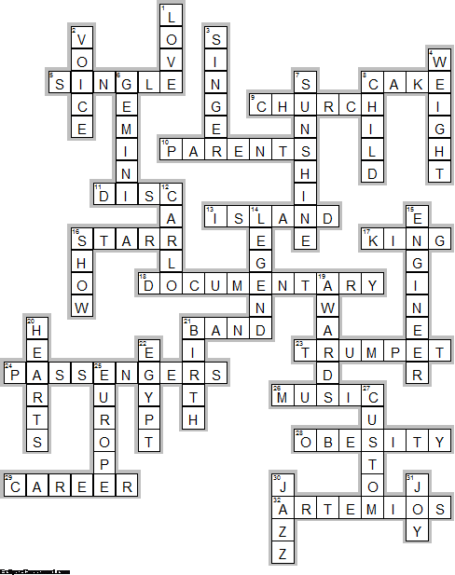

Across

5. SINGLE—His ... "Forever and Ever" was No. 1 in the UK Singles Chart in 1976.
8. CAKE—He spent his 39th birthday on the hijacked plane and when released unharmed, thanked his captors, at a press conference, for giving him a birthday ... .
9. CHURCH—Attracted to singing, he joined the choir of the Greek Byzantine ... with which he sang for five years as a soloist.
10. PARENTS—He was raised there until his ... moved to Greece in the early 60s after losing their possessions during the Suez crisis.
11. DISC—In Italy he was awarded a gold ... after selling 150 000 copies of his album ‘Universum’.
13. ISLAND—His first UK single to chart was in 1975: "Happy to Be on an ... in the Sun" written by an Englishman David Lewis.
16. STARR—In 1978, he decided to keep a lower profile and moved to Malibu Beach in the US, where he shed much of the weight that had seen him routinely mocked by comedians like Freddie ... .
17. KING—Roussos’ fondness for kaftans saw him dubbed “the Kaftan ...” and he often wore them for his performances on shows such as Top of the Pops.
18. DOCUMENTARY—BBC TV producer John King made a ... entitled "The Roussos Phenomenon" in 1976.
21. BAND—At the age of 17, with only music in his head and to the great disappointment of his mother who was hoping to send him to the best school in Athens, Demis formed his first ... .
23. TRUMPET—He studied musical theory and learnt how to play the guitar and the ... .
24. PASSENGERS—In June 1985, Roussos was among the .... of TWA Flight 847 from Athens to Rome, which was hijacked, by members of Hezbollah and Islamic Jihad, but he was released along with four other Greeks after five days while most of the other hostages remained there for 17 days.
26. MUSIC—From his early childhood he was immersed in folk ... .
28. OBESITY—In 1982 he co-authored the book A Question of Weight with his close friend photographer Veronique Skawinska, in which he dealt candidly with his struggles with ... .
29. CAREER—Roussos also began a solo ... with the song "We Shall dance" in 1971.
32. ARTEMIOS—Demis Roussos' real name is ... Venturis Roussos.

Down

1. LOVE—Other hits by Roussos included "My Friend the Wind", "My Reason", "Velvet Mornings", "Goodbye My ..., Goodbye"
2. VOICE—Greek singer, Nana Mouskouri, paid tribute on French radio RTL: “He had a superb ... , he travelled in the world ... he loved what he was doing.
3. SINGER—Demis's mother Olga was a ... .
4. WEIGHT—For years, Roussos struggled with his ... .
6. GEMINI—Demis Roussos's zodiak sign is .. .
7. SUNSHINE—“We will miss the amazing Demis, whose singing brought ... to the world,”his manager Denis Vaughan told the BBC.
8. CHILD—Roussos came to a wider audience in 1967 when he joined progressive rock band Aphrodite's ... .
12. CARLO—Demis Roussos lived in Los Angeles, Paris, Monte ... , London and Athens including Alexandria.
14. LEGEND—“He was a ... . He played hard, he worked hard. The world is a less fun place without Demis”, his manager Denis Vaughan told the BBC.
15. ENGINEER—Demis's father George (Yorgos Roussos) was a classical guitarist and an ... .
16. SHOW—In 1973, Roussos made one of his earliest television appearances on The Basil Brush Show and also appeared on Nana Mouskouri's TV ... in the UK.
19. AWARDS—From Rio to Tokyo, from Montreal to Teheran, Demis has sung in more that 35 countries, given over 1,000 concerts, sold millions of albums, received countless gold-record ... .
20. HEARTS—He has throughout the world conquered the ... of the people who flock to see him.
21. BIRTH—A world-reknown astrologist once explained the theme of Demis Roussos' life in the following terms: "Though a child of Greece, Demis Roussos had to leave the place of his ... in order to find the artistic success promised to him by the stars."
22. EGYPT—Demis Roussos was born on 15 June 1946 in Alexandria, ... .
25. EUROPE—Initially unsuccessful, he toured around ... and became a leading artist.
27. CUSTOM—Following the Greek ... , the baby was named after his paternal grandfather, Demis being a pet name for Artemios.
30. JAZZ—His formative years in the ancient port city's cosmopolitan atmosphere were influenced by ..., but also traditional Arab and Greek Orthodox music.
31. JOY—His only ambition is to offer to his fellows a moment of relaxation and the ... of sharing the music which he loves.

Использованная литература:

http://birding.about.com/od/birdprofiles/a/20-Fun-Facts-About-Owls.htm
http://www.sciencekids.co.nz/sciencefacts/animals/owl.html
http://easyscienceforkids.com/all-about-owls/
http://animalstime.com/owl-facts-for-kids-owl-habitat-diet/
http://idahoptv.org/dialogue4kids/season12/owls/facts.cfm
http://www.owlpages.com/articles.php?section=Owl+Mythology&title=Myth+and+Culture
http://www.activityvillage.co.uk/owls

